

iProcurement Punchout

Author Financial System Service (FSS)

Introduction

iProcurement Punchout

Punchout is the result of a collaboration between EA and Findel whereby items, mainly from Hope, that were previously ordered using the Non-Catalogue method or iProcurement shop

can be ordered much easier though a ‘Punchout’ link to the Findel website. This website is a customised website specifically for EA only available through the link. It is not accessible by going directly to Findel’s website, it is only available through Oracle iProcurement.

After clicking on the Punchout link in Oracle iProcurement, the user will be able to search and add items to the basket using H item code reference or by just browsing through the available categories. Once all required items are added to the basket the checkout button will return the user to the ‘Edit and Submit’ section within Oracle and they can proceed as usual with their order.

There will be no need to add Item descriptions or calculate any discount as this is done automatically.

Below is a detailed user guide on how to raise an order using Punchout.

- Log into Oracle. NB*Chrome is not recommended for Oracle, only MS Edge.
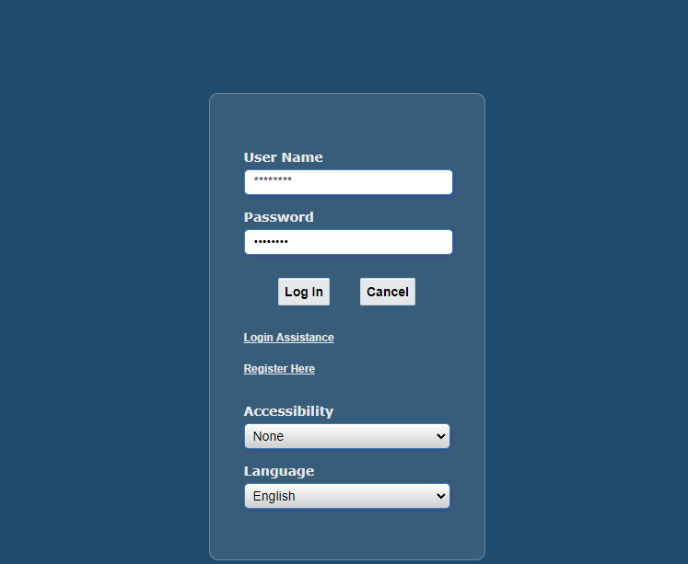

- Click on “EA iProcurement”. This is underneath “Navigator” on the left hand side of
the page.

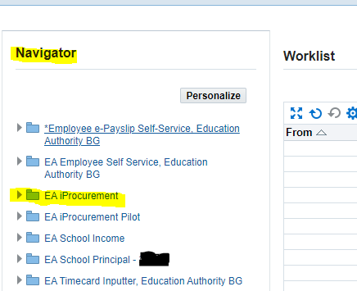
- Click on “Findel Punchout Store” (highlighted in yellow below)
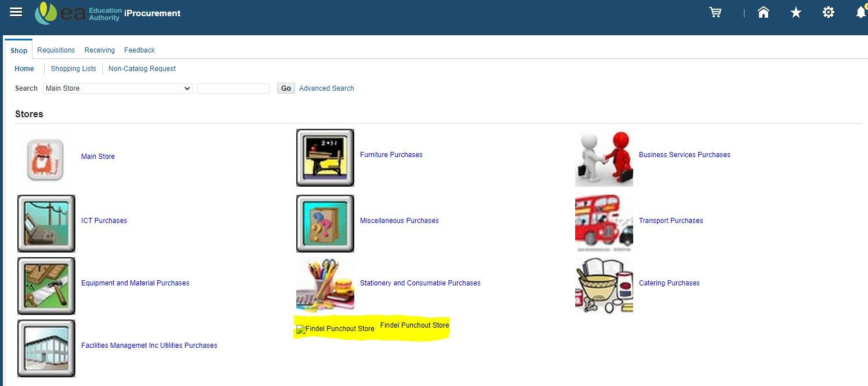

- The Findel store page will appear, either press the categories provided such as “Early Years” etc. or use the search bar to search for desired items, either by typing their description or the Findel item code e.g. HE1691844. An item with ‘Product

Restricted’ displayed is not part of EA contract and cannot be ordered. If you have any queries with regards to this type of item, please contact EA. Procurement Education Resources. (educationresource.procure@eani.org.uk)
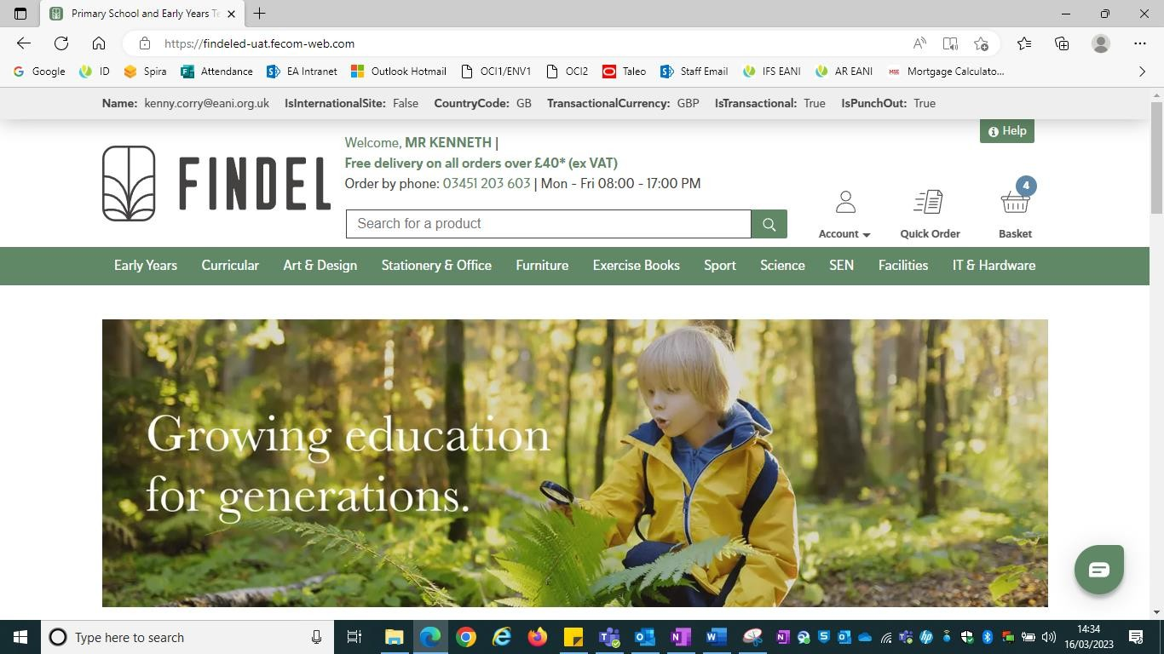
- Once the item is found, choose the quantity required using the arrows as shown and press “Add to Basket” to add the item to the basket. The number of items in the basket updates by the quantity of items so if you add 3 of one item the basket quantity inside the blue circle will show 3. If you add two more of another item, it will display 5. Please note: The add to favourites star in Findel punchout is standard but of Findel’s website, this is not for EA purposes.
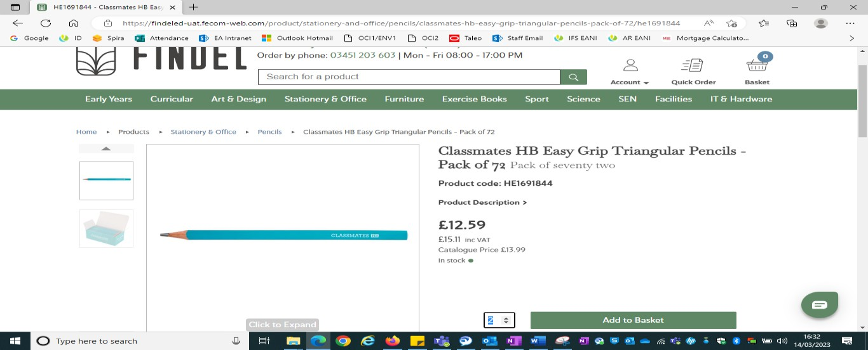

- When the order is complete, press “Basket” to see the basket as shown here.

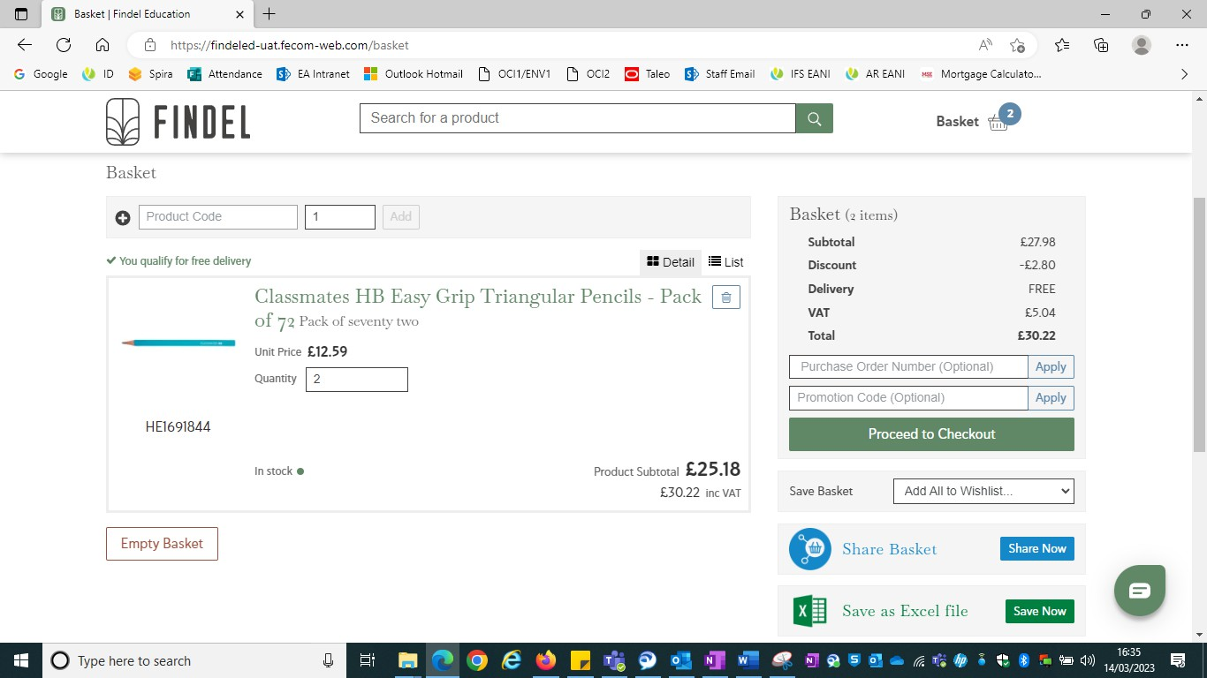

You will notice that there are a few features here to help you manage your order. You can empty the entire basket using the ‘Empty Basket’ button, you can delete a single item from the basket using the ‘bin icon’ against the line or you can change the quantity of any item by removing the current quantity and keying the new quantity.
- Please note that ANY changes made in the basket will need to be applied so the
‘Proceed to checkout’ button will neatly change to become ‘Apply changes’ and after
pressing it, it will revert and allow you to checkout.
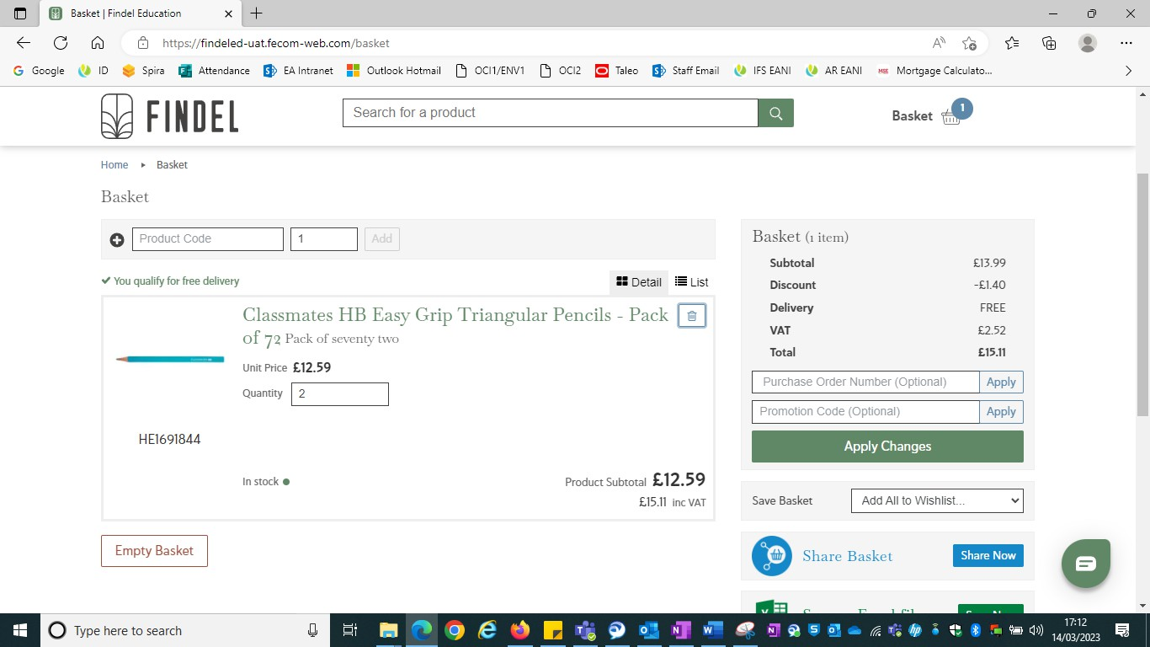

The unit price displayed against the item is the net price including discount and you can see in the basket ‘Total’ on the right, the total discount that is being applied to this order. The Total also displays the VAT but only the net price is brought back into Oracle and VAT is dealt with as usual when the Invoice is keyed in Accounts.

Please note there is still a recommended limit of 15-18 lines per requisition.
The ‘Purchase Order Number (Optional)’ and ‘Promotion Code (Optional)’ fields are not in use for EA punchout and do not require details to be entered.
The Findel content on the website e.g. Share Basket, Save Basket, Save to Favourties, Help, Returns, Accounts are Findel’s standard website advice and not EA content or advice. If you require advice on EA Procurement processes and procedures please contact EA Procurement.

When you are happy with your order press ‘Proceed to checkout’.

- You will be brought back into Oracle where you will see your order in the ‘Edit and Submit’ screen. Please do not make any changes at this point as they may not retain. Click on the ‘Shop’ tab.
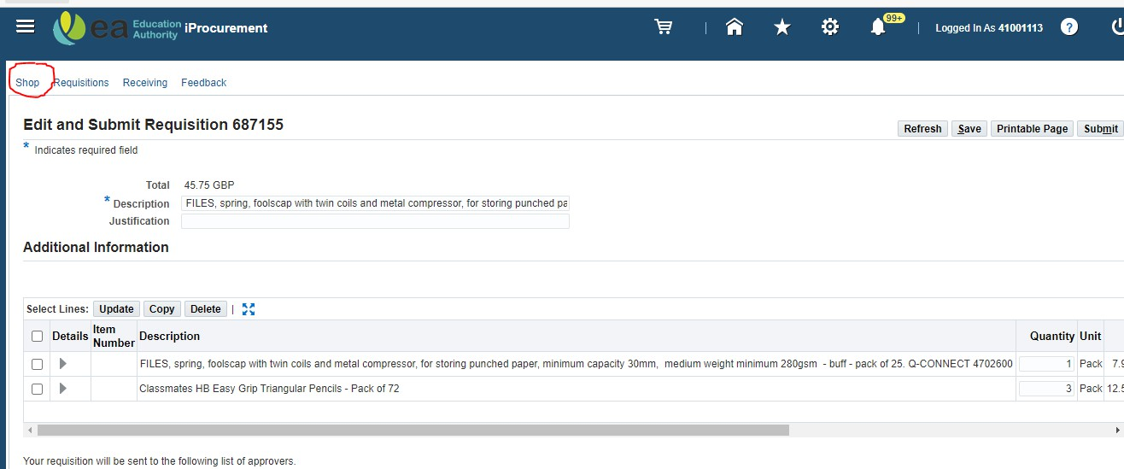

- From there click on ‘View cart and checkout’ and continue with your order as usual,
returning to the Edit section if required.

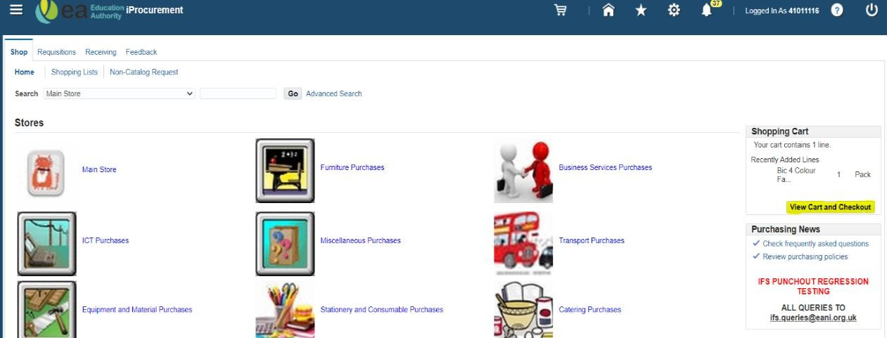

NB* For Findel punchout any special instructions please continue to use the ‘Note to Supplier – Header’ field in iProcurement, please do not enter details in the ‘note to supplier – line’ as this not required for punchout and will impact your delivery label. When entering a name for delivery in the note to supplier header field this should begin with FAO followed by the name and telephone number of the recipient. School address is not required. Please ensure that the note does not exceed 120 characters as anything over this will not be recognised by Findel's system and therefore won't be displayed on the delivery docket.

