

**EA One Self-Service Handbook**



|  |
| --- |
| **Introduction**  This Handbook covers key areas of Employee Self-Service (ESS) and Manager Self-Service (MSS). This handbook provides a step by step guide to completing EA One Self-Service along with best practice advice, EA Policy guidance and a series of frequently asked questions.  If you cannot find the answer you are looking for in this handbook, contact the EA One helpdesk. Your query will be forwarded to a member of the team who will be happy to assist you. Contact details are:   * **Email:** [EAOneHelpdesk@eani.org.uk](mailto:EAOneHelpdesk@eani.org.uk) * **Phone:** 02890 418 060 |

|  |
| --- |
| Contents  What is EA One Self-Service? 3  EA One Policies 4  Best practice 4  Using EA One Self-Service - ESS 5  How to access forms 5  Common Guidance 7  How to view Historical EA One Self-Service information 10  Annual Leave Request Guidance 12  How to Submit an Annual Leave Request 13  How to Cancel an Annual Leave Request 14  How to Locate Annual Leave Balance 15  How to Locate Assignment Number 16  How to View P60 17  How to Update Email Adress 18  How to Update Bank Details 19  How to View an Employee Payslip 20  Using EA One Self-Service - MSS 21  Viewing Team Information 21  How to View My Team’s Annual Leave Balances 23  Submitting on Behalf of an Employee 24  Approving Employee Requests 28  Frequently Asked Questions 29  Glossary – EA One Self-Service Definition List 30  EA One Self-Service Elements 30 |

|  |  |  |  |  |  |  |  |  |
| --- | --- | --- | --- | --- | --- | --- | --- | --- |
| What is EA One Self-Service? EA One Self-Service is a key component of EA One, with the purpose of:   * Providing channels better aligned to modern customer preferences. * Improving quality and timeliness of incoming information; and * Introducing digital efficiencies into corporate services.   EA One Self-Service features will be delivered through both the **EA Employee Self-Service (ESS)** and **EA Manager Self-Service (MSS)** responsibilities.  The **EA Employee Self-Service** functionality will include:   * Annual Leave Requests * Updating ‘My Information’ * Updating ‘Payroll Information’ which will include information such as; * Online Payslips * Bank Details * P60 * Updating ‘Absence Information’ which will include information such as; * Self-Certification * Viewing Absence History   The **EA Manager Self-Service** functionality will include:   * Annual Leave Overview * Updating ‘My Teams Personal Information’ which will include information such as; * Basic Details * Phone Numbers * Main Address * Emergency Contacts * Updating ‘My Teams Employment Information’ which will include information such as; * Occupational Health Requests * Workplace Assessment Request * Reasonable Adjustments * ‘My Teams Absence Information’ which will include; * Sickness Self-Certificate * Absence Certificate  EA One Policies This form of Self-Service is well established in other parts of public sector in Northern Ireland including Health and Central Government. As with all EA initiatives, EA One is a Digital First Programme, thus encouraging users to adopt digital approaches for their ease of use and effectiveness in completion. Where this is not possible users will be able to access offline methods.  When using the new EA One Self-Service facilities within Oracle, you will need **adhere to the various policies** that are currently in place within the Education Authority.  When requesting **Annual Leave** using EA One Self-Service, please ensure that you review the **various Leave and Working Arrangements Policies** which can be found [here](https://www.eani.org.uk/ea-staff-hub/hr-online/leave-working-arrangements).  When submitting **Self-Certifications** and **Absence Certificates** using the EA One Self-Service, please ensure that you review the **EA Managing Attendance Policy** which can be found [here](https://www.eani.org.uk/sites/default/files/2020-02/Managing%20Attendance%20Policy-EA%20Support%20Staff.pdf). Best practice We have compiled some top tips for using EA One Self-Service that you should be aware of. By following these tips, it will help ensure that you are using EA One Self-Service correctly and efficiently.   |  |  | | --- | --- | |  | **Input information on time**  It is important to fill out Self-Service forms on time to ensure information is accurate. For example, where possible you should submit a self-certification the day you return work. | |  | **Keep personal information up to date every six months**  To keep information accurate, it is recommended you review personal data every six months. For example, changing your address if you have moved house recently. | |  | **Review and approve requests as they appear in your worklist**  For managers, to support your staff you should review and approve requests as they appear in your worklist. You will receive email notifications when a request needs approved. | |  | **Read the common guidance for EA One Self-Service forms**  All Self-Service forms follow a similar design and user path. To ensure that you have the confidence to complete forms with ease, please read the ‘Common Guidance’ section in this handbook. | |

# 

# Using EA One Self-Service - ESS

## How to access forms

|  |  |
| --- | --- |
| **1** | On the Oracle homepage, select the **EA Employee Self-Service, Education Authority BG** responsibility.  Please select the 'EA Employee Self Service, Education Authority BG' responsibility. |
| **2** | After selecting the responsibility you can now view the drop-down menu from which you will access EA One Self-Service forms. The screenshot below shows the **My Information** tab**,** from this tab you can access the following forms:   * Personal Information * Equal Opportunity Monitoring Data   My Information tab. |
| **3** | Selecting the **Annual Leave Request** form, will let you access the Annual Leave Self-Service form**.** To view your Annual Leavehistory select **Annual Leave Details.** |
| **4** | The screenshot below shows the **Payroll Information** tab**,** from this tab you can access the following forms:   * Education Authority Online Payslip * Bank Details * P60   Payroll Information tab. |
| **5** | The screenshot below shows the **Absence Information** tab**,** from this tab you can access the following forms:   * Self-Certification * Absence Certificate * Absence History   Absence Information tab. |

Using EA One Self-Service - ESS

## Common Guidance

*Employees are encouraged to check their Supervisor is correct before submitting any Self Service forms, if your Supervisor is incorrect please contact EA One Helpdesk immediately*

|  |  |
| --- | --- |
| **1** | All EA One Self-Service forms follow a similar design and user path. In this example, we are using the Self Certification form to demonstrate common guidance when accessing these forms.  When you click ‘Self-Certification’ from the Absence Information drop down, this screen will be displayed. Any previous Self-Certification submissions you have on record will be listed here. To submit a new Self-Certification, click **Add**.  Click the 'Add' button. |
| **2** | Begin to fill out the form. Fields marked with an **asterisk (*)** are **mandatory** and must be entered when completing any EA One Self-Service form. When you get to the **Absence Reason** field, click the **search icon** (indicated below), this icon is a common feature within the EA One Self-Service forms.  Click the 'Search Icon'. |
| **3** | Upon clicking the search icon in any EA One Self-Service form, the search window will open. Click **Go.**  Click the 'Go' button. |
| **4** | Upon clicking Go, a list of options will appear. In this case, a range of absence reasons will be displayed for the self-certification form. Select the most appropriate one for your circumstances and click **Select**.  Please select the appropriate reason of absence and click the 'Select' button. |
| **5** | Complete the rest of the dropdown fields as required. Once everything is complete on the form, click **Apply**.  Click the 'Apply' button. |
| **6** | Once Apply is clicked, the information from the form will be recorded on the system. For Self-Certification the absence will be recorded. To confirm it, click **Next**.  Click the 'Next' button. |
| **7** | A review page will be displayed. Check the information entered so far and upload any supportive evidence such as a doctor’s certificate. To upload documents, click the **“+”** button(inidicated below).  Once you are content to submit, click the **Submit** button.  Click the 'Submit' button. |
| **8** | A confirmation message will be displayed informing you that your EA One Self-Service form has been sent to your line manager for approval. You can now exit the system.  Confirmation message will be displayed. |

Using EA One Self-Service - ESS

## How to view Historical EA One Self-Service information

|  |  |
| --- | --- |
| **1** | You will be able to view historical EA One Self-Service information for forms such as;   * Self-Certification * Training History   In this example we are using self-certification and how to view your absence history.  On the Oracle homepage, select the **EA Employee Self-Service, Education Authority BG** responsibility.  Select the 'EA Employee Self Service, Education Authority BG' responsibility. |
| **2** | After selecting the responsibility you can now view the drop-down menus available. For Self-Certification select **Absence Information** and then **Self-Certification**.  Please select 'Absence Information' and then 'Self Certification' to access the Self Certification form. |
| **3** | The Self-Certification screen will then be displayed, showing a history of all your absences logged in the system. **Repeat this process for other EA One Self-Service forms within both ‘My Information’ and ‘Payroll Information’.**  The Self Certification screen is displayed, repeat this process for other EA One Self Service forms within 'My Information' and 'Payroll Information'. |

Using EA One Self-Service - ESS

## Annual Leave Request Guidance

|  |  |  |  |  |  |  |  |  |
| --- | --- | --- | --- | --- | --- | --- | --- | --- |
| |  |  | | --- | --- | |  | **Who can access Annual Leave Requests**  All employees (except agency user accounts) have access to ‘**EA Employee Self Service’.** This means that all employees have access to annual leave requests even if their contract type isn’t entitled to annual leave. ***Please only submit annual leave requests if you are entitled to annual leave.*** | |  | **How to book Annual Leave over bank holidays**  When booking annual leave over a bank holiday please ensure that you only book the dates you are taking as Annual leave. This may mean making separate bookings at either side of the bank holiday. For example, the 12th and 13th July are bank holidays, however if you submit a holiday request for 10th July to the 14th July you will be deducted 5 days instead of 3. To ensure the correct number of days are deducted 2 requests should be made. One with the start date as 10th July and the end date as 11th July and another request with the start date 14th July and the end date 14th July. This will ensure only 3 days are deducted. | |  | **School closures**  Term time and Retained employees **should not** input annual leave requests as they do not have an Annual Leave card, School Closure should be returned on the timecard. | |  | **Who approves Annual Leave Requests**  Before submitting annual leave, employees should ensure that the listed supervisor is correct as this will be who approves the request. If the supervisor is incorrect, please contact the Helpdesk via email; [EAOneHelpdesk@eani.org.uk](mailto:EAOneHelpdesk@eani.org.uk) | |

Using EA One Self-Service - ESS

## How to Submit an Annual Leave Request

1) Screenshot of 'annual leave requests' on the navigator on Oracle homepage.
2) Screenshot demonstrating how to add a new annual leave request.
3) Screenshot demonstrating how to add or correct an existing annual leave booking.
4) Screenshot showing how to enter start and end date
5) Screenshot demonstrating how to apply changes
6) Final screenshot which shows how to submit the annual leave request.

**\*To correct an already submitted Annual Leave request, follow step 3 – by selecting the request you wish to correct and click ‘Amend Holiday Booking’. Then complete the form with the correct details.**

Using EA One Self-Service - ESS

## How to Cancel an Annual Leave Request

1) Screenshot of 'annual leave requests' on the navigator on Oracle homepage.
2) Screenshot demonstrating how to add a new annual leave request.
3) Screenshot demonstrating how to correct an existing annual leave booking.
4) Screenshot showing how to amend start and end date
5) Screenshot demonstrating how to apply changes
6) Final screenshot which shows how to submit the annual leave request.

Using EA One Self-Service - ESS

## How to Locate Annual Leave Balance

|  |  |
| --- | --- |
| **1** | On the Oracle homepage. Select the **EA Employee Self Service, Education Authority BG** responsibility. Then select **Annual Leave Details** from the drop-down menu. |
| **2** | A list of your assignments will then be displayed upon clicking. Depending on your work situation this may be one or more assignments.  Your **‘Total Entitlement’** is the amount of days annual leave you are allocated (factoring in balance carry over where necessary). The **‘Days Taken’** is the amount of annual leave you have used so far. Finally, the **‘Net Entitlement’** is your current annual leave balance, factoring your entitlement and days taken.  You can see annual leave balances for different assignments by clicking the Select button on the left hand side. |

1) Screenshot showing the self-service option on the navigator on the Oracle homepage
2) Screenshot demonstrating the selection of 'assignment details and history'
3) Assignment details will appear on the page, including assignment number.

Managers can access their employees' assignment numbers under 'my team personal information'.


Using EA One Self-Service – ESS/MSS

## How to Locate Assignment Number

1) Screenshot of how to access self-service on the navigator on Oracle homepage.
2) Screenshot demonstrating drop-down options which will appear, user should select 'personal information' and then 'P60'.
3) The P60 page will then be displayed, user can select tax year and then hit 'view report'.

Using EA One Self-Service - ESS

## How to View P60

Using EA One Self-Service - ESS

## How to Update Email Address

*Employees should only update their email address from a personal email to another personal email or a corporate email. If the employee already has a corporate email address, they can change the email to another corporate email address however they can’t change it to a personal one*1) Screenshot of how to select self-service on the navigator on the Oracle homepage
2) Screenshot showing drop-down options to select 'update email address' under 'my information'.
3) To update, click 'update' and then click next
4) User should then type in new email address and then hit next
5) User should then review information and select 'submit'

After selecting the responsibility, you can now view the drop-down menu. Select **My Information**, followed by **Update Email Address**

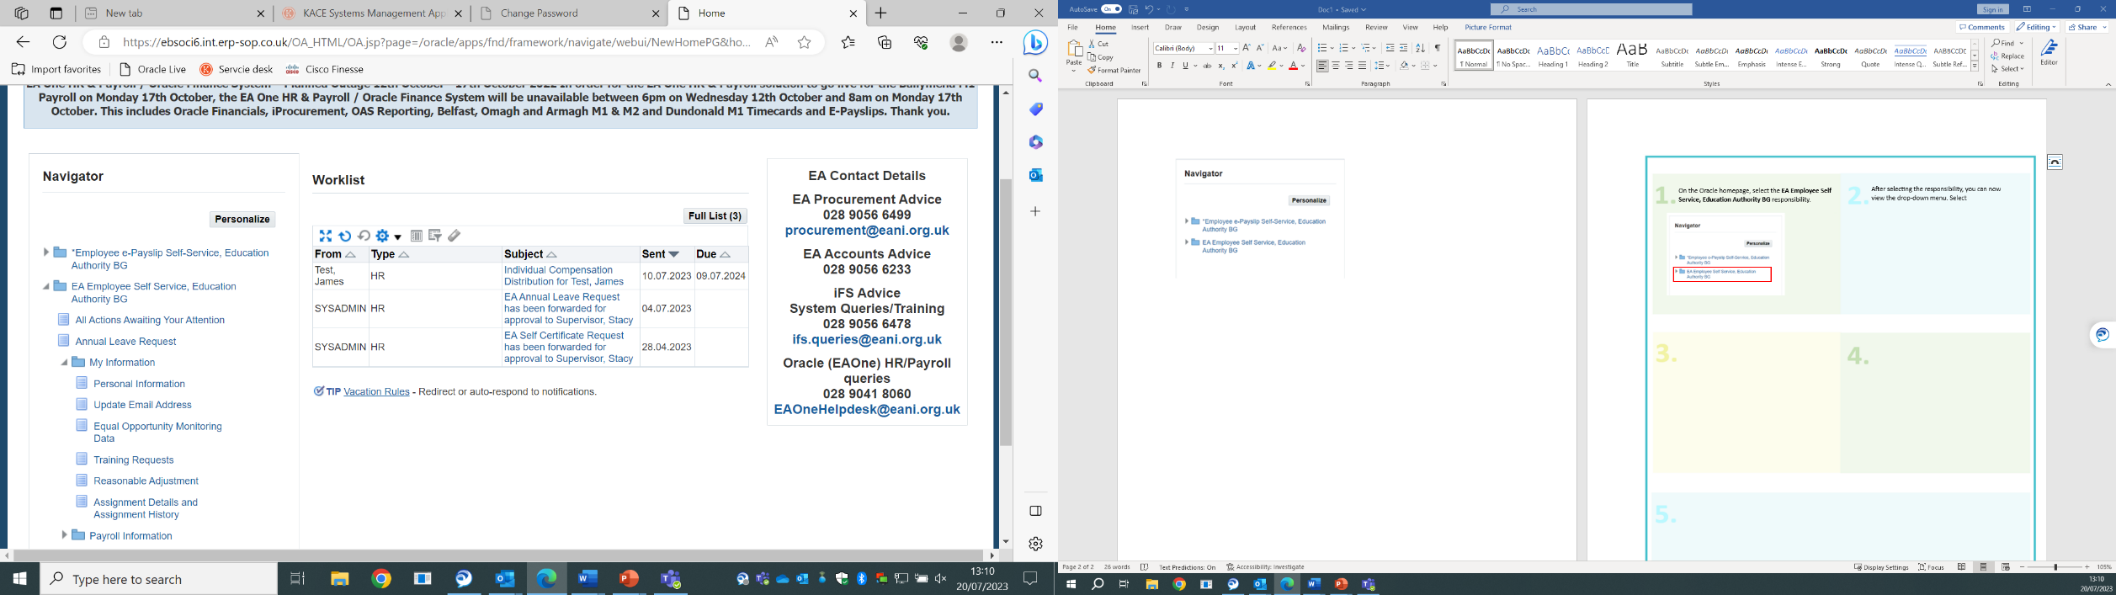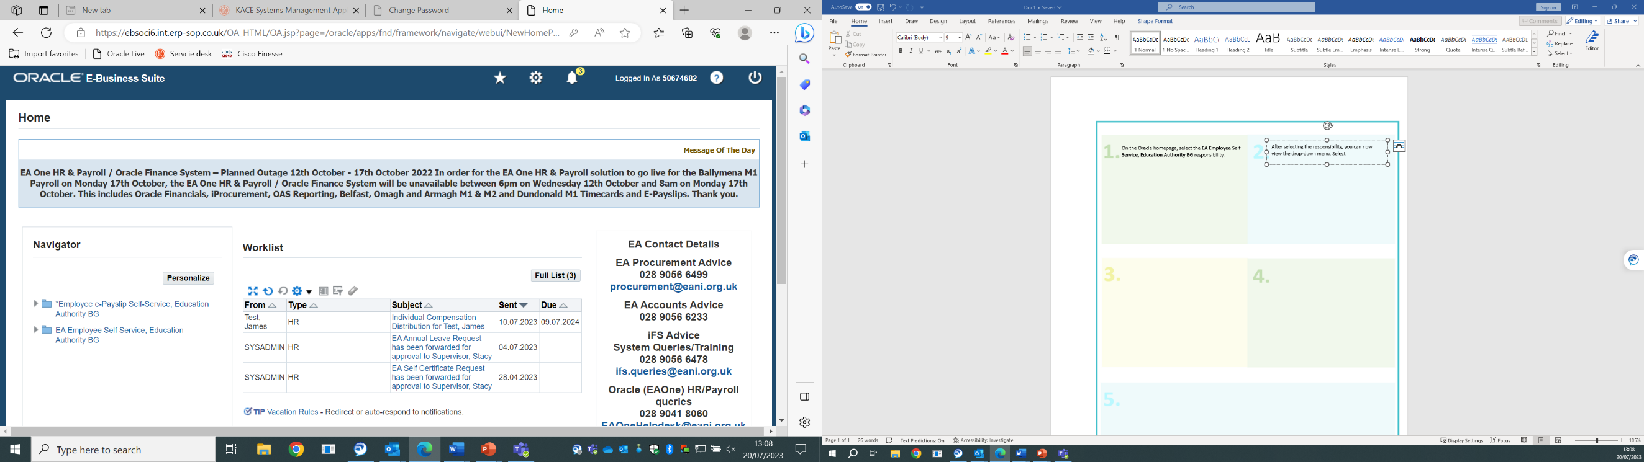

On the Oracle homepage, select the **EA Employee Self Service, Education Authority BG** responsibility.

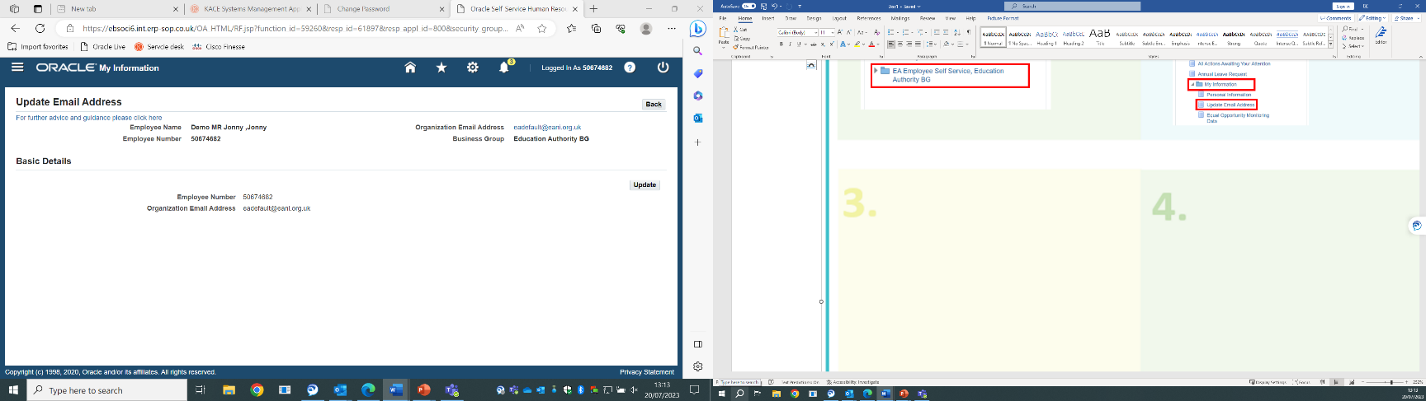

Your details and current email address will be displayed. Click **Update**. Select an option for the change and then click **Next**.

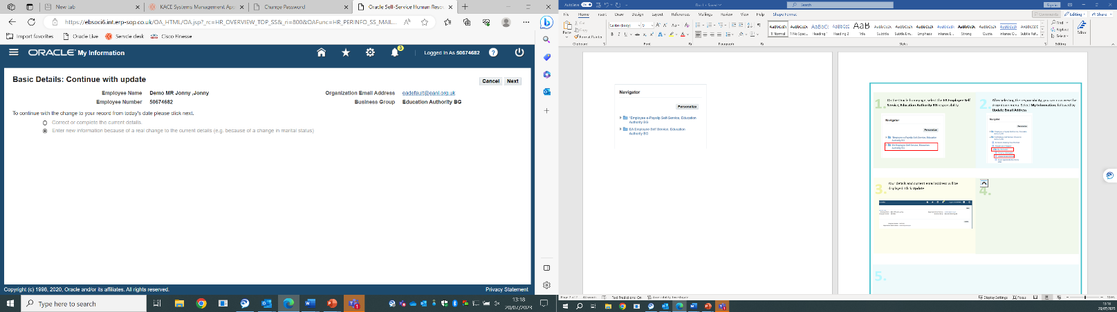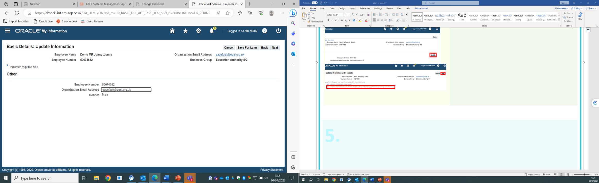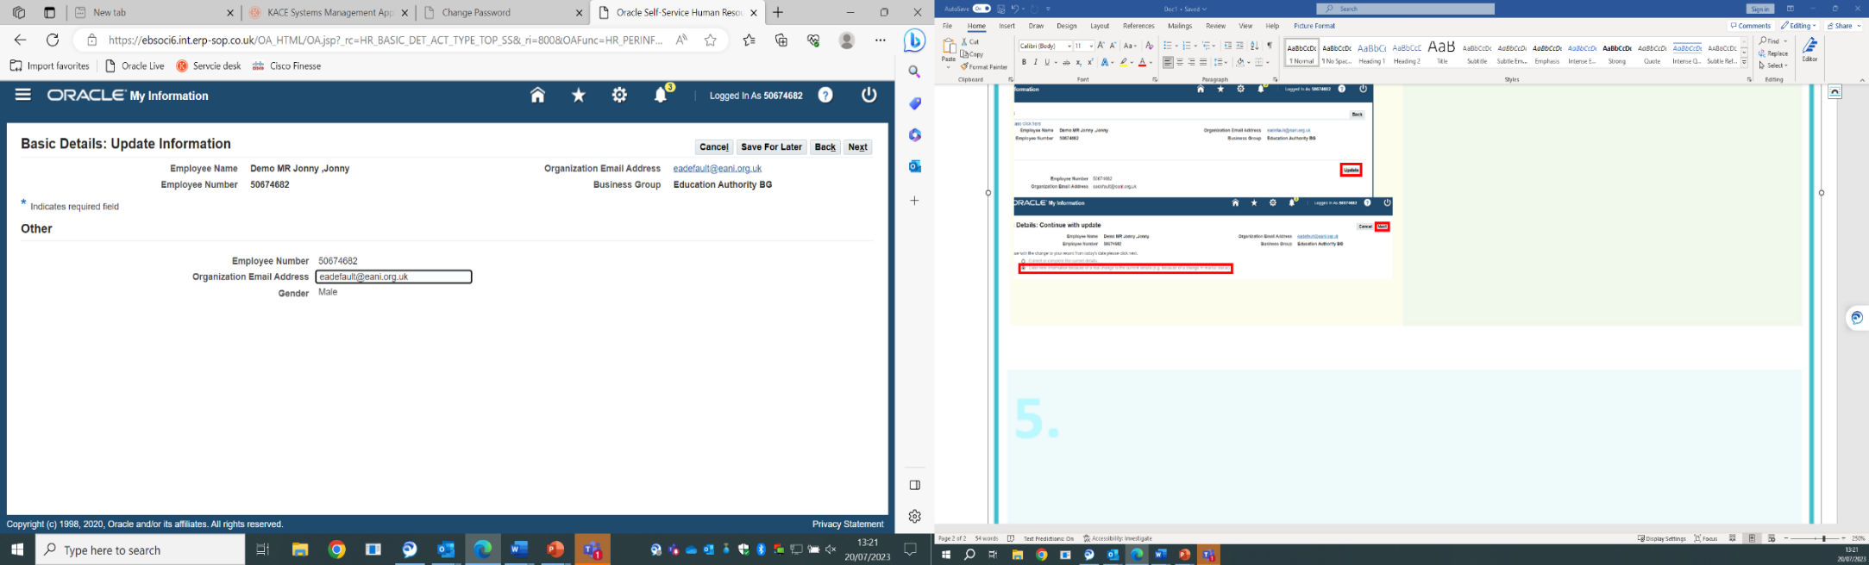

Type in the new email address. Click **Next.**

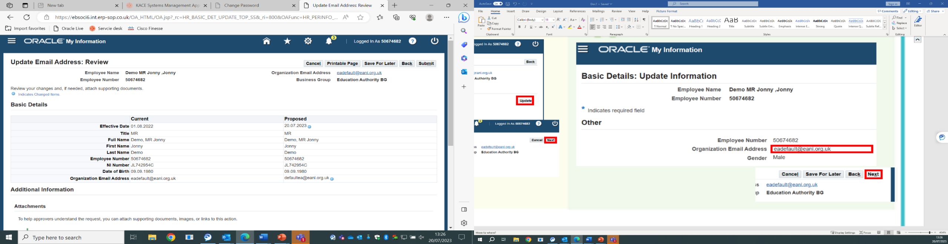

Review the information and click **Submit.** Once submitted the change request will be sent to the Helpdesk for approval.

1) Screenshot of how to select self-service on the navigator on the Oracle homepage
2) Screenshot showing drop-down options to select 'bank details' under 'payroll information'.
3) To update, click 'update'
4) Once updated, user should select 'apply'
5) User should then review information and select 'submit'

Using EA One Self-Service - ESS

## How to Update Bank Details

1) Screenshot of how to select self-service on the navigator on the Oracle homepage
2) Screenshot showing drop-down options to select 'Education Authority Online Payslip' under 'payroll information'.
3) To view, click 'choose a payslip'
4) User can print physical copies
5) User can save PDF copy

## How to View an Employee Payslip

Using EA One Self-Service - ESS

# Using EA One Self-Service - MSS

## Viewing Team Information

*Managers are encouraged to regularly check MSS to ensure their Team information is correct. Please notify the EA One Helpdesk immediately if there are any changes to your Team*

|  |  |
| --- | --- |
| **1** | Using MSS you will be able to view team information and individual employee information. You are able to view the following:   * An employee’s Self-Certification history   For this example we are showing how to view an employee’s self-certification history. **Repeat this process for viewing other historical EA One Self-Service information for employees.**  On the Oracle homepage, select the **EA Manager Self-Service, Education Authority BG** responsibility.  Please select the 'EA Manager Self Service, Education Authority BG' responsibility. |
| **2** | After selecting the responsibility you can now view the drop-down menu. Select **My Team** **Absence Information** andthen **Self-Certificate.**  Please select 'My Team Absence Information' and then 'Self Certificate' to view an employee's self certification history. |
| **3** | The People in Hierarchy screen will be displayed, listing all the employees that you currently manage. Locate the employee you want to view the self-certifications for and then click the **Action** button (indicated below) in their respective row in the table.  The People in Hierarchy screen will now be displayed, listing all employees you currently manage.  Locate the employee you want to view and click the 'Action' button on their row in the table. |
| **4** | The Self-Certification screen will be displayed, listing all the Self-Certifications submitted for the employee.  The Self Certification screen is now displayed, listing all Self Certifications submitted by the employee. |

Using EA One Self-Service – MSS

## How to View My Team’s Annual Leave Balances

|  |  |
| --- | --- |
| **1** | On the Oracle homepage. Select the **EA Manager Self Service, Education Authority BG** responsibility. Then select **My Team** **Annual Leave Details** from the drop-down menu. |
| **2** | A list of employees within your hierarchy will be displayed with their various assignments.  The **‘Total Entitlement’** is the amount of days annual leave allocated (factoring in balance carry over where necessary). The **‘Days Taken’** is the amount of annual leave used so far. Finally, the **‘Net Entitlement’** is current annual leave balance, factoring your entitlement and days taken.  You can see annual leave details for each employee by clicking the Select button on the left hand side.  A screenshot of a computer  AI-generated content may be incorrect. |

Using EA One Self-Service - MSS

## Submitting on Behalf of an Employee

|  |  |
| --- | --- |
| **1** | Using MSS you will be able to submit EA One Self-Service forms on behalf of an employee. This can be done for forms such as;   * Self-Certification * Training Requests * Absence Certificates * Reasonable Adjustments * Occupational Health Requests * Work Assessment Requests   All of these forms will follow a similar design and user path, please refer to the Common Guidance section of this handbook.  In this example, we are submitting an absence certificate on behalf of an employee. **Repeat this process when submitting the other EA One Self-Service forms listed above on behalf of employee.**  On the Oracle homepage, select the **EA Manager Self-Service, Education Authority BG** responsibility.  Please select the 'EA Manager Self Service, Education Authority BG' responsibility. |
| **2** | After selecting the responsibility you can now view the drop-down menu. Select **My Team** **Absence Information** andthen **Absence Certificates**.  Please select 'My Team Absence Information' and then 'Absence Certificates' to submit an absence certificate on behalf of an employee. |
| **3** | The People in Hierarchy screen will be displayed, listing all the employees that you currently manage. Locate the employee you want to submit the absence certificate for and then click the **Action** button (indicated below) in their respective row in the table.  The People in Hierarchy screen will now be displayed, listing all employees you currently manage.  Locate the employee you want to submit on behalf of and click the 'Action' button on their row in the table. |
| **4** | The Absence Certificates screen will be displayed, listing any previous absence certificates submitted, if there are any on record. To submit a new absence certificate, click **Add**.  Click the 'Add' button. |
| **5** | Begin to fill out the form. Fields with an **asterisk (*)** are **mandatory.** When you get to the **SART Level 1** field, click the **search icon** (indicated below).  Click the 'Search Icon'. |
| **6** | The search window will open. Click **Go**.  Click the 'Go' button. |
| **7** | A list of sickness categories will display. Select the most appropriate one for your circumstances and click **Select**.  Select the most appropriate sickness category and click the 'Select' button. |
| **8** | Repeat the process of **steps 5-7** for the **SART Level 2** field, and fill out the rest of the form.  Once all details have been entered, click **Apply**.  If required, repeat steps 5-7. Once the form is complete, click the 'Apply' button. |
| **9** | The absence certificate will be recorded on the system. To confirm it, click **Next**.  Click the 'Next' button. |
| **10** | Review the absence certificate details entered before submitting. You can also attach supporting documentation, such as a doctor’s note, by clicking the **“+”** button(indicated below).  Once you are content, click **Submit**.  Click the '+' button to add any attachments if required, then click the 'Submit' button. |
| **11** | A confirmation message will be displayed confirming that the Absence Certificate has been saved. You can now exit the system.  Confirmation message will then be displayed. |

Using EA One Self-Service - MSS

## Approving Employee Requests

|  |  |
| --- | --- |
| **1** | If an employee has requested something for approval using EA One Self-Service, this will appear in your **Worklist** on the Oracle homepage. Using MSS, you be able to approve the following employee requests;   * Annual Leave * Training Requests   In this example we are using annual leave and how it is approved. To access the approval facility, click on the worklist entry.  To access the approval facility, please click on the 'Worklist Entry' within your worklist. |
| **2** | The details of the employee’s annual leave request will be displayed. Review the details of the annual leave request. To approve the annual leave, click **Approve** in the top-right corner of the screen. You can also **Reject** or **Request Information** as required. **All approvals for employee requests will follow this same format.**  Review the details of the request before approving. To approve, click the 'Approve' button. You can also reject and request more information as required. |

|  |
| --- |
| Frequently Asked Questions ***Will the Line Manager receive an email notification to approve a medical Self-Certification form when it is submitted on Self-Service? Can the approval be done via email?***  Yes, once the medical Self-Certification is submitted for a position, the Line Manager for that position will receive an email and can approve via that email. They will receive options to Accept, Reject and Request More Information that can be selected within the body of the email. The Line Manager can also access it via the “bell notification” icon in Oracle.  ***Will staff be expected to manage their own Self-Service requests?***  Staff will be expected to manage their own HR and Payroll information through EA One Self-Service. Where an employee is unable to access Self-Service, paper forms can be made available to complete. It is not the EA's expectation that Secretaries/Administrators complete personal forms on behalf of employees as in certain instances this would have GDPR implications.  ***Will staff who do not currently use internet for accessing payslips etc. need to gain internet access in the future for Self-Service functionality?***  EA One will provide functionality to manage HR activities, including completion of medical Self-Certification online. Existing paper-based processes will still be available for staff who cannot practically access the online system.  ***Do non-teaching staff have the ability to directly submit annual leave themselves?***  Non-teaching staff can use the EA One Self-Service functionality to request annual leave. The Timesheet Inputter will still need to record Annual Leave on the digital timecard (non-salaried staff only).  ***If Self-Service is not mandatory, can I continue to use the existing processes?***  EA One will provide functionality to manage activities, including completion of medical Self-Certification online. Existing paper based processes will still be available for staff who cannot practically access the online system.  ***How do I report a change in Team/Service structure on EA One***  When there is a change to a Team or Service structure including change in Supervisor or Line Management please notify the EA One Helpdesk as soon as possible with Head of Service/Budget Holder approval. |

|  |  |  |  |  |  |  |  |  |  |  |  |  |  |  |  |  |
| --- | --- | --- | --- | --- | --- | --- | --- | --- | --- | --- | --- | --- | --- | --- | --- | --- |
| Glossary – EA One Self-Service Definition ListEA One Self-Service Elements There are many different types of forms within both Employee (ESS) and Manager (MSS) Self-Service. The table below explains which responsibilities and categories these forms apply to, as well as providing a definition for each form.   |  |  | | --- | --- | | **Input** | **Details** | | Personal Information | Employees can keep personal information up to date via Self-Service and should be refreshed every 6 months if necessary. Details such as; Basic Details, Phone Numbers, Main/Other Addresses, Emergency Contacts, Dependents and Beneficiaries are maintained. | | Equal Opportunities Monitoring Data | Employee can complete an Equal Opportunities form via Self-Service. Equal Opportunities Monitoring Data allows the Education Authority to monitor their employment processes to ensure that they are fair. See the [EA Equality](https://www.eani.org.uk/about-us/equality) page for more information. | | Education Authority Online Payslip | Education Authority Online Payslips & P60s simply refers to an electronic Payslip and P60.  EA staff will be able to access their Payslips and P60s securely, as opposed to receiving paper copies (paper option still available). See the [EA Online Payslips and P60s](https://www.eani.org.uk/epayslips) page for more information. | | Bank Details | Bank details for employees is kept up to date via Self-Service, employees will be able to update bank payment details and main address. | | P60 | Employees will be able to view their P60 using Self-Service and choose the relevant tax year they wish to view. See the [EA Online Payslips and P60s](https://www.eani.org.uk/epayslips) page for more information. | | Self-Certification | Employees can submit self-certification forms via Self-Service to prove they were absent from work due to illness. See [EA Managing Attendance Policy](https://www.eani.org.uk/sites/default/files/2020-02/Managing%20Attendance%20Policy-EA%20Support%20Staff.pdf) for more information. | | Absence History | Employees can view their entire absence history via Self-Service by viewing all their previous self-certification submissions in one place. | |