iExpenses
Submit an Expense Claim
NOTE | Please ensure your supervisor is correct on the system before submitting a claim. DO NOT submit claims to an incorrect supervisor. To update your supervisor please email eaonehelpdesk@eani.org.uk. You will require confirmation from your Head of Service for this to be amended on the system.  Guidance of specific types of expense claims  Eye Tests  The Eye Test/Glasses claim form and link is now available. The form is now on both SharePoint under “For Staff” and the Staff Hub - see links for both below:  Sharepont - Eyesight Test Application Form  EA Staff Hub – Health and Wellbeing  Please note that if staff are claiming reimbursement for an eye test or glasses the attached form will need to be completed and receipt(s) attached to substantiate the claim  ---  Reimbursement of Professional Fees  The Application for Reimbursement of Professional Fees form needs to be completed and receipt(s) attached to substantiate the claim. The following is a link to the Payment of Professional Fees page, which includes the Professional Fees Policy and application form:  Payment of Professional Fees (eani.org.uk)
1 | On the Oracle homepage, select the EA Employee Self Service, Education Authority BG responsibility, and then select Internet Expenses.  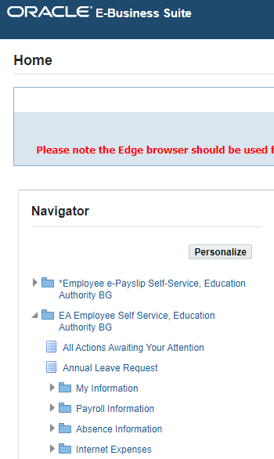
2 | This will take you to the main page of the expenses application. Here you can see reports you have submitted and raise new claims.  To raise a new claim, click Create Expense Report.  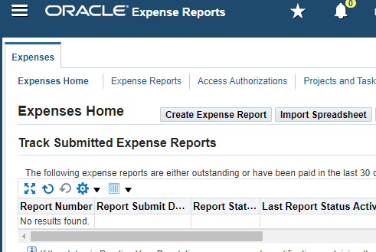
3 | This will open the General Information page. Starred fields are mandatory. Your Name, Default Cost Centre and Approver will load by default, however you can change the cost centre or approver if required.  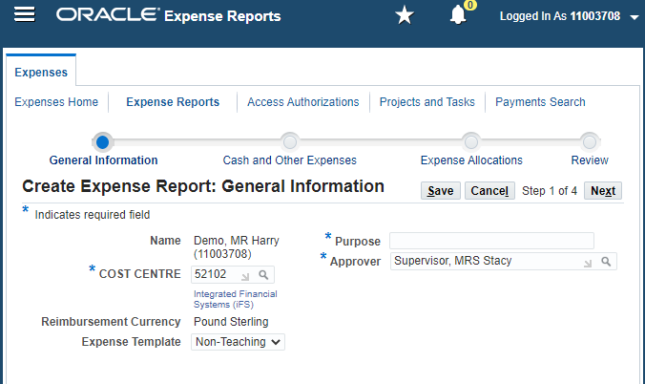
4 | Enter a Purpose for the expense claim. Once the form is filled out in full, click Next.  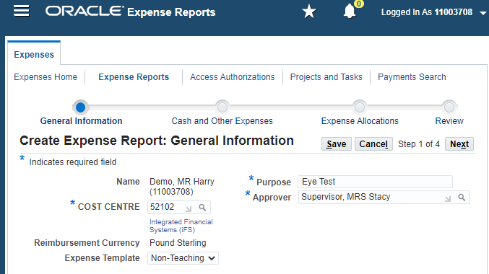
5 | This will open a section where you can catalogue the individual expenses in your claim. This is split into rows with Date, Receipt Amount, Expense Type and Justification.  The Expense Type field is a dropdown (shown below) that contains a list of approved expense reasons. Some of these have limits, which are detailed out as shown.  In our example, we are submitting a reimbursement claim for an Eyesight Test, which is capped at £20.  You can also Save if you need to return to the form later.  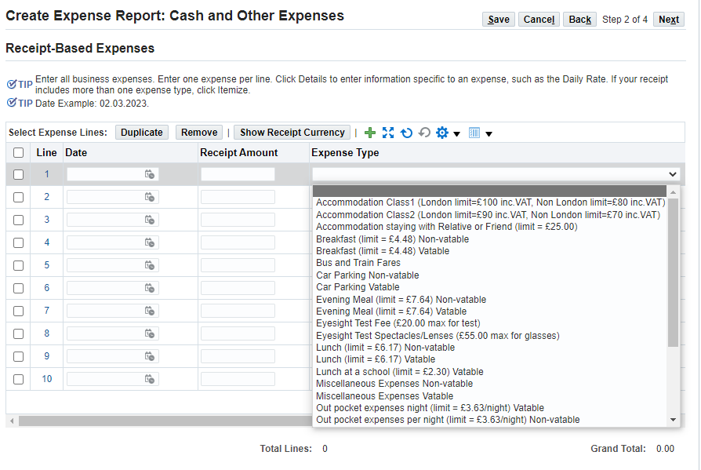
6 | Fill out the form as required. When entering the date, ensure it’s in the DD.MM.YYYY format. You do not need to enter a £ symbol when entering the Receipt Amount value, just the number.  Once you’ve filled out the details on a line, scroll to the right and click the Details icon (circled below.  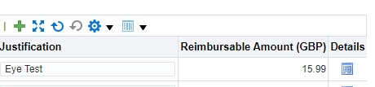
7 | This will open a detailed view of the claim. You will need to upload a receipt to support the claim. To do this, click the plus symbol (circled below).  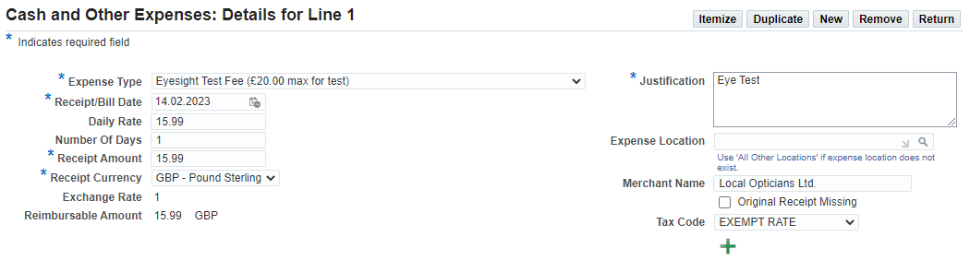
8 | Give your receipt a Title and set the Category to ‘Receipts’ as shown. Then click the Choose File button to upload the receipt file from your computer. This can be in the form of a PDF or image file.  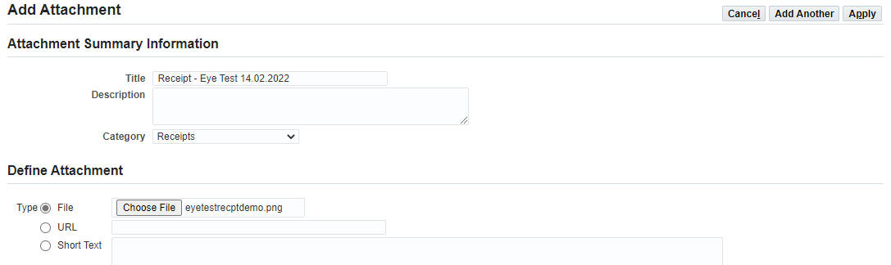
9 | Now click Apply.
10 | You’ll receive a confirmation that your receipt has been uploaded. Now click Return to go back to the overall claim page.  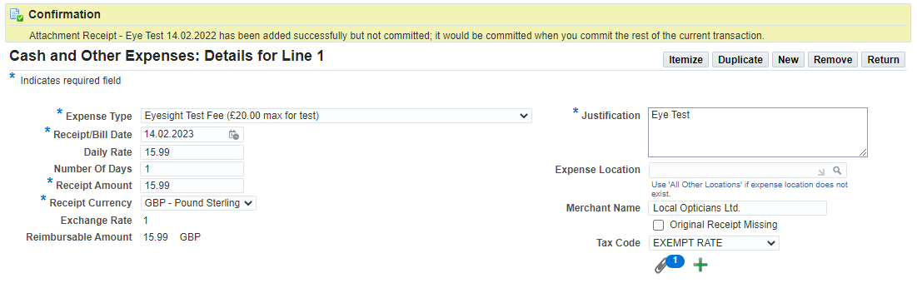
11 | Repeat Steps 5-10 if you have any additional lines you wish to add to the claim. When you’re ready, click Next.  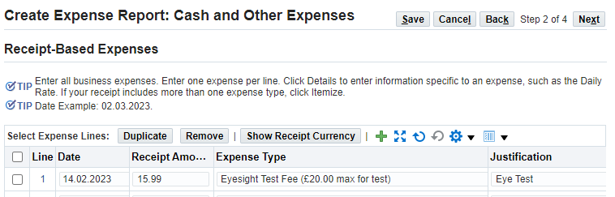
12 | This will bring you to the allocations section. If required, you can assign your claim to a specific function code in addition to your cost centre.  If the claim is a generic claim to your cost centre, you can leave this as default. If the claim is assigned to a specific function and/or area, you can amend the codes as required in the FUNCTION and AREA fields shown below.  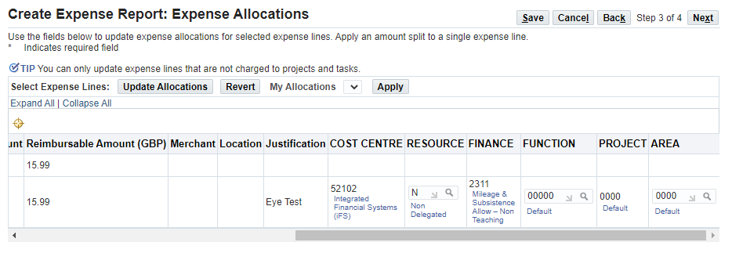
13 | Once you’ve confirmed the costing is correct, click Next.
14 | This will take you to the submit page. Before you submit, carefully read the Terms and Conditions in red, ensure your approver is correct and check the claim details are correct.  Once you are ready to submit, click the Submit button.  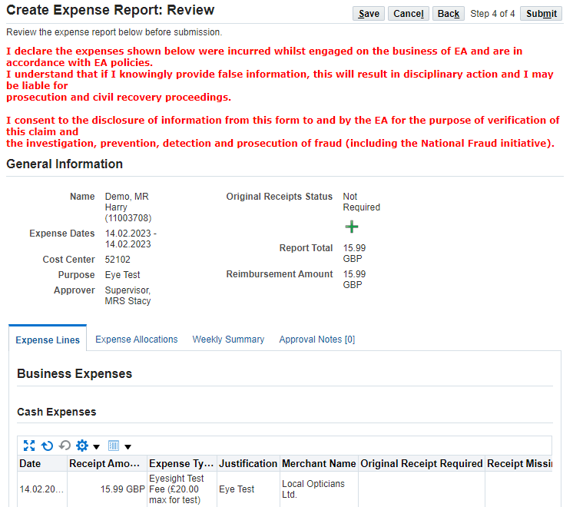
15 | You will see a confirmation, letting you know that your claim has successfully gone to your designated approval for review.  Click Return to go back to the main expenses page.  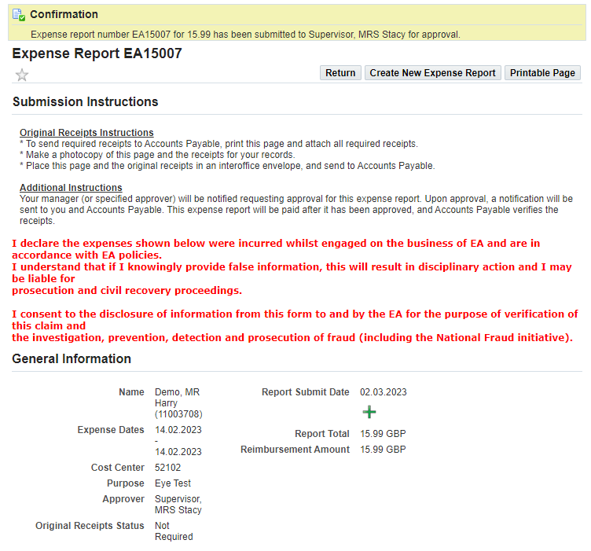
16 | Your claim will appear in the expenses tracker as shown.  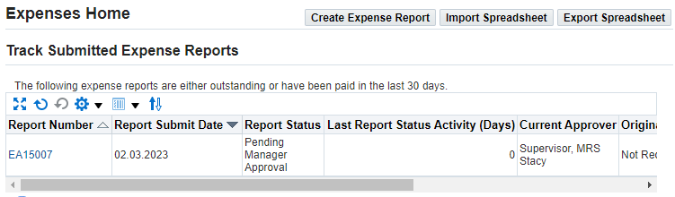
17 | Once your claim has been approved/rejected, a notification will appear on your homepage letting you know of the outcome.  NOTE – if your line manager does not have spending authority, the request will be forwarded on to the next person in the hierarchy to review the claim.  