For Teachers and Principals
Submit an Expense Claim
NOTE | Expenses relate to all non-mileage related expense claims. Please ensure all expenses claims are within policy when making a claim. For any queries around policy or expense entitlements, please contact EA_TravelandExpensesTeaching@eani.org.uk.  If you are claiming for an Eyesight Test, please follow the TNC guidance set out here.  If you are claiming any expenses listed as VATable (e.g. parking, taxi fares), you MUST include a receipt with a VAT number. Credit card receipts are not acceptable.  - For Principals: please attach evidence of approval from your school’s Board of Governors when making a claim.  - For Temporary Teachers: please attach evidence of approval from the school you are charging the expenses to when making a claim. This must come from the school’s Principal.  For both of the above, you can upload this with your receipts. This is covered in steps 7-8 of the guide.
1 | On the Oracle homepage, select the Teaching Self-Service responsibility that you have (either Permanent, Principal or Temporary), and then select Internet Expenses. This will open the folder. Click Expenses Home to open the form.  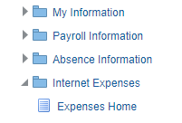
2 | This will take you to the main page of the expenses application. Here you can see reports you have submitted and raise new claims.  To raise a new claim, click Create Expense Report.  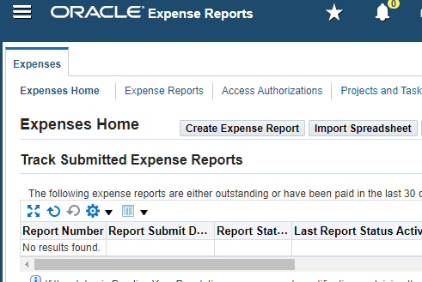
3 | This will open the General Information page. Starred fields are mandatory.  IMPORTANT – read the guidance specific to your role  - For Permanent Teachers your Approver and Cost Centre should appear automatically. If either/both are incorrect, do not progress the claim. Contact the EA One Helpdesk at EAOneHelpdesk@eani.org.uk to get this updated. Once they have corrected this you can proceed.  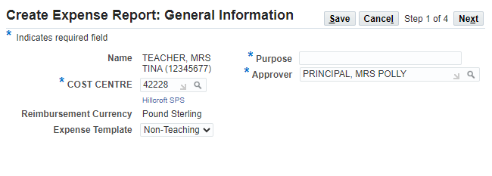  - For Principals, the Approver field will be blank, and the Cost Centre will be your school’s cost centre. Your claim will be routed directly to Accounts for review and approval, so you can leave the Approver field blank.  - For Temporary Teachers, the Cost Centre and Approver fields will be blank. You will need to manually enter the cost code for the school where you are assigned, and the Principal of that school as your approver for audit records. However, your claim will be routed directly to Accounts for review and approval.  To do this, for both fields click the magnifying glass logo on each field, which will open a new window.  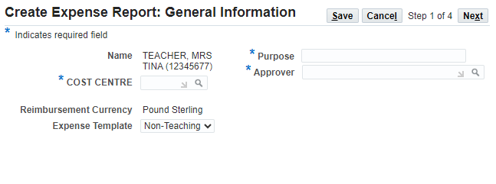  Then look up the relevant cost centre/approver using the search function, as demonstrated below. Click Select to confirm this.  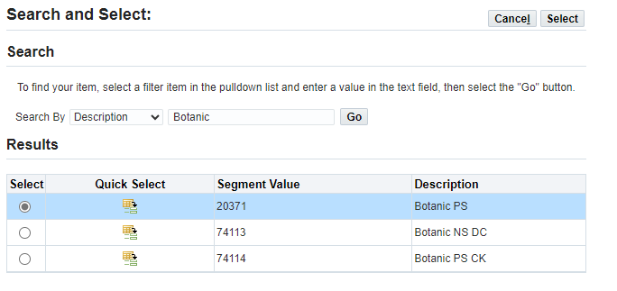
4 | Enter a Purpose for the expense claim. Once the form is filled out in full, click Next.  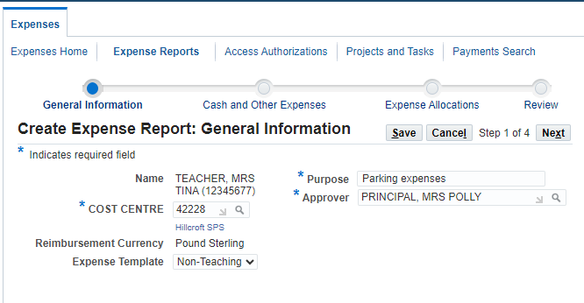
5 | This will open a section where you can catalogue the individual expenses in your claim. This is split into rows with Date, Receipt Amount, Expense Type and Justification.  The Expense Type field is a dropdown (shown below) that contains a list of approved expense reasons. Some of these have limits, which are detailed out as shown.  In our example, we are a non-vatable parking claim.  You can also Save if you need to return to the form later.  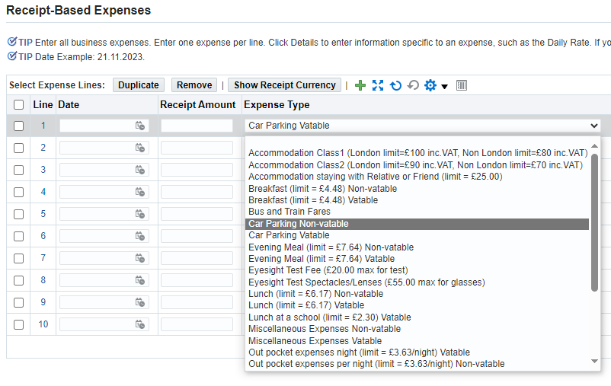
6 | Fill out the form as required. When entering the date, ensure it’s in the DD.MM.YYYY format. You do not need to enter a £ symbol when entering the Receipt Amount value, just the number.  Once you’ve filled out the details on a line, scroll to the right and click the Details icon (circled below.  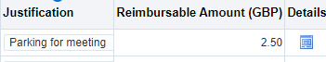
7 | This will open a detailed view of the claim. You will need to upload a receipt to support the claim. To do this, click the plus symbol (circled below).  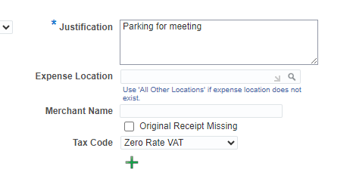
8 | Give your receipt a Title and set the Category to ‘Receipts’ as shown. Then click the Choose File button to upload the receipt file from your computer. This can be in the form of a PDF or image file.  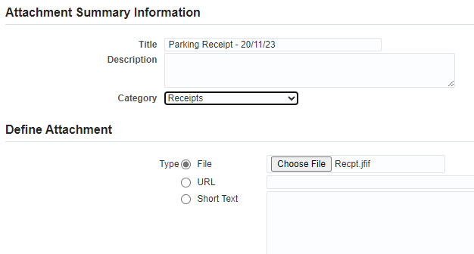
9 | Now click Apply in the top-right of the screen.  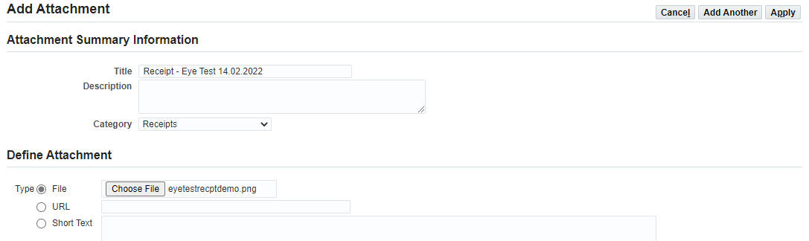
10 | You’ll receive a confirmation that your receipt has been uploaded. Now click Return to go back to the overall claim page.  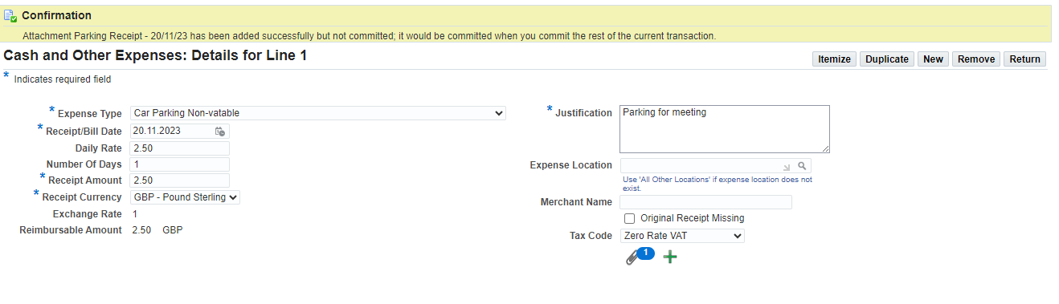
11 | Repeat Steps 5-10 if you have any additional lines you wish to add to the claim. When you’re ready, click Next.  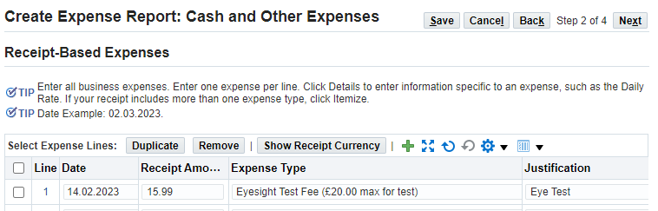
12 | This will bring you to the allocations section. If required, you can assign your claim to a specific function code in addition to your cost centre.  If the claim is a generic claim to your cost centre, you can leave this as default. If the claim is assigned to a specific function and/or area, you can amend the codes as required in the FUNCTION and AREA fields shown below.  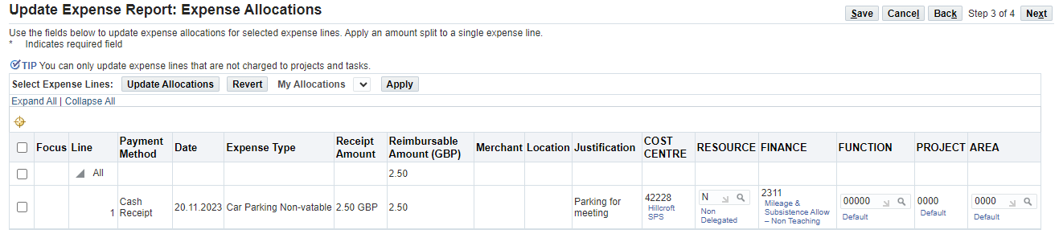
13 | Once you’ve confirmed the costing is correct, click Next.
14 | This will take you to the submit page. Before you submit, carefully read the Terms and Conditions in red and check the claim details are correct.  - For Principals and Temporary Teachers, disregard the approver on this page. Your claim will be routed to the Expenses team in Accounts for review and approval.  Once you are ready to submit, click the Submit button.  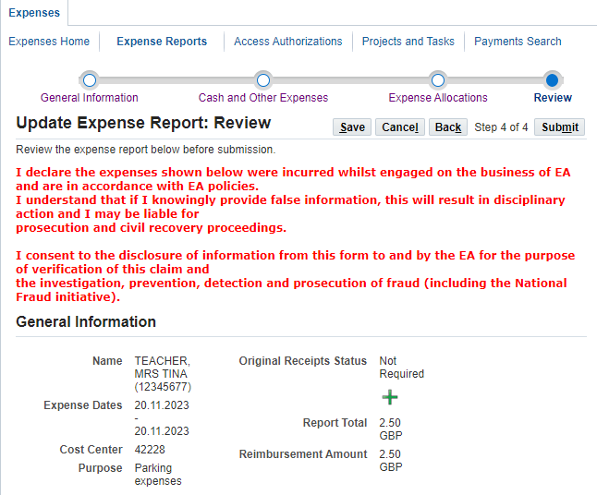
15 | You will see a confirmation, letting you know that your claim has successfully gone to your designated approval flow for review.  Click Return to go back to the main expenses page.  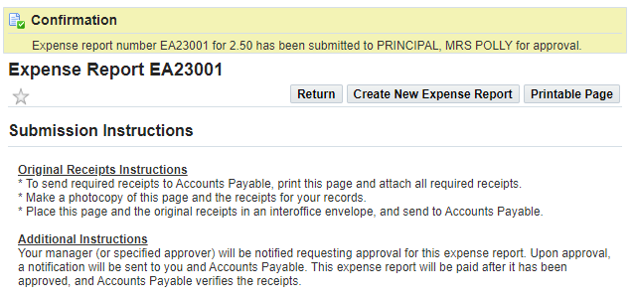
16 | Your claim will appear in the expenses tracker as shown.  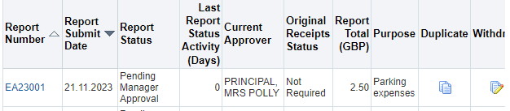
17 | Once your claim has been approved/rejected, a notification will appear on your homepage letting you know of the outcome.

