For Temporary Teachers
Submitting a Mileage Claim
NOTE | Please read the below guidance carefully before making a claim on the system.  Please key individual days when making a mileage claim on the system.  In cases where this is not feasible (such as when you have a large volume of individual journeys over a claim period), please key one summary claim for the total mileage of the claim period. Then attach the standard TSE form detailing out your journeys.  Please follow the below steps as required, with the following additional points:  - For keying multiple days in a single transaction, guidance is on Step 10.  - For keying a summary claim, follow the core process but put through the total mileage of the claim period in one form (e.g. the total miles of journeys taken in a month). Then when you go to submit, attach your required evidence with the claim. This is detailed in Steps 13 & 14.  - Your claim will be processed by the Accounts team. Further details of this are on Step 15. For all claims, you must attach a signed proforma from the Principal at your assigned school approving your mileage. For summary claims, include the TSE form as an attachment.
1 | On the Oracle homepage, select the relevant teaching self-service option. Our demo version is called Teachers Self Service, Education Authority BG. Yours will be called DE Temporary Teacher Self Service.  
2 | After selecting the responsibility you can now view the drop-down menu. Select Payroll Information and then Mileage Claims.  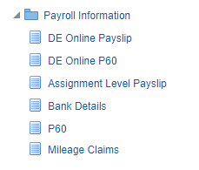
3 | On the page that opens, click the Add button to start a claim.  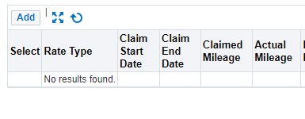
4 | The Mileage Claims form will be displayed. Please read the Terms and Conditions in red carefully, then scroll down to start entering the details of your claim.  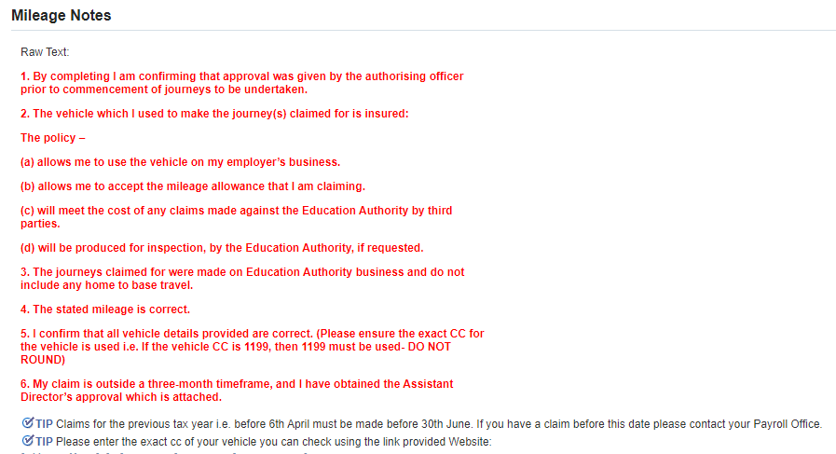
5 | Begin to fill out the form as required. Starred fields are mandatory.  Select the appropriate rate type field. For Teachers, this should be HMRC Rates (Teachers).  For Location from, Location To and Via fields the name of the location must be clear.  Rates will be applied based on Claimed Mileage. Claimed Mileage is the shortest route. Actual Mileage is the mileage which you have actually travelled but may not be the shortest route.  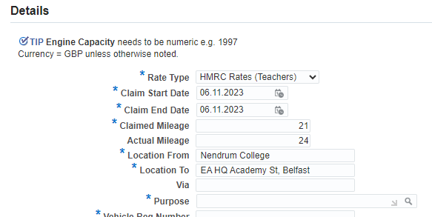  For a summary claim for multiple journeys, your claim will look more like the below:  - Your start and end dates should be the dates of the first and last journeys  - Your claimed and actual mileage will be your total shortest route mileage and actual mileage respectively for the journeys  - Your location from and to should be ‘Multiple sites – in attached form’  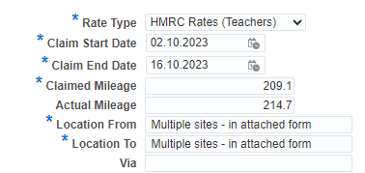
6 | Continue to fill out the form with the required information.  NOTE - Please use exact CC (do not round) in the engine capacity field for correct calculation of rates.  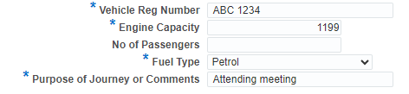
7 | At the bottom of the form is the costing section. This is so you can cost the mileage to the specific school that you claimed the mileage for. This is mandatory, and if you are unsure of the school’s costing details, please speak to their secretary or principal for confirmation of the code required.  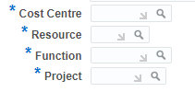  - The Cost Centre will be the 5-digit code for your school  - The Resource will either be D or N:  - Use D (delegated) for Controlled Schools, Maintained Schools (CCMS  managed) or Controlled Integrated Schools. All of these schools will have a cost code number between 20002 and 21980.  - Use N (non-delegated) for all other EA Services, including Special Schools, EOTAS and Peripatetic Services.  - Unless advised otherwise, set Function to 00000 and Project to 0000.  Your details will automatically populate as you fill this out, as shown below.  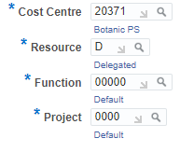
8 | Once you’ve completed the form, click Apply (located in the bottom right of the screen).  
9 | This will enter the mileage claim on your record.  If you needed to add another day to the same claim, repeat the previous process from Steps 3-8.
10 | All unsubmitted claims will display like the lines in the picture below.  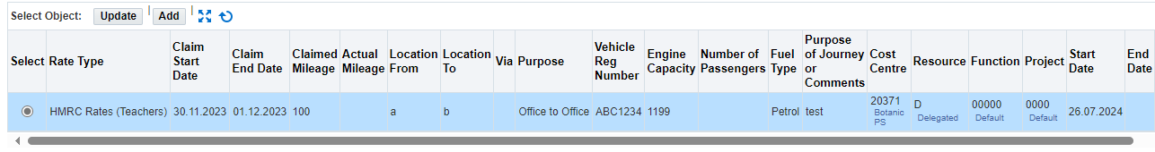  To submit the claim to your line manager for approval, click Next.  
12 | This will provide you with a summary of your claim. Review this information to make sure it’s correct.  You’ll see one of these for each day you’ve entered.  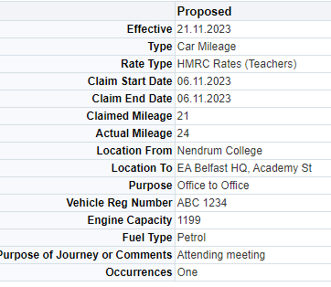  If you’re entering a summary claim, you’ll see one summary of the total miles you entered for the claim period like below.  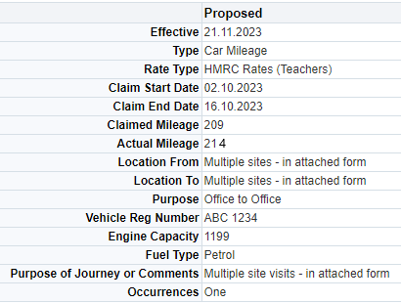
13 | To attach evidence to your claim, such as when making a summary claim for the month and recording your Principal’s approver, click the Green Plus button under attachments.  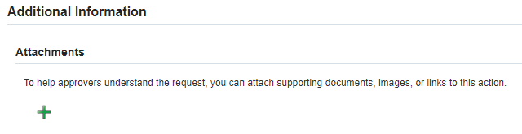
14 | Give your attachment a name to make it clear what it is, e.g. “Summary of Journeys April 2023” and click Choose File to upload the document from your computer.  Once you’ve done this, click Apply. This will return you to the submit page.  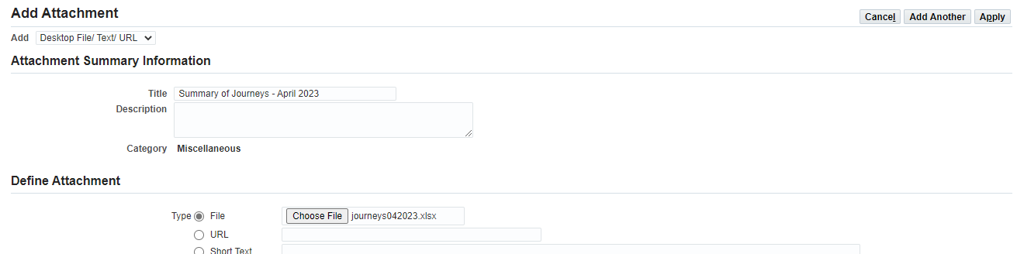  Repeat this process for any additional attachments – such as approvals from a Principal or Board of Governors.
15 | Your Approvers should be Accounts with the below 4 staff listed as approvers for your claim. If you are seeing something different, please contact eaonehelpdesk@eani.org.uk.  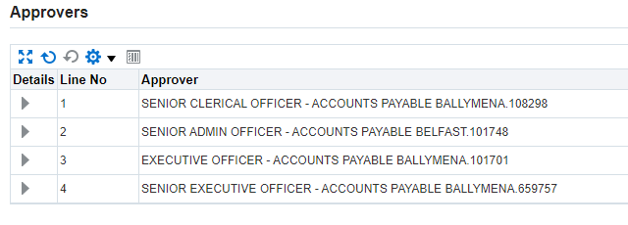
16 | You can also leave a comment for the approver if required. Once you’re ready to send the claim for approval, click Submit.  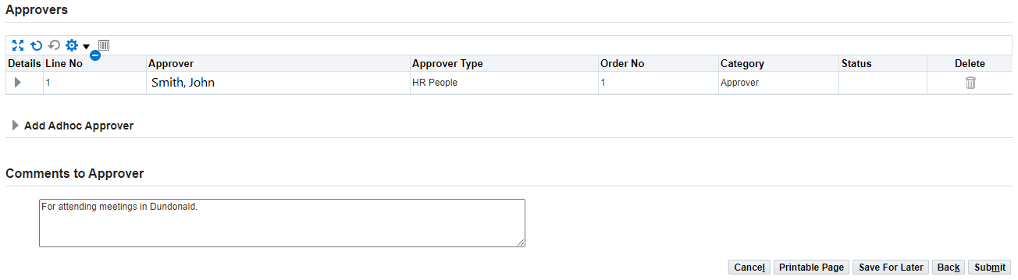
17 | You will receive a notification to confirm that your mileage claim has been successfully sent to your line manager for approval.  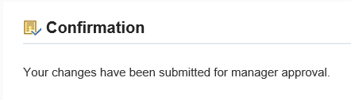
18 | Once a decision has been made on your claim, a notification will appear on your Oracle homepage.

