For Teachers & Principals
Submitting a Mileage Claim
NOTE | Please read the below guidance carefully before making a claim on the system.  If you are a temporary teacher, please refer to the separate Temporary Teacher’s Mileage Job Aid.  Please key individual days when making a mileage claim on the system.  In cases where this is not feasible (such as when you have a large volume of individual journeys over a claim period), please key one summary claim for the total mileage of the claim period. Then attach the standard TSE form detailing out your journeys.  Please follow the below steps as required, with the following additional points:  - For keying multiple days in a single transaction, guidance is on Step 10.  - For keying a summary claim, follow the core process but put through the total mileage of the claim period in one form (e.g. the total miles of journeys taken in a month). Then when you go to submit, attach your required evidence with the claim. This is detailed in Steps 13 & 14.  GUIDANCE BY INDIVIDUAL STAFF TYPE:  - For Permanent Teachers: please ensure your line manager is correct on the system when processing your claim. If you are making a summary claim, include the TSE form as an attachment.  - For Principals: your claim will be processed by the Accounts team. Further details of this are on Step 15. For all claims, you must attach a signed proforma from your school’s Board of Governors approving your mileage. For summary claims, include the TSE form as an attachment.
1 | On the Oracle homepage, select the relevant teaching self-service option. Our demo version is called Teachers Self Service, Education Authority BG. Yours will either be DE Permanent Teacher Self Service or DE Principal and Temporary Teacher Self Service (for Temporary Teachers on the Permanent Payroll).  
2 | After selecting the responsibility you can now view the drop-down menu. Select Payroll Information and then Mileage Claims.  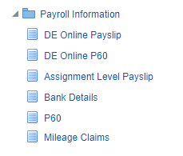
3 | The Mileage Claims window will be displayed. Please read the Terms and Conditions in red carefully. To start a new claim, click Mileage Claims.  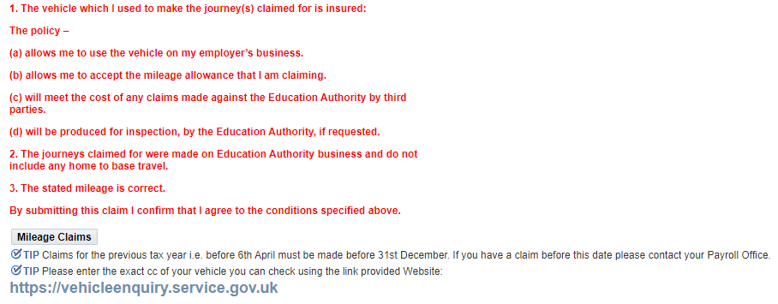
4 | Again, read the Terms and Conditions in red on the window that opens. Set the claim type to Mileage. Then select the type of vehicle you are claiming mileage for in the Mileage Type field.  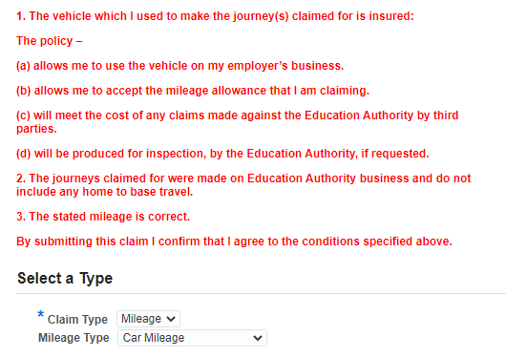
5 | Once you’ve done this, a form will open below. Begin to fill out the form as required. Starred fields are mandatory.  Select the appropriate rate type field.  For Location from, Location To and Via fields the name of the location must be clear.  Rates will be applied based on Claimed Mileage. Claimed Mileage is the shortest route. Actual Mileage is the mileage which you have actually travelled but may not be the shortest route.  When you get to the Purpose field, click the Search button (indicated below).  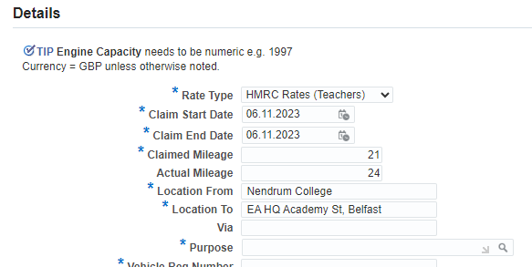  For a summary claim for multiple journeys, your claim will look more like the below:  - Your start and end dates should be the dates of the first and last journeys  - Your claimed and actual mileage will be your total shortest route mileage and actual mileage respectively for the journeys  - Your location from and to should be ‘Multiple sites – in attached form’  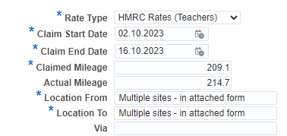
6 | Click Go.  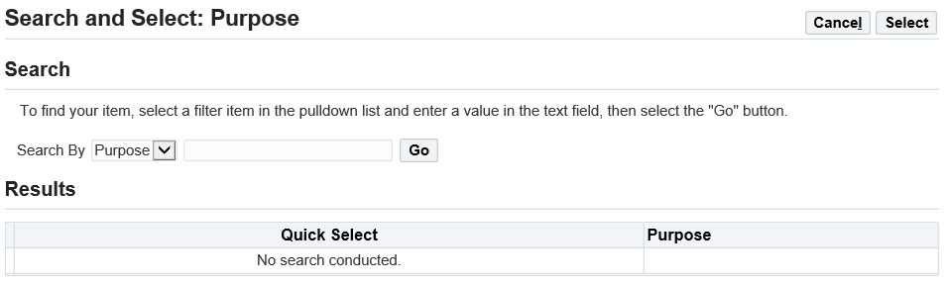
7 | Select the appropriate option from the list and click Select.  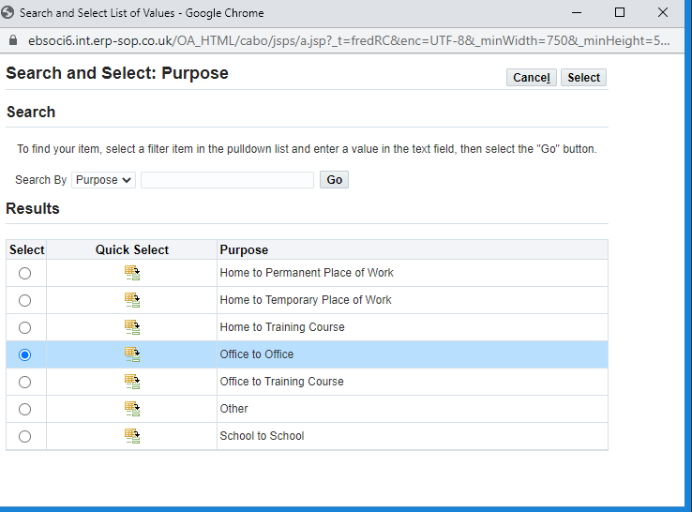
8 | Continue to fill out the form with the required information.  NOTE - Please use exact CC (do not round) in the engine capacity field for correct calculation of rates.  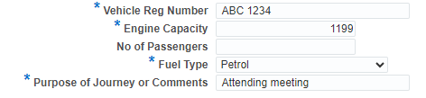
9 | Once you’ve completed the form, click Apply (located in the bottom right of the screen).  
10 | This will enter the mileage claim on your record.  To add another day to the same claim, click Mileage Claims again and repeat the previous process from Steps 4-9.  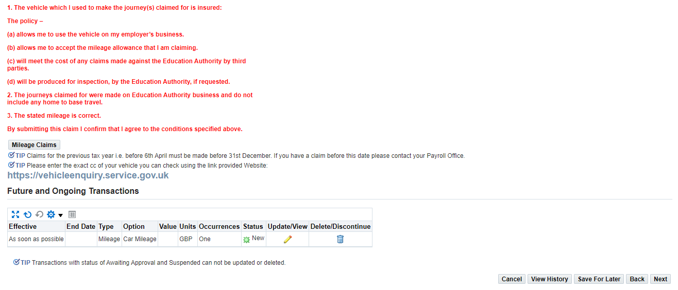
11 | All unsubmitted claims will display like the lines in the picture below.  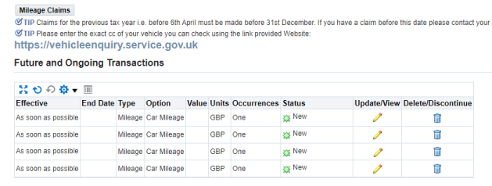  To submit the claim to your line manager for approval, click Next.  
12 | This will provide you with a summary of your claim. Review this information to make sure it’s correct.  You’ll see one of these for each day you’ve entered.  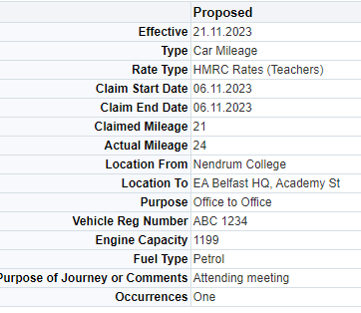  If you’re entering a summary claim, you’ll see one summary of the total miles you entered for the claim period like below.  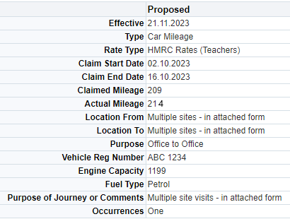
13 | If you need to attach evidence to your claim, such as when making a summary claim for the month, click the Green Plus button under attachments.  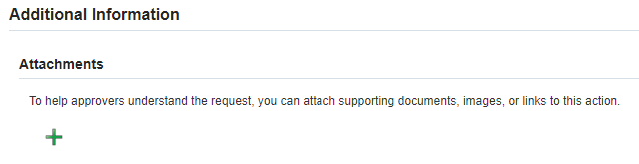
14 | Give your attachment a name to make it clear what it is, e.g. “Summary of Journeys April 2023” and click Choose File to upload the document from your computer.  Once you’ve done this, click Apply. This will return you to the submit page.  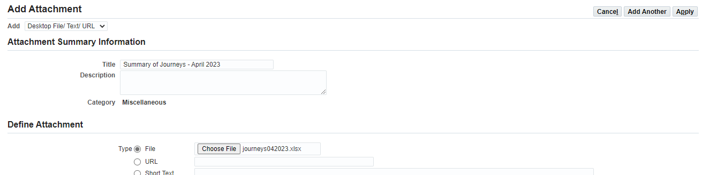  Repeat this process for any additional attachments – such as approvals from your Board of Governors.
15 | Your supervisor (Approver) will be listed below. If the supervisor appearing is incorrect, contact eaonehelpdesk@eani.org.uk to correct it before making the submission.  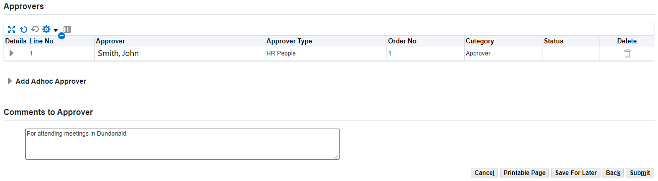  For Prinicpals and Temporary Teachers, this should be Accounts with the 4 staff listed as approvers for your claim. If you are seeing this and are one of these types of staff, you can continue with the claim. If you are seeing something different, please contact eaonehelpdesk@eani.org.uk.  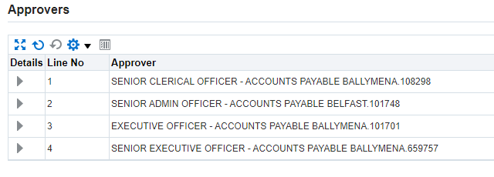
16 | You can also leave a comment for the approver if required. Once you’re ready to send the claim for approval, click Submit.
17 | You will receive a notification to confirm that your mileage claim has been successfully sent to your line manager for approval.  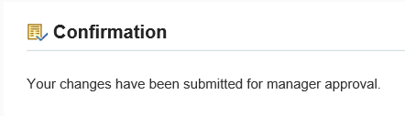
18 | Once a decision has been made on your claim, a notification will appear on your Oracle homepage as shown below.

