

14

Viewing attachments on a Requisition

13

Uploading shortlisting documents to a Requisition

10

Viewing Candidate Submissions (Applications) – In bulk

5

Viewing Candidate Submissions (Applications) – Individually

7

A Hiring Manager’s Guide to Shortlisting

3

Candidate Counts

**Page**

**Content**

Candidate Counts

If you are named on a Requisition, you can log into your account at any stage of the recruitment process to establish how many candidates have submitted a completed application.

From the Recruiting Centre, click on the **total number** next to the **Open** staff requisitions within the Job Requisitions channel.

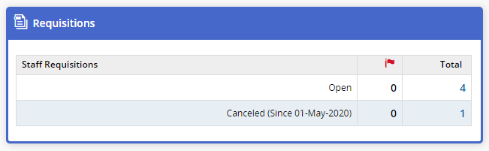

The candidate count for completed applications/submissions is visible in the third column of each requisition. Incomplete applications will not be counted or displayed.

*E.g. In the screenshot below the first requisition has 5 completed submissions:*

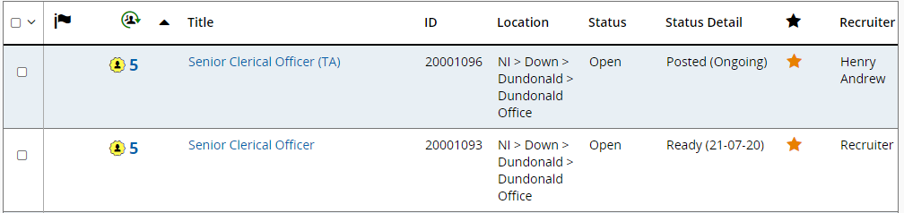

To display the list of candidates who have applied for a requisition, click on the candidate count number.

**NB:** If you have less candidates displaying on your list in comparison to the candidate count, this will be because an applicant/applicants have been automatically rejected for not meeting the disqualification question during their application.

The following screen will be displayed listing the applicants for the role:

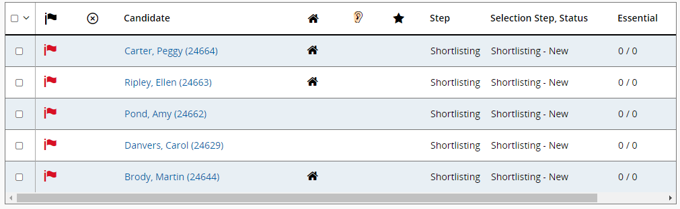

**Tip:** Click on a column title to sort alphabetically, numerically or to group data together.

**Tip:** It is recommended that the panel reviews the candidate list and any conflict of interest is declared prior to shortlisting. Where a conflict of interest has been declared and the panel member has been added to the requisition to provide them remote access to applicant details, the chairperson or the recruiter may need to remove the panel member from the requisition to disable their access to the recruitment campaign. Please note that this system action is only required for posts recruited by Corporate and not those recruited through schools as Boards of Governors will not be added to the system as panel members.

A Hiring Manager’s Guide to Shortlisting

**Hiring Manager’s should not begin to shortlist until a post has closed**. Although a Hiring Manager can access submissions prior to the post closing, an applicant can continue to update their submission until the deadline for the post closing. Any amendments made by the applicant, will automatically update on the Hiring Managers list.

If you opted to use either single select or multiple select questions for a recruitment campaign, you and your Recruiter may have updated the **Essential/Desirable** column within the requisition form. Doing this prior to advertising the post would have allowed the system to score your candidates answers based on the selection(s) they made on their application form. In turn, this can then provide a quick overview of how many essential and desirable criteria each candidate has met prior to shortlisting. If you did not use this functionality whilst creating your requisition, the scoring will remain ‘0/0’.

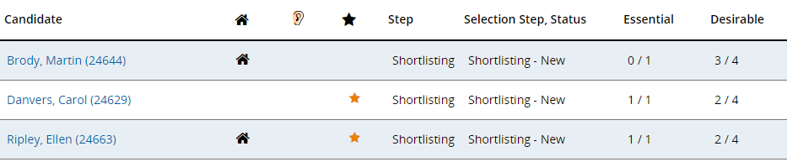

*Exampleof calculated responses:*

**NB:** This star illustrates top candidates

who meet all your essential criteria.

**Tip:** If candidates are calculated, you can click on the **Essential** column header to sort the column numerically. If your initial click sorts the column ascending, you can click the header again to sort descending and vice versa.

*Example of non-scored responses:*

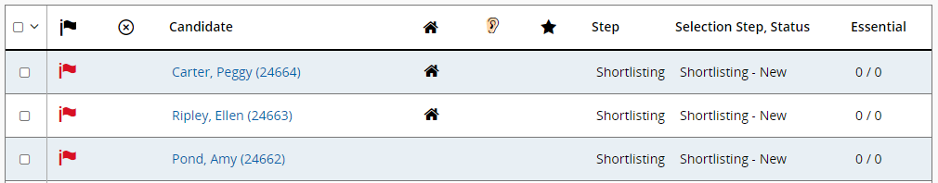

Viewing Candidate Submissions (Applications) – Individually

To view a candidate submission, click on their name within the Candidate column:

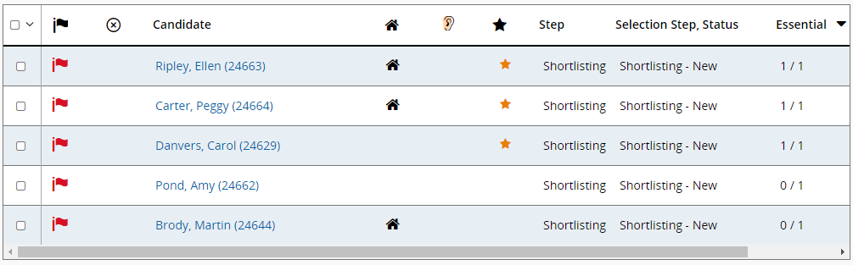

Their job submission (application form) will be displayed:

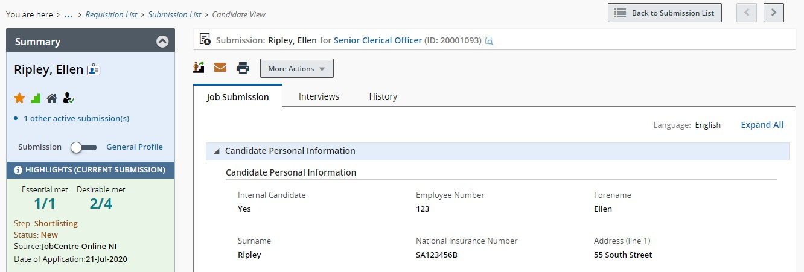

Job submissions will have six sections:

1. Candidate Personal Information
2. Employment
3. Education and Qualifications
4. Pre-screening Questions/Shortlisting Criteria
5. References
6. eSignature

Use the arrow to the left of the section to expand and collapse that section as necessary:

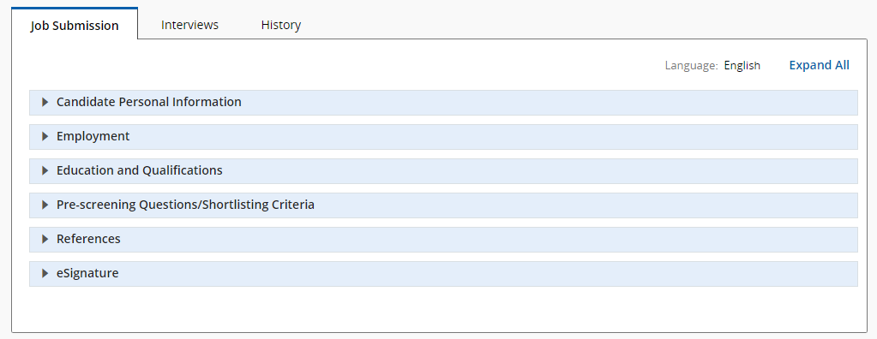

The ‘Pre-screening Questions/Shortlisting Criteria’ section will display candidate responses to the questions set at requisition stage:

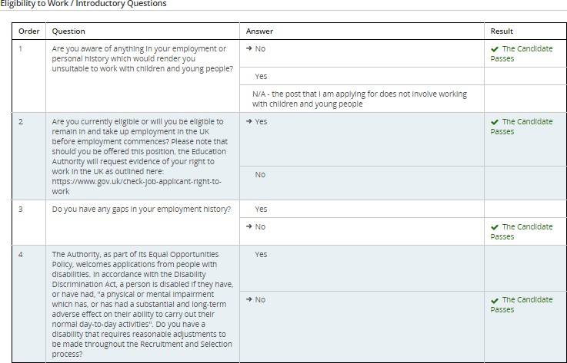

NB: Remember to review the responses to the Eligibilityto Work/Introductory Questions reviewing any gaps in employment listed and being mindful of reasonable adjustments required as necessary.

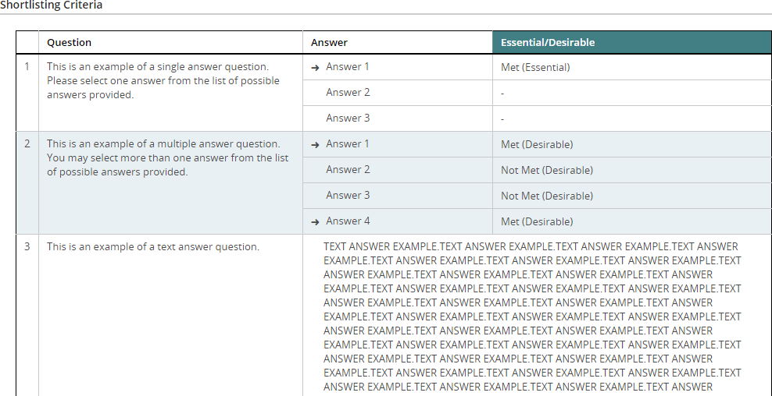

If you have asked for text responses to questions, you may find it difficult to read the responses in the small pane provided on this page. In order to view answers easier, click the print button to the top of the candidate submission. This will print the candidate file to PDF:

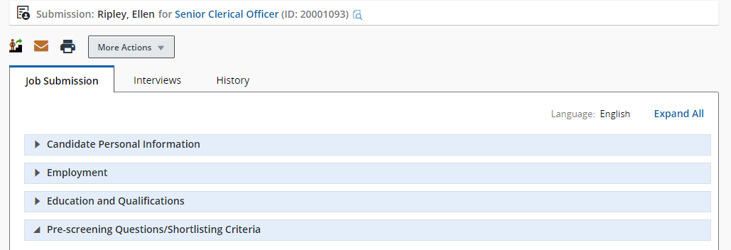

The print configuration pop up is displayed. Deselect all sections apart from the Pre-screening

Questions/Shortlisting Criteria section:

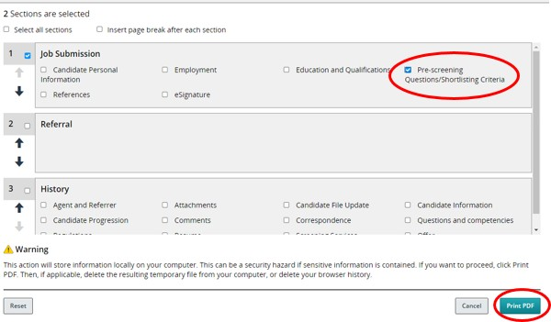

Click the **Print (PDF) button**. The candidate questions will then be displayed in a separate tab in PDF format, making is easier to read the text responses:

*Example of PDF display of text response:*

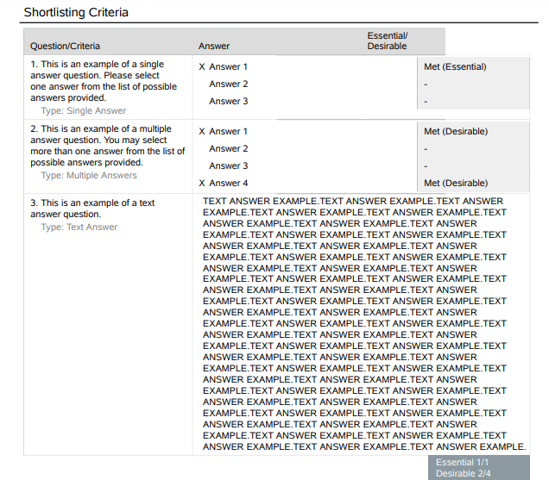

Should you prefer to have a hardcopy of the candidate responses, you can right click on the individual PDFs per candidate and select to print a hardcopy.

To return to the previous page, close the tab.

You can use the navigation arrows to either return to the candidate list or move through the candidate submissions. **Click Back to Submission List** to return to submissions.

This screenshot shows how to navigate through the candidate submissions

**Tip:** If you are unsure of what an arrow does, hover over it and a tooltip will be displayed to assist you.

Viewing Candidate Submissions (Applications) – In bulk

You can view candidate submissions by selecting candidates on your main candidate list. To do this, tick the checkbox in the first column and then click the print button. By doing this, you can display more than one candidate submission at a time:

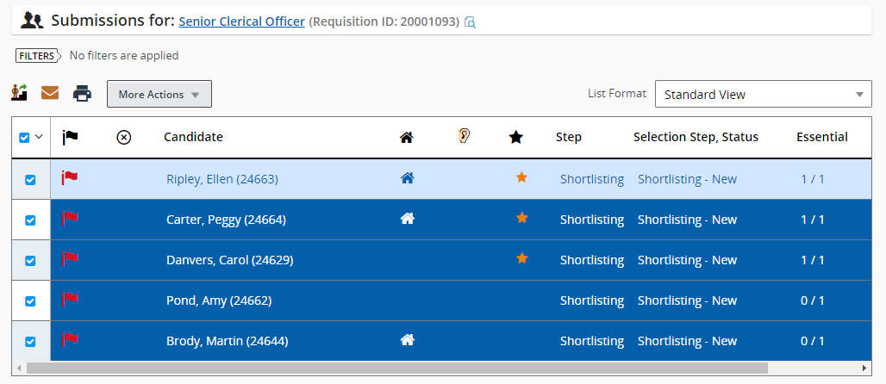

NB: Clicking here will select all candidates on your list.

The print configuration pop up is displayed. You can select to print the list of selected candidates only or you can select to print the candidate file details:

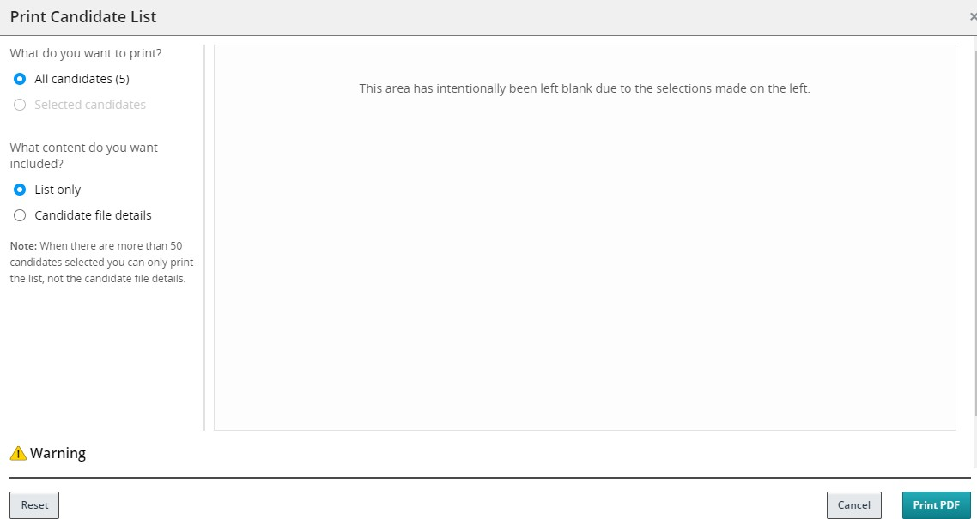

Page 10

*Example of List only:*

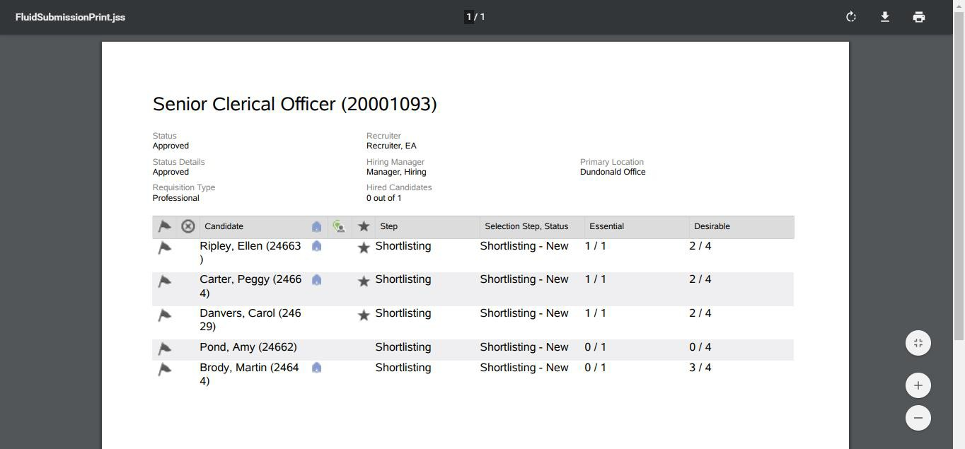

If you select to display the candidate file details for the selected candidate(s), the following print configuration pop up is displayed. Deselect all sections apart from the Job Submission Questions section:

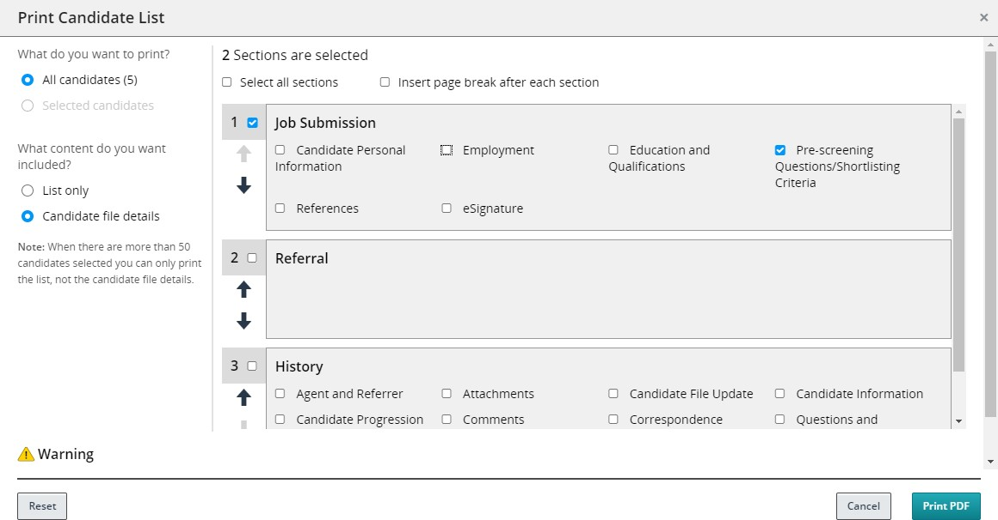

Click the **Print (PDF) button**. All selected candidates question responses will then be displayed in a separate tab in PDF format, making is easier to read the text responses.

Review all candidates and complete the relevant off-system shortlisting forms.

Page 11

**Tip:** In order to speed up the shortlisting process, i t is recommended that you select all candidates on your list and use the functionality to print all candidates together at one time, either to PDF displayed on the screen, or to hardcopy should you prefer. (NB: To print to hardcopy you must first print to PDF and then right click on your mouse and print the document as normal).

*Example of candidates selected in bulk and printed to PDF (notice there are 23pages reflective of all 11 applicants for this post):*

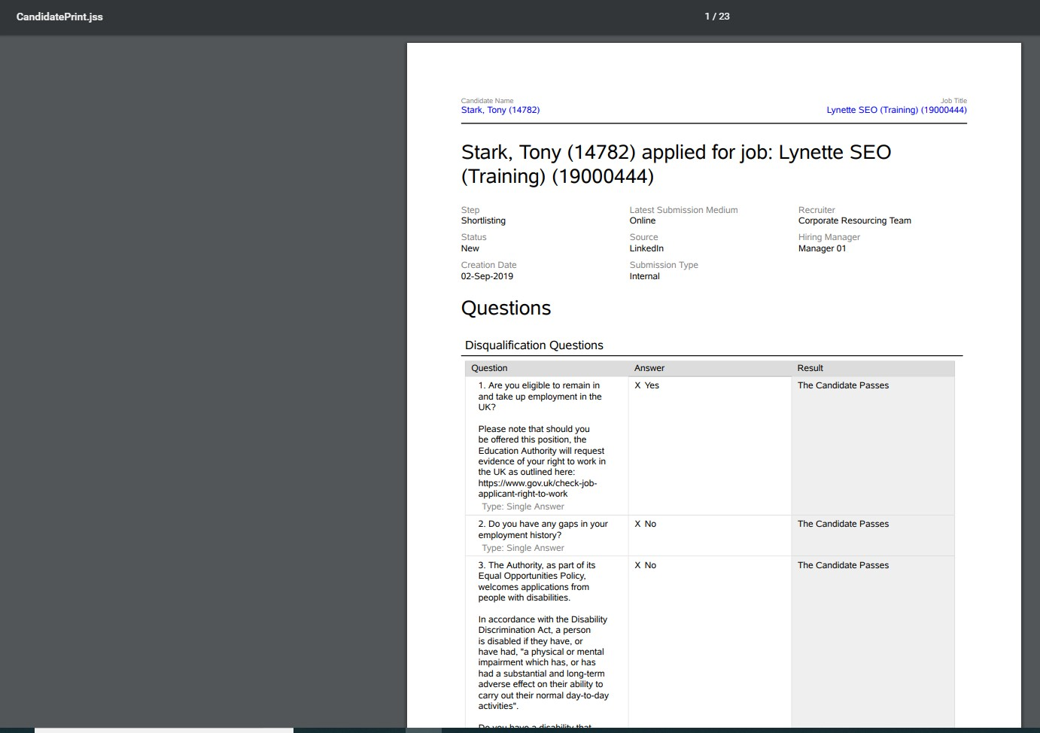

Close the tab to exit and return to the Recruiting Centre.

Ensure you review all candidates and complete the relevant off-system shortlisting forms.

Uploading shortlisting documents to a Requisition

When you have completed your shortlisting forms, only the ‘Shortlisting Final Order of Merit form’ needs to be uploaded the to the requisition on the e-recruitment system. The process for uploading shortlisting document is the same as that of uploading any documents to a requisition. In fact, they are all added, stored and viewable under the same tab. You will need to have the document(s) you wish to upload either scanned or saved to your computer. From the Recruiting Centre, click the Requisitions channel. Locate the relevant requisition and click onto the requisition title to open it.

Click on the **Attachments** tab. The following screen will be displayed:

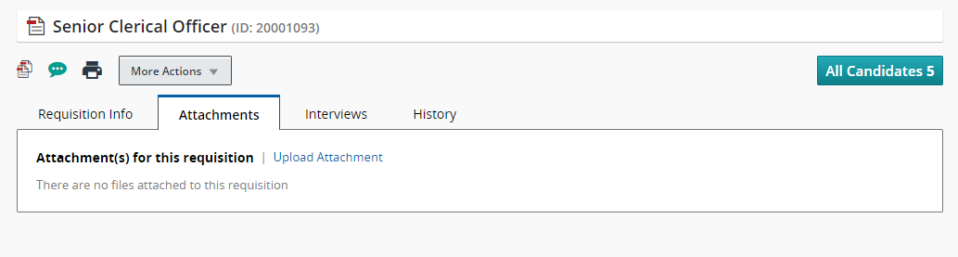

**NB:** You can have a maximum of 10 attachments to a requisition. An attachment may have more than one page however; an attachment must not exceed the allocated limit of 1,024 kilobytes.

Click the **Upload Attachments** link to search for the document you would like to upload. The upload Attachment pop up is displayed. Click the **Browse** button to locate the document.

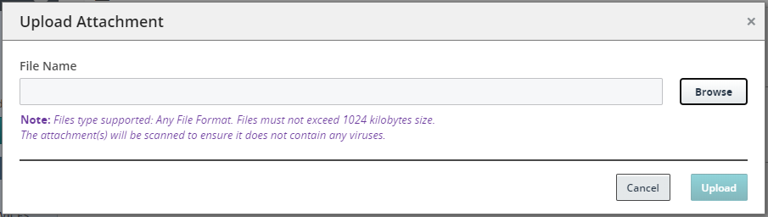

When you have located the document, click on it and click **Open.**

The **file name** field will now be populated with the title of the document you have selected. Click the **upload** button to add the document as an attachment to your requisition.

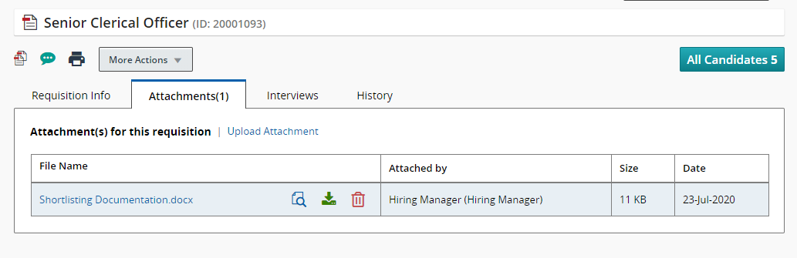

**NB:** To review the document you have uploaded, click on the document file name which is displayed in blue.

**NB**: If you have uploaded a document in error, click on the bin icon next to the file name to delete

**Tip:** If you are attaching shortlisting documents, it is recommended that you PDF these documents so that they cannot be amended after upload. You should also title them with a relevant name so that the contents can be easily identified.

For posts recruited within Corporate, please email the Recruiter/Recruiter Assistant to advise that the shortlisting document(s) have been attached. This will enable your recruiter to issue the shortlisting outcomes correspondence (i.e. not shortlisted or invites to interview). **Failure to do so may result in a delay in your interviews taking place as candidates should be given reasonable notice.**

Posts recruited via schools do not need to email their Recruiter/Recruiter Assistant to advise that shortlisting documents have been attached as it is the schools responsibility to issue the relevant shortlisting outcomes correspondence (i.e. not shortlisted or invites to interview).

Viewing attachments on a Requisition

You can view shortlisting documents, and any documents that have been added to a requisition, by following a similar process to that of uploading attachments:

* + Log on to the Recruiting Centre
  + Click the Requisitions channel
  + Locate the relevant requisition for which you would like to view the attachments
  + Click onto the requisition title to open it
  + Click on the **Attachments** tab
  + All attachments are listed under the ‘File Name’ column of the page
  + Click on the document to open and review the content