

|  |  |
| --- | --- |
| **Content** | **Page** |
| Terminating an Approval Path | 3 |
| Modifying Approval Process | 5 |
| Sending an approval reminder | 8 |

Terminating an Approval Path

If you need to remove a previously selected approver from a requisition, you will need to terminate the full approval path and then resend the requisition for approval. To do this, click **More Actions** and select **Terminate Approval Process** as shown below:

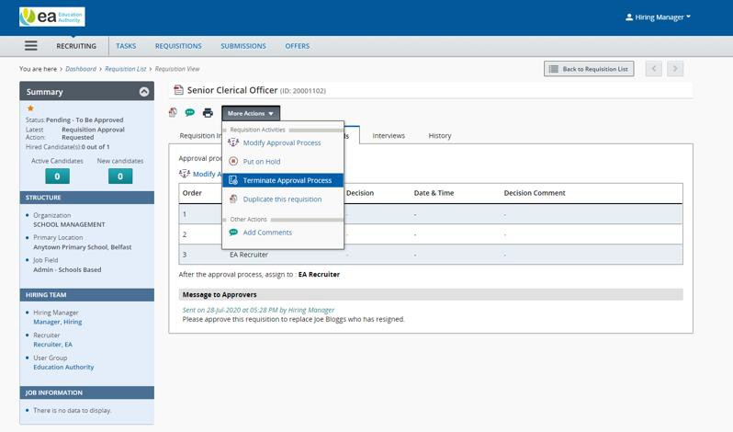

This pop up will display. It is best practice to add a comment with the reason you have terminated the approval pathway.

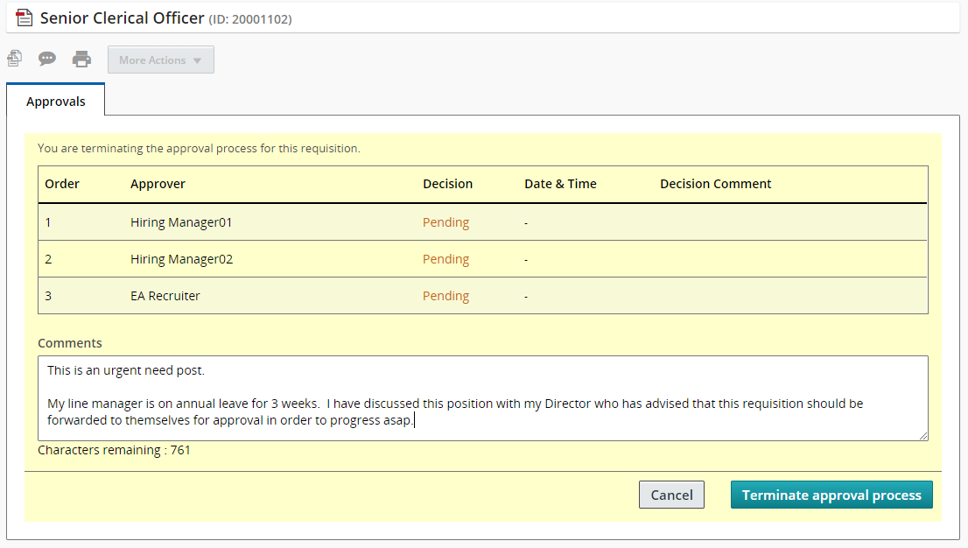

When you have done this, click **Terminate Approval Process.**

You will then be returned to the requisition where the status in the summary card will be updated to

* **Approval process terminated.**

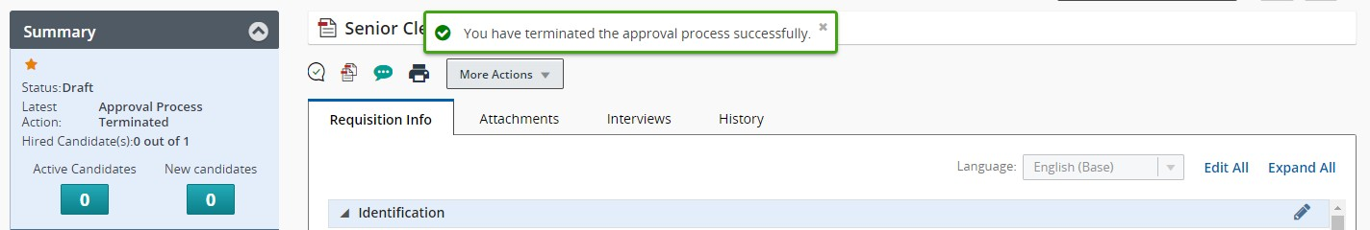

This action will be logged in the History tab.

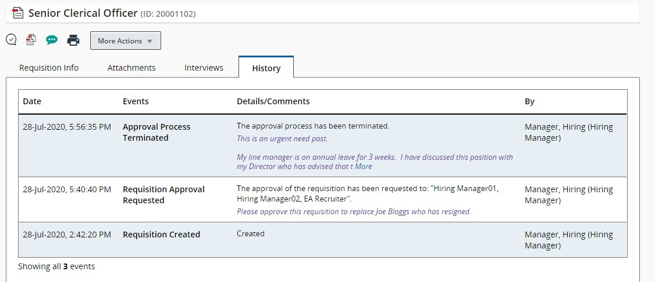

You can now re-send the requisition for approval.

Modifying Approval Process

Should you wish to add additional approvers to a requisition that has already been sent for approval, there 2 different ways to modify the approval process.

You can either:

* 1. Click the **Modify Approval Process link**

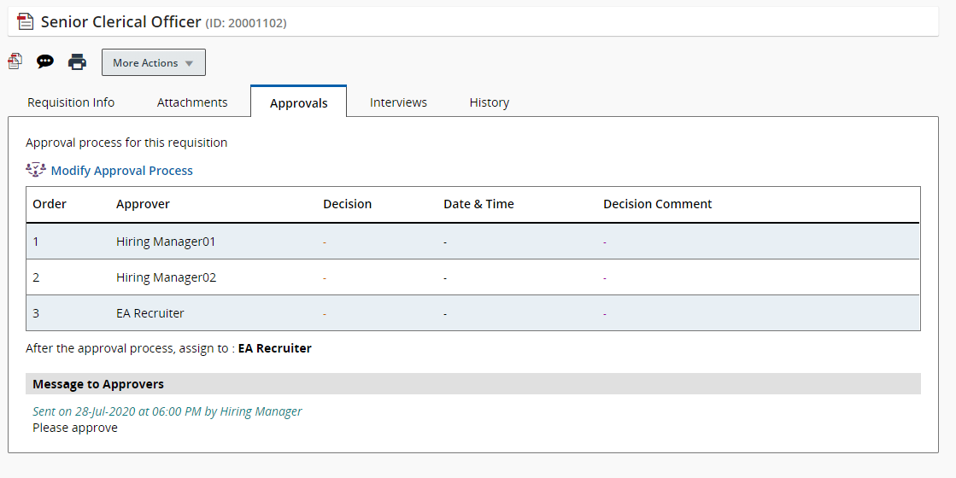

* 1. From the More Actions menu and select **Modify Approval Process.**

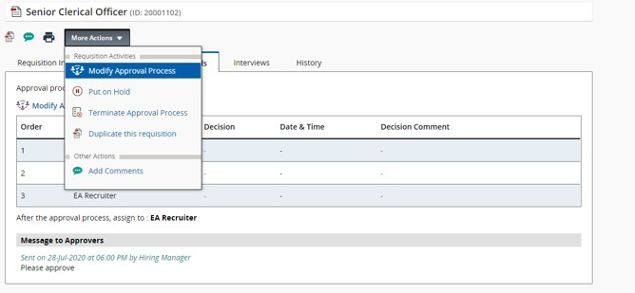

The approvals page is displayed.

Click **Add Approvers** to display the approver list. Use the checkbox beside the relevant approver to add them to the approval list.

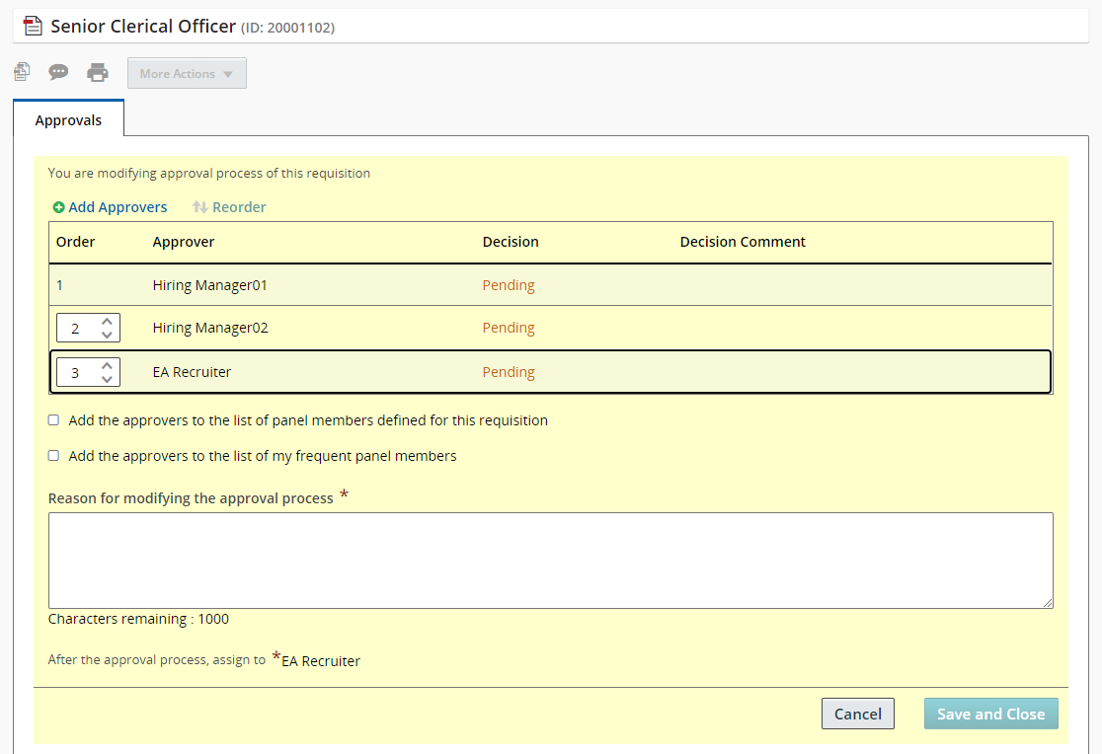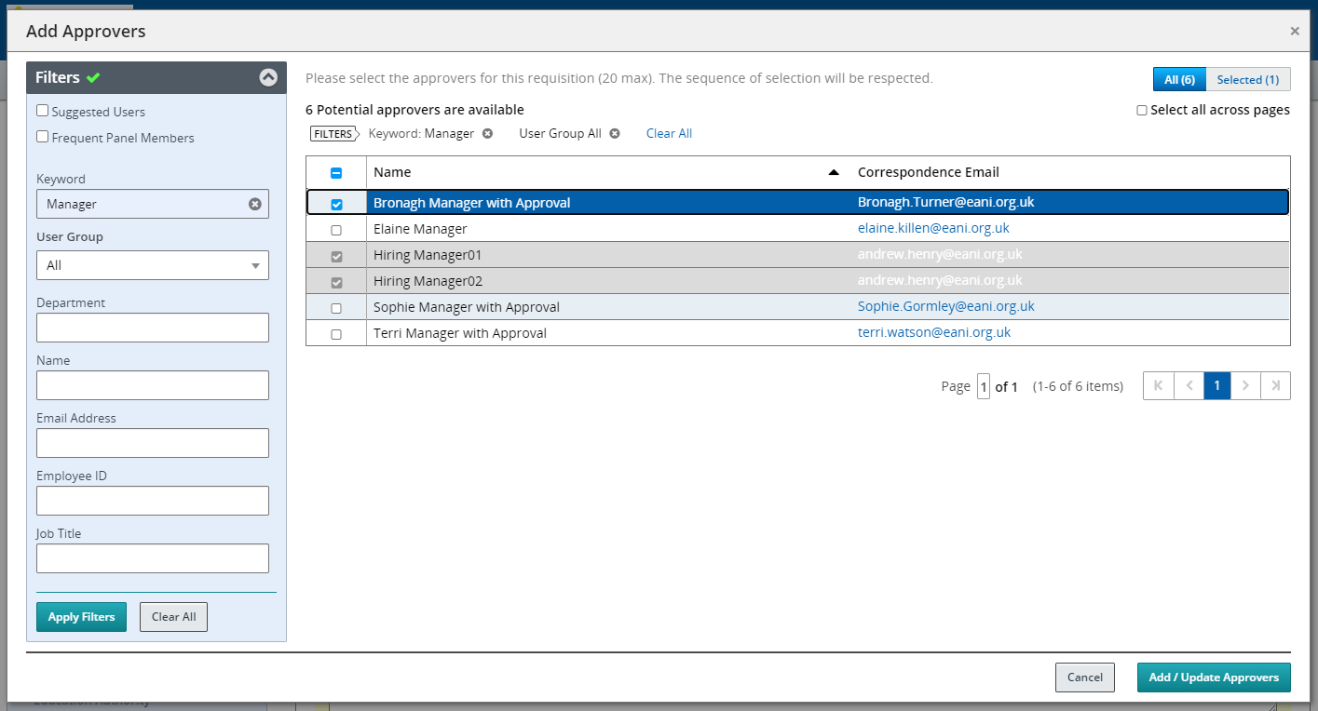

**NB:** You can use the filters to assist you with your search.

Click **Add/Update Approvers** button.

When you have added all the additional approvers, add a comment to the reason for modifying the approval process box and click **Save and Close.**

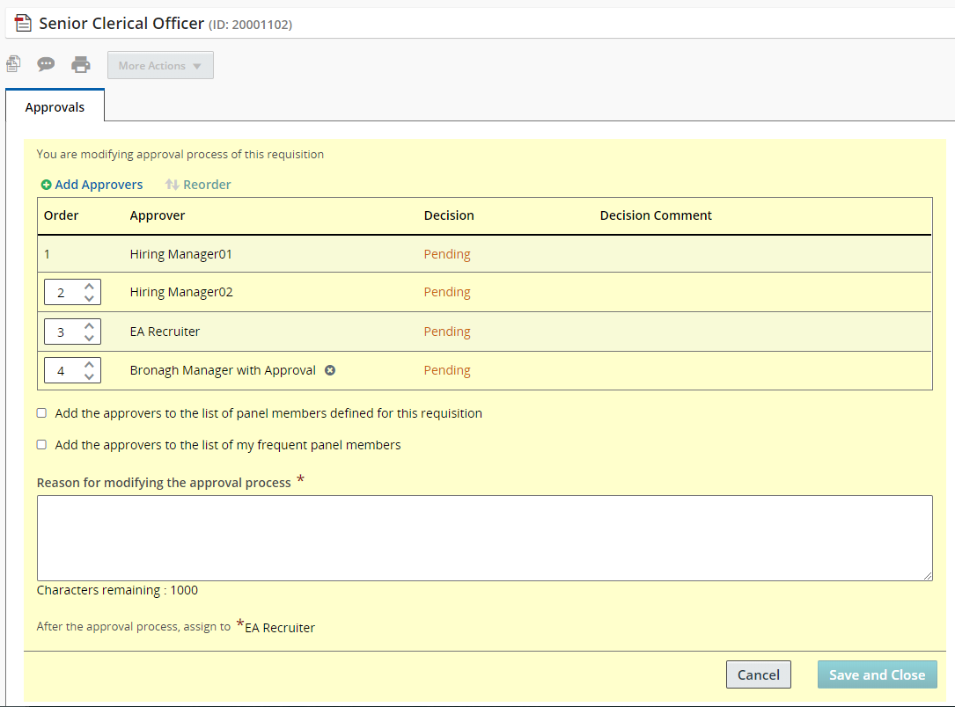

**NB:** You will be unable to delete any approvers previously selected to approve a requisition. To do this, you will need to terminate the full approval pathway and restart the approval process.

When you have added additional approvers, you will return to the Approvals tab where the updated approver path will be listed.

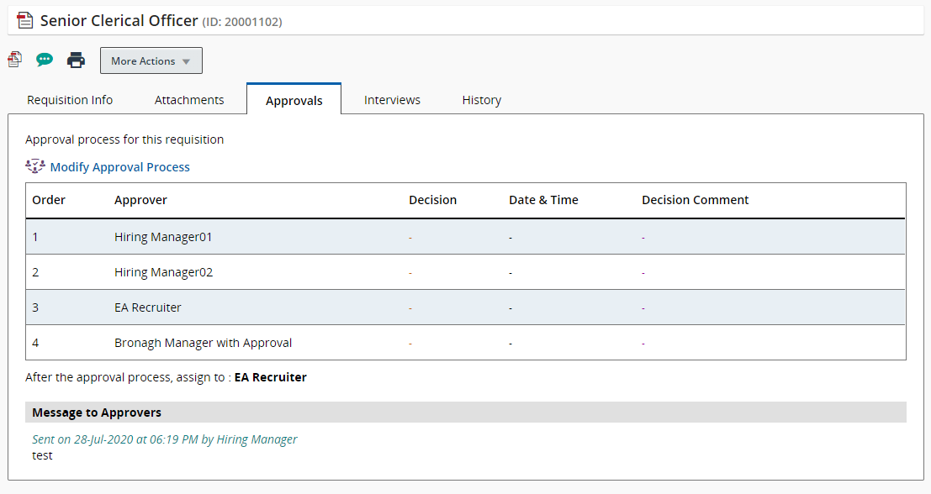

Sending an approval reminder

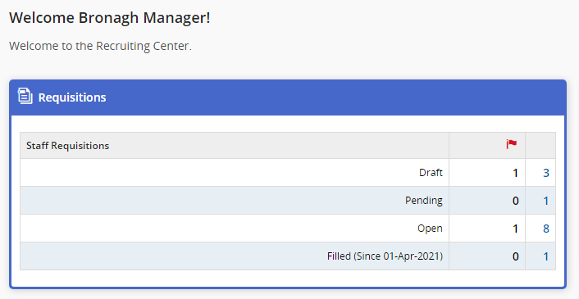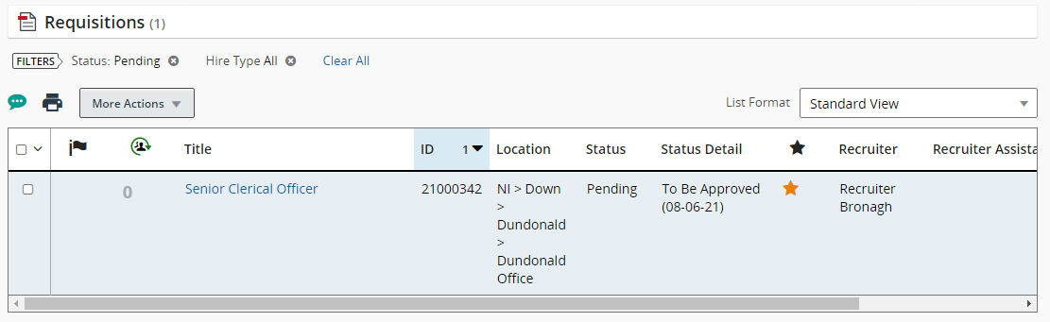

The system will automatically send approval reminders to selected approvers every 7 days until the approver either approves or rejects the requisition.

However, if you wish to send a requisition approval reminder, you must locate the requisition. The requisition will have a status of pending on your requisitions dashboard.

Click on the number 1 link, this will then take you to the requisition list.

To open the requisition/approvals tab, click on the title of the post. You will now be directed to the approvals tab within the requisition.

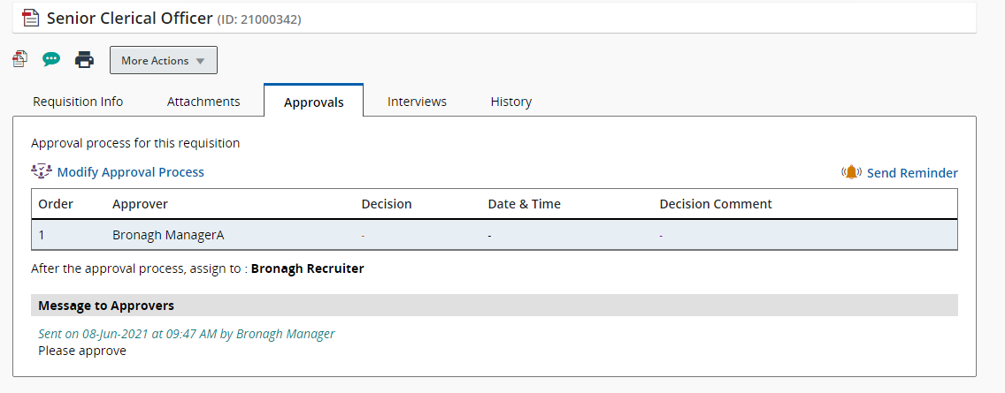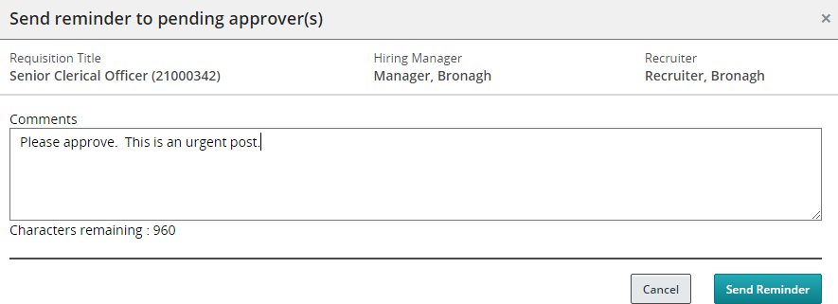

Click the **Send Reminder** button. The following pop up will be displayed. Add a comment to your approver.

Click the **Send Reminder** button. A reminder will now have been sent to your approver.