

The purpose of this user guide is to assist you with logging into the Online Recruitment System

**CONTENTS**

|  |  |
| --- | --- |
| **Content** | **Page** |
| About the Online Recruitment System | 3 |
| Launching the Online Recruitment Centre | 3 |
| Adding a webpage as a favourite   * Via Google Chrome | 4  4 |

About the Online Recruitment System

The Education Authority’s online recruitment system is a cloud-based system that can be accessed by users on demand via the Internet. This online recruitment system is now compatible with mobile devices which will now allow you to carry out tasks such as requisition and candidate management.

As with all cloud-based systems, this application will be subject to mandatory upgrades and users will be kept informed of any changes may impact the user experience.

Launching the Online Recruitment Centre

The recommended browser for this application is Google Chrome. 

To access the online recruitment centre, enter the following URL into your browser: [https://eani.taleo.net](https://eani.taleo.net/)

**Tip:** If you are viewing this guide electronically, you can access the website from this document by holding **Ctrl** on your keyboard and clicking on the aforementioned URL.

The following screen will appear:

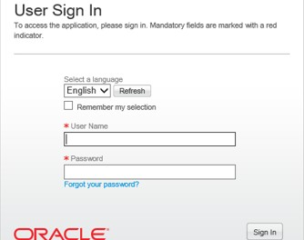

Adding a Webpage as a Favourite page

Frequent users may find it beneficial to bookmark this URL to their browser favourites for quick and easy access. You can do this as follows:

Via Google Chrome:

Click on the **star icon** on the top right of the screen:

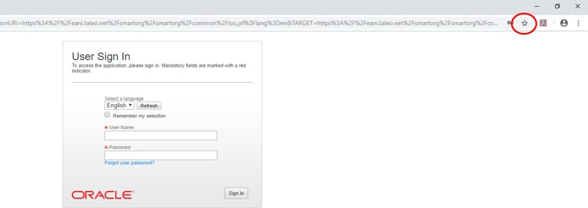

Re-name the link so that it is easily identifiable and click the **Done** button:

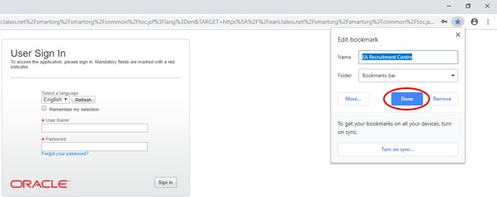

When you next launch Google Chrome, the website will now be bookmarked at the top of your browser for quick and easy access in the future:

