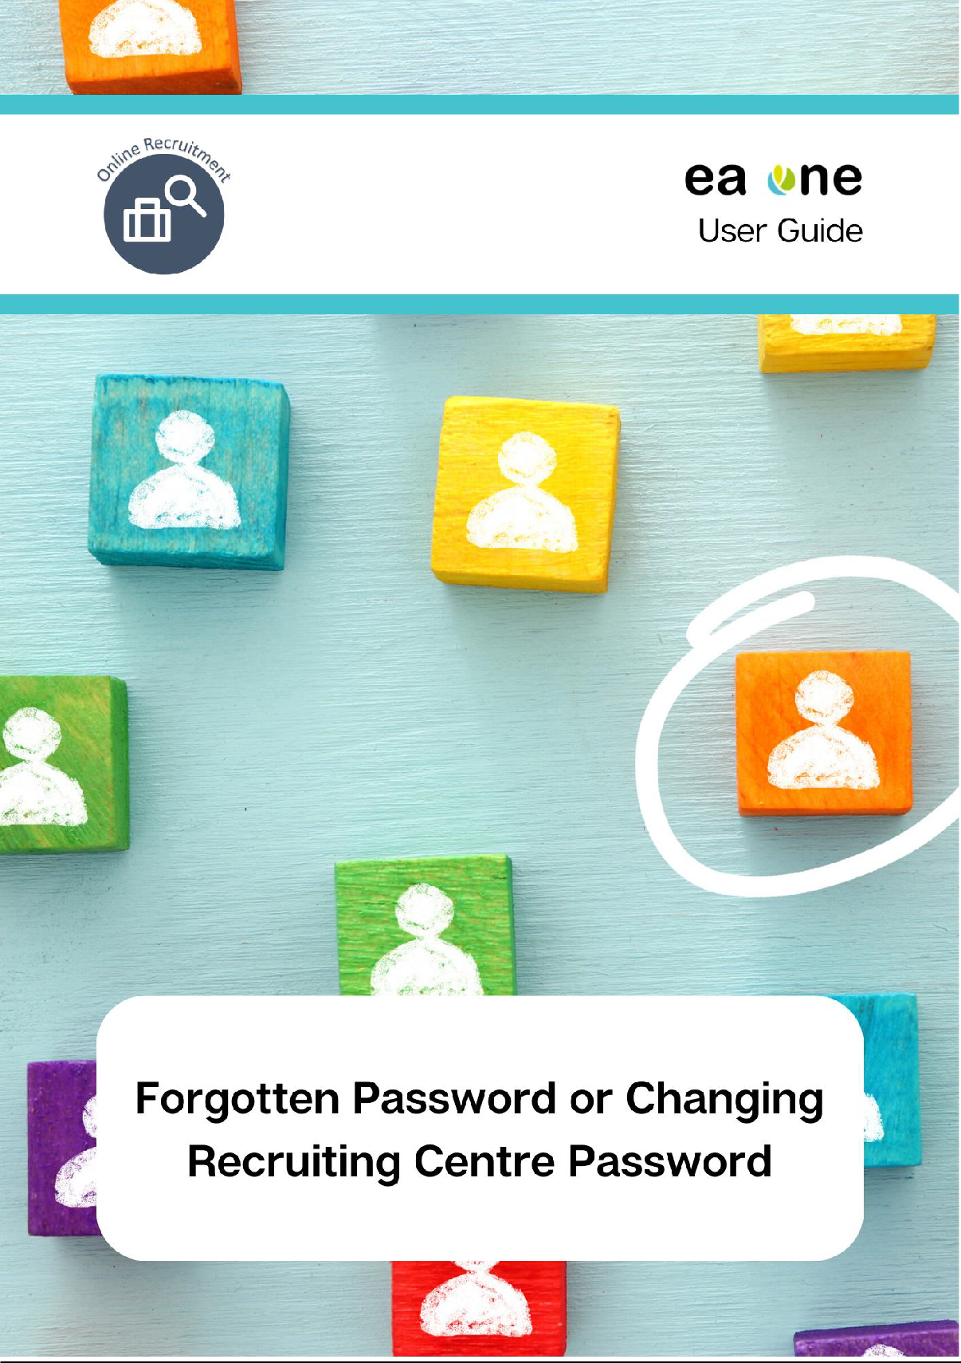

|  |  |
| --- | --- |
| **Content** | **Page** |
| Forgotten/Changing your Recruiting Centre account password | 3 |

Forgotten/Changing your Recruiting Centre account password

To access the online recruitment centre, enter the following URL into your browser: [https://eani.taleo.net](https://eani.taleo.net/)

The ‘User Sign In’ screen will appear. Click the forgot your password  hyperlink as circled below:

This is a screenshot of the user sign in page and also outlines how to request a password reset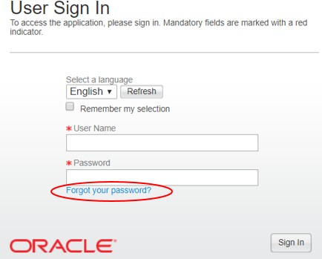

Clicking the hyperlink will display the following screen. Follow the instructions provided by completing your user name and email address and clicking the **OK** button:

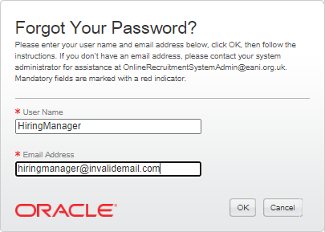

You will receive the following message on screen:

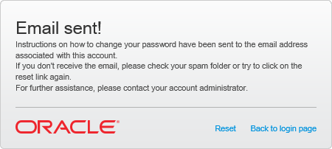

Locate the email that has been sent to you. Note that this email contains an access code that you will need to copy (highlight the code, ensuring that you do not highlight to copy any blank spaces, and either right click with your mouse and select ‘Copy’ or use the shortcut Ctrl + C on your keyboard). Click on the blue hyperlink within this email to reset your password:

*Example:*

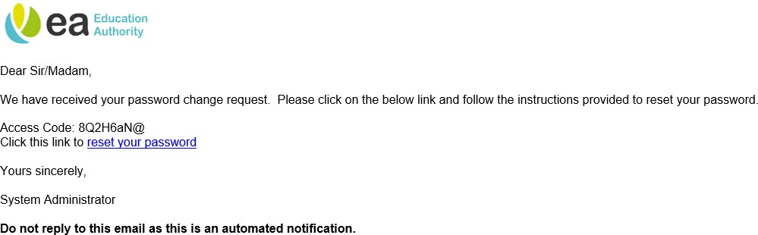

The hyperlink will prompt the following page to be displayed. Enter your user name again along with the access code found within the email (to paste either right click with your mouse and select the relevant Paste option or use the shortcut Ctrl + V on your keyboard). Next, click the **Sign In** button:

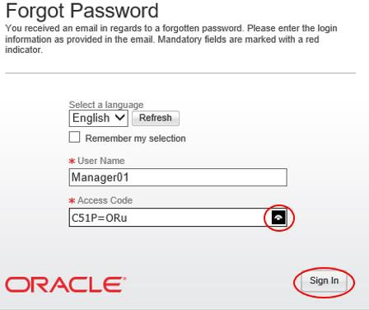

**Tip:** For security purposes, the system will not display the password you have entered. To show the password click the eye symbol.

On the next page, you will need to re-enter the access code that you were issued along with your new password and confirmation of this new password. When you have completed this form, press the **OK** button:

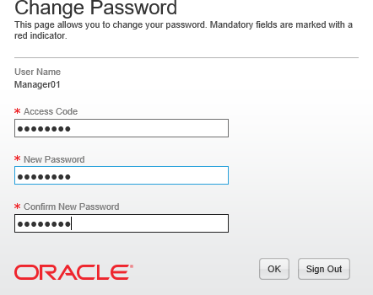

**Password Rules:**

Passwords are case sensitive and must contain between 6 and 32 characters. Passwords must contain at least 1 letter and 1 numerical value and must not contain more than 5 identical consecutive characters (e.g.

AAAAA...). Passwords must not contain your user name.

When resetting passwords, they must be different to a previously used password.

The following pop up will be displayed:

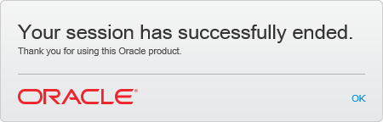

Click **OK** to return to the User Sign In screen, enter your User Name along with your new password and click **Sign In:**

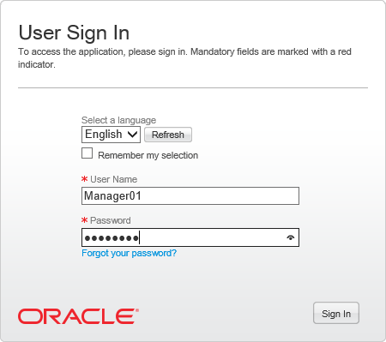

You will then be successfully logged into the Welcome Centre:

