

|  |  |
| --- | --- |
| **Content** | **Page** |
| Approving a Requisition via eShare notification | 3 |
| Approving a Requisition via the Recruiting Centre | 7 |

Approving a Requisition

As an approver, there are two ways that you can view requisitions in order to approve or reject these:

* Via eShare notification
* Via the Recruiting Centre

Via eShare notification

You will receive eShare notifications via email when a Hiring Manager has selected you to approve their requisitions.

From this email, click **Respond.**

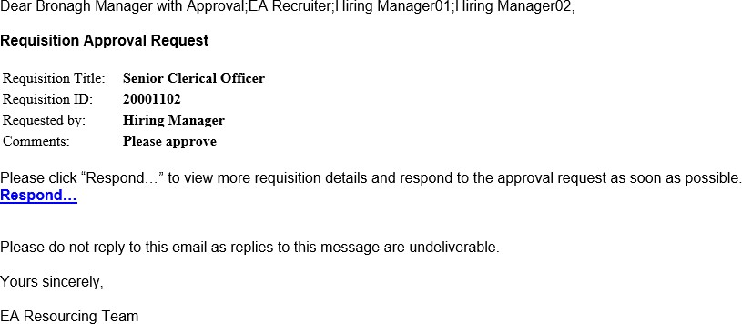

You will then be directed to the Recruiting Centre ‘User Sign in’ page as shown below.

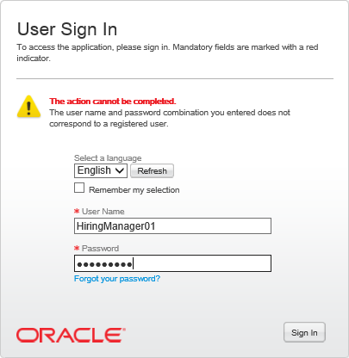

Enter your username and password. Click the **Sign In** button.

When this screen appears, click on **Requisition Details** within the Requisition Information Summary box, to view the requisition.

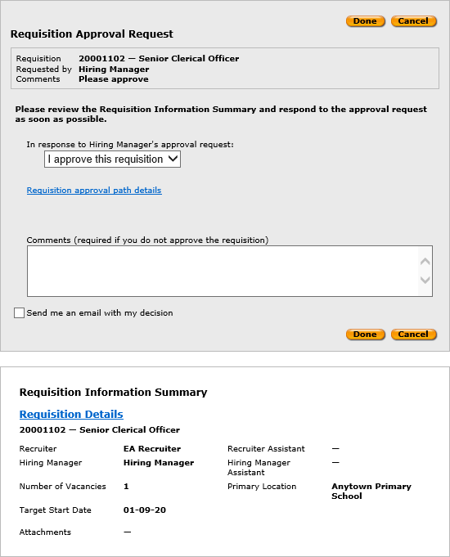

**NB:** Any attachments added to a requisition by a Hiring Manager will be displayed here as a blue hyperlink which you can click on to open and review.

The full requisition will then be displayed as a PDF in a separate tab within your browser. Scroll down the page to read the full requisition requested.

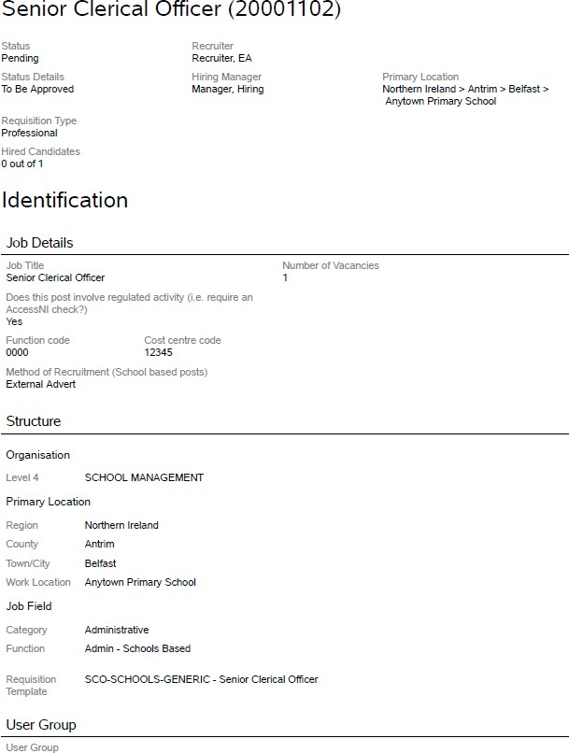

When you have reviewed the requisition, you can close the separate browser and return to the Taleo eShare Centre. Review any attachments as necessary.

To respond to the approval request, click to display the drop down menu as shown below. There are two options available, you can approve the requisition or you can reject the requisition:

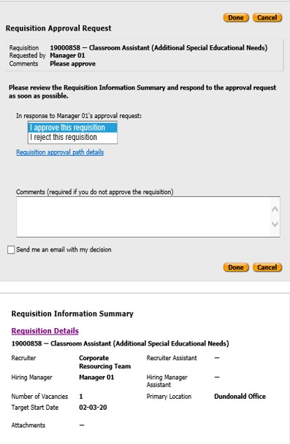

Tick this checkbox should you wish to receive an email with your decision. Your decision details will be logged against the requisition within the Recruiting Centre.

Click here to view all approvers required for this requisition.

If you reject the request, please enter your reasons for doing so in the comments box. The Hiring Manager can then make any necessary changes to the requisition prior to re-sending this for approval. If you have selected to approve the requisition, the system workflow will then send the requisition to the next approver/relevant resourcing team as selected by the Hiring Manager when generating the requisition.

When you have made your choice, click **Done.** The following screen will be displayed:

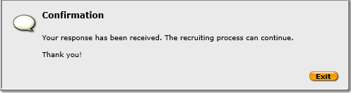

Via the Recruiting Centre

When logged onto the Recruiting system click to access the Recruiting Centre. Under the Tasks channel, there will be a heading ‘Tasks assigned to me’:

Click on this hyperlink to display all your pending tasks. The following screen will appear:

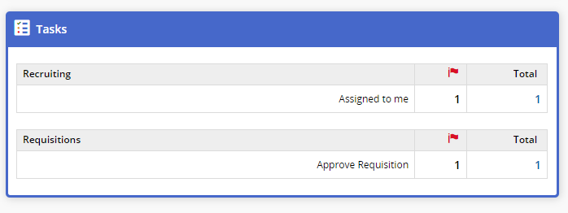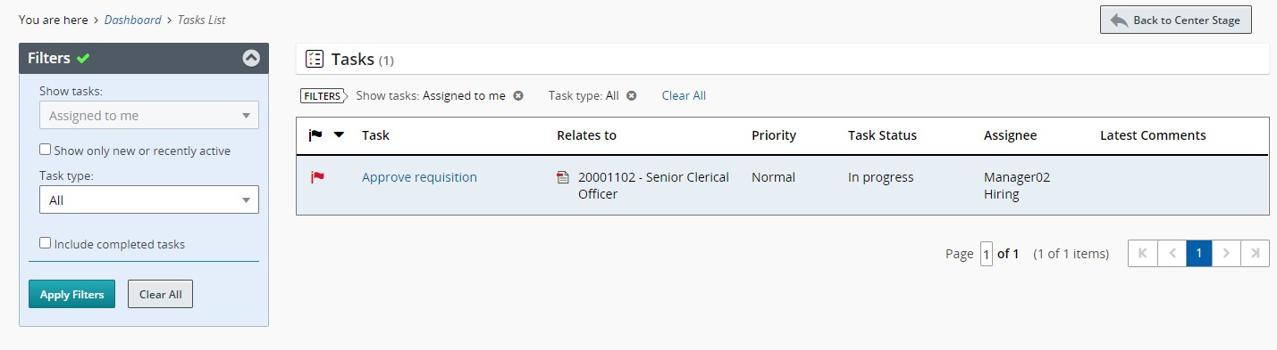

A red flag will display beside all new tasks.

Normally, if you click the requisition title you can view the requisition information:

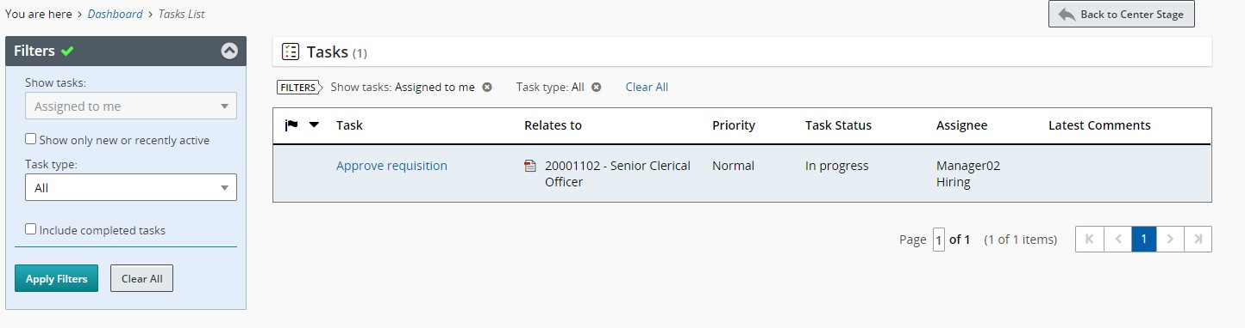

**Tip:** Use the Quick Filters to speed up your search as necessary.

However, as an approver you may get the following warning message. This will be because you are not listed as a panel member on the requisition:

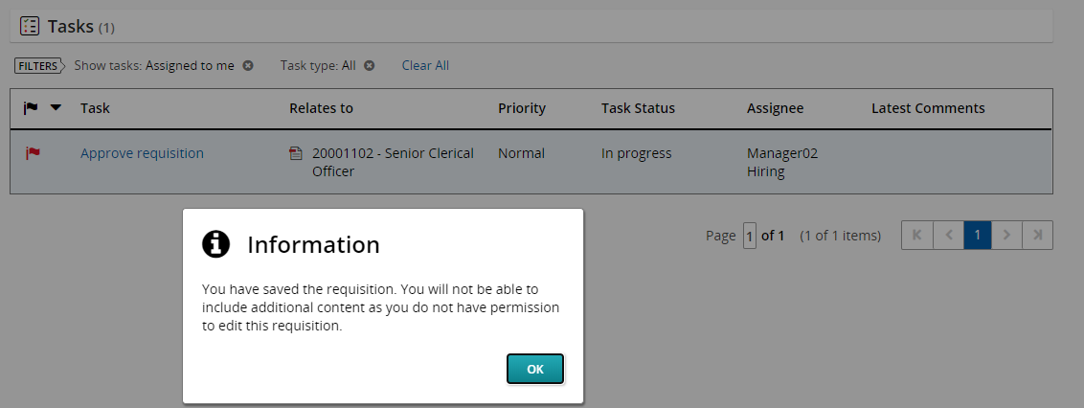

Instead, click on the task entitled ‘Approve Requisition’. The following pop up will be displayed. To review the requisition thoroughly, expand the **Requisition Details** tab.

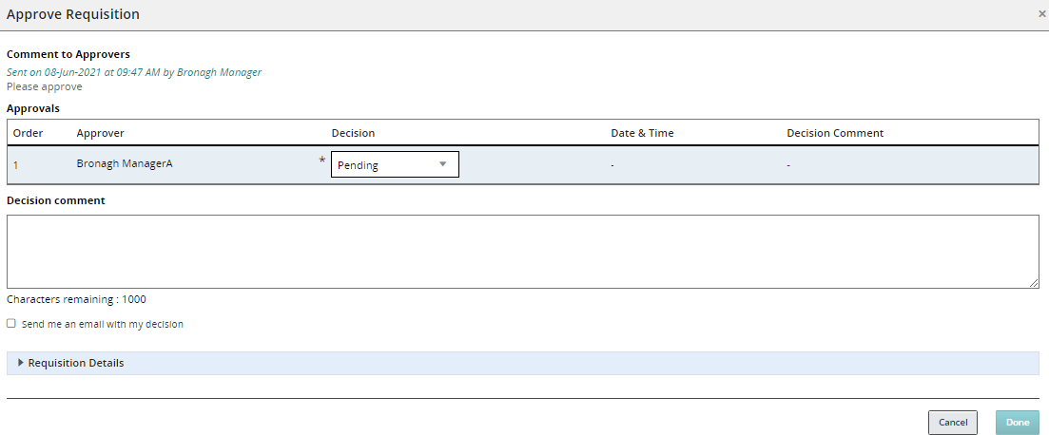

Click on the requisition title.

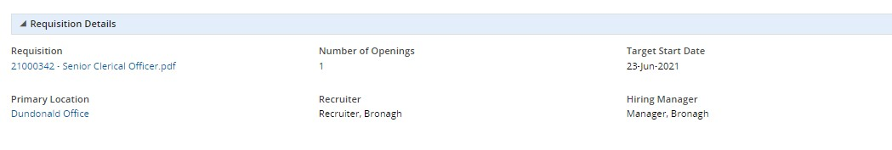

The requisition will be displayed in a new tab.

When you have finished reviewing the requisition, you can select to approve or reject the requisition from the selection list.

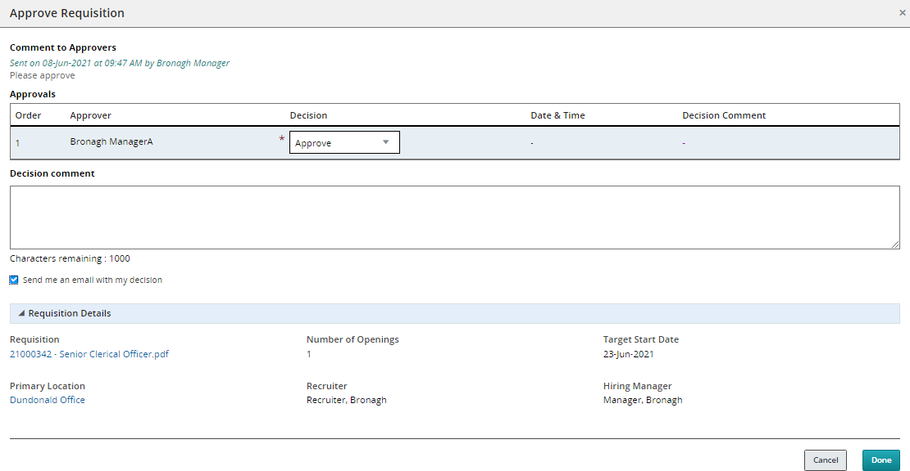

Tick this checkbox should you wish to receive an email with your decision. Your decision details will be logged against the requisition within the Recruiting Centre.

Add a comment as necessary. The comments section is optional, however, it is advised that you provide rational to the Hiring Manager when you are rejecting their requisition.

Click the **Done** button**.**

If you have selected to receive an email with your decision, you will receive the following:

