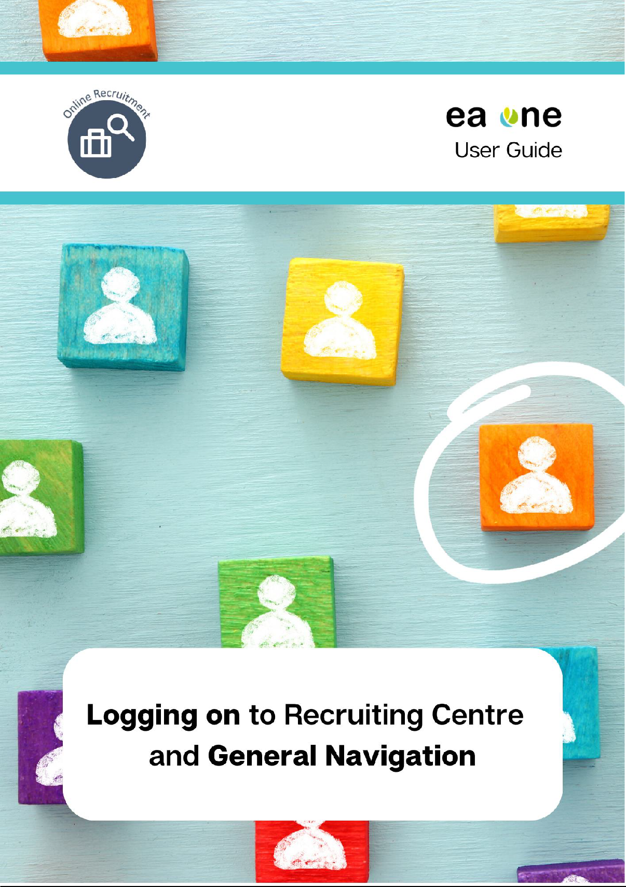

The Welcome Centre

5

The Recruiting Centre

5

The Communications Channel

Managing your Account Setup

8

Preferences - Requisition

8

Preferences - Frequent Panel Members

11

Preferences - Frequent Approvers

13

General Preferences

15

18

Icon Directory

17

General Navigation Tips

6

4

Logging on

3

Glossary of terms

**Page**

**Content**

A Hiring Manager’s Guide to Logging on to the Online Recruiting Centre and General Navigation

Glossary of terms

|  |  |
| --- | --- |
| **Hiring Manager** | For Schools, it is anticipated that the Hiring Manager will be the Principal who will be responsible for creating the Staff Requisition and completing the recruitment activities to fill the vacancy.  For Corporate and EA Managed Front Line recruitment, it is anticipated that the Hiring Manager will be the Line Manager or Service Manager. |
| **Hiring Manager Assistant** | For Schools, it is anticipated that the Hiring Manager Assistant will be the Principal’s nominee who will assist with recruitment activities  For Corporate and EA Managed Front Line recruitment, it is anticipated that the Hiring Manager Assistant will assist the Line Manager or Service Manager with recruitment activities. |
| **Recruiter** | The Recruiter will oversee the recruitment and selection process and guide the Hiring Manager throughout the exercise. The relevant role based resourcing team should be initially selected as the recruiter, then the team leader will re-assign requisitions to a team member to oversee the end to end recruitment. |
| **Recruiter Assistant** | The Recruiter Assistant will be nominated by the role based team leader (where applicable) to provide assistance to the recruiter as and when required. |
| **Welcome Centre** | The Welcome Centre is a home page that is displayed to users immediately after they log in. |
| **Recruiting Centre** | The Recruiting Centre is the main page within the Online Recruitment Centre that is used by Hiring Managers/Hiring Manager Assistants, Recruiters and Recruiter Assistants to navigate between requisitions, candidates, offers and tasks. |

Logging on

The Education Authority’s online recruiting system is cloud-based system which means it can be accessed by users on demand via the Internet. This online recruitment system is now compatible with mobile devices which will now allow you to carry out tasks such as requisition and candidate management.

As with all cloud based systems, this application will be subject to mandatory upgrades and users will be kept informed of any changes that may impact the user experience.

To access the online recruitment centre, enter the following URL into your browser: [https://eani.taleo.net](https://eani.taleo.net/)

The recommended browser for this application is Google Chrome.

Please note that Internet Explorer is not supported for the use of this application Image of Internet Explorer logo

**Tip:** Frequent users may find it beneficial to bookmark this URL to their browser for quick and easy access. For guidance on how to do this, please refer to the following document[: Launching Online](https://www.eani.org.uk/sites/default/files/2021-11/Launching%20Online%20Recruitment%20and%20Adding%20the%20Webpage%20as%20a%20Favourite%20-%20User%20Guide%20.pdf) [Recruitment and Adding the Webpage as a Favourite](https://www.eani.org.uk/sites/default/files/2021-11/Launching%20Online%20Recruitment%20and%20Adding%20the%20Webpage%20as%20a%20Favourite%20-%20User%20Guide%20.pdf)

The following screen will appear. Enter your username and password. Click the **Sign in** button.

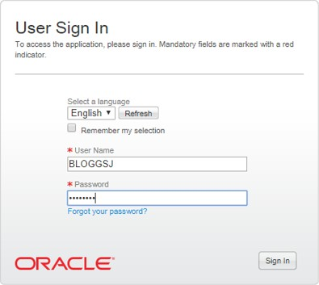

**Password Rules:**

Passwords are case sensitive and must contain between 6 and 32 characters. Passwords must contain at least 1 letter and 1 numerical value and must not contain more than 5 identical consecutive characters (e.g.

AAAAA...). Passwords must not contain your user name.

When resetting passwords, they must be different to a previously used password.

In the event that you have difficulties logging in or have forgotten your password, you can click on

the ‘Forgot your password?’ link or contact a system administrator via email. The email address for system administrators is: [onlinerecruitmentsystemadmin@eani.org.uk](mailto:onlinerecruitmentsystemadmin@eani.org.uk)

The Welcome Centre

The Welcome Centre is a home page that is displayed to users immediately after they log in.

It is strongly recommended that users continually review the ‘News Items’ section as this is where any notifications regarding system downtime or upgraded functionality will be published.

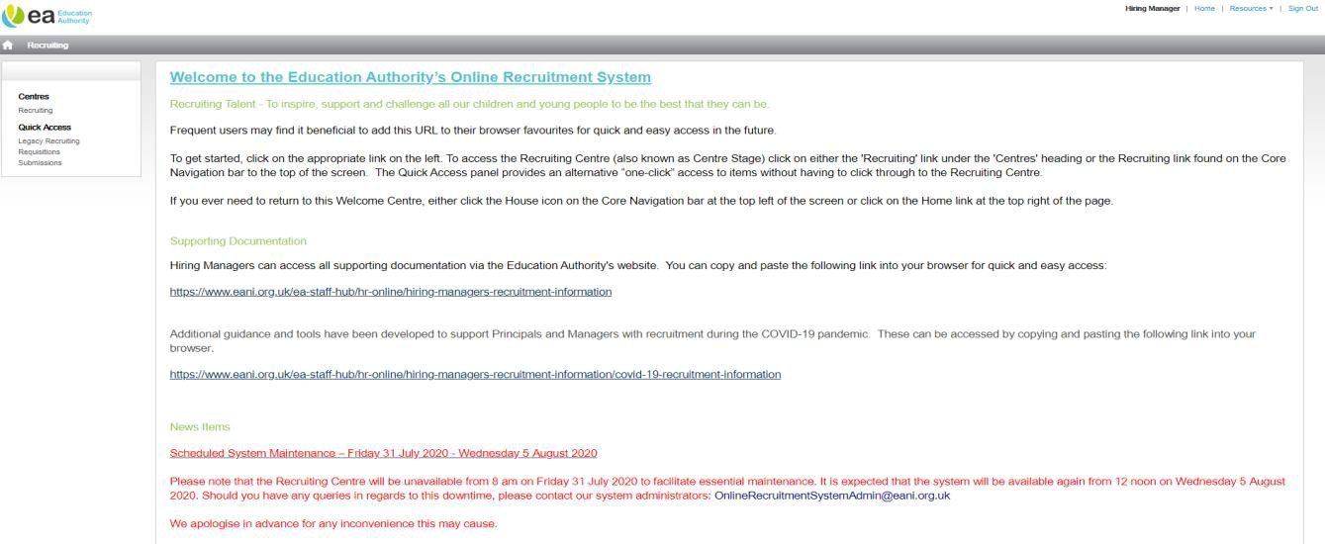

The Recruiting Centre

To access the Recruiting Centre click on either of the **Recruiting** buttons.

**Tip:** The Quick Access panel found on the Welcome Centre provides an alternative “one- click” access to items without having to click through to the Recruiting Centre.

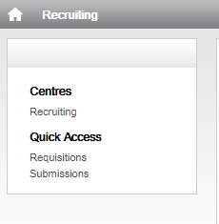

The Hiring Manager’s Recruiting Centre has four channels, **Requisitions**, **Candidates**, **Offers** and

**Tasks**, as shown below:

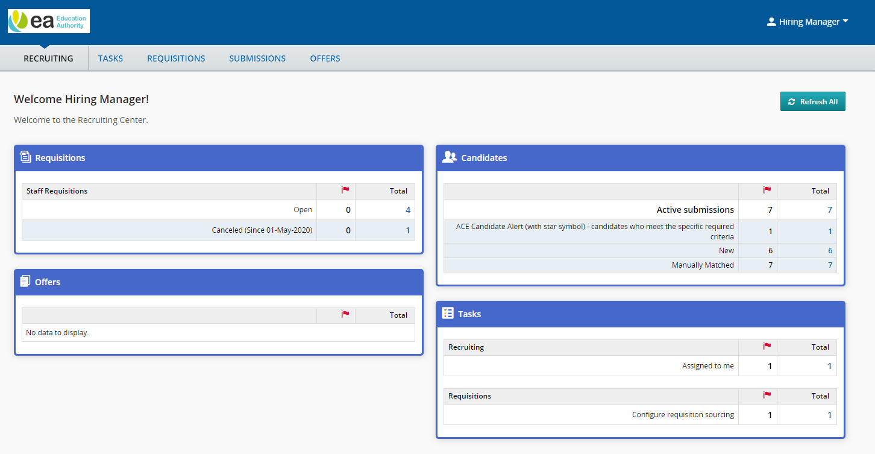

**NB:** You can click these tabs to access any information or items that you are named on as the associated Hiring Manager, Hiring Manager Assistant or Panel Member.

The communications channel

The communications channel can be accessed from the help tab under your user name at the top right of the Recruiting Centre. Within this channel you will find helpful information and supporting documents. This channel will be continually updated with relevant information.

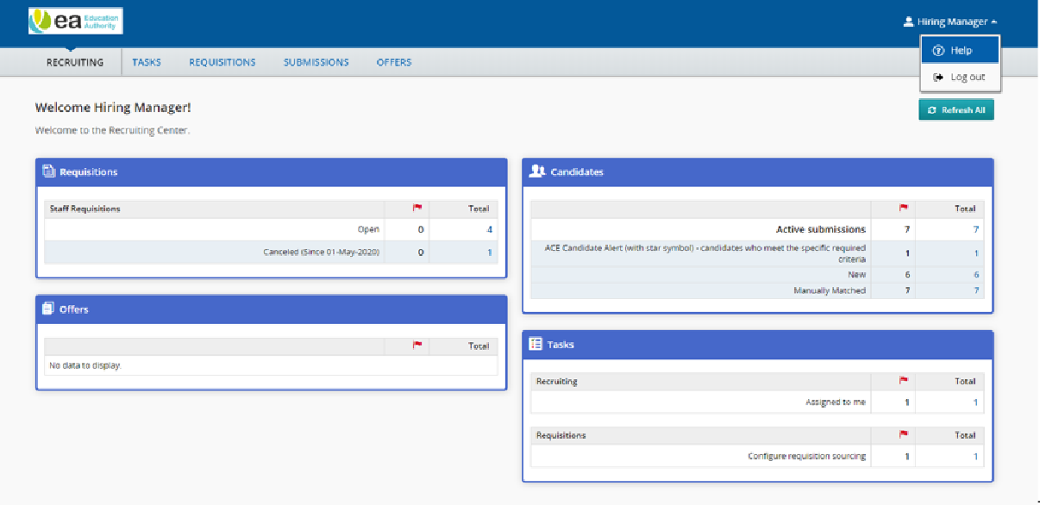

To exit the communications channel, close the tab.

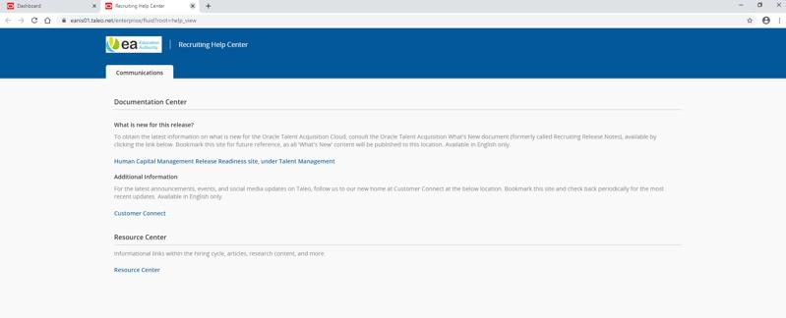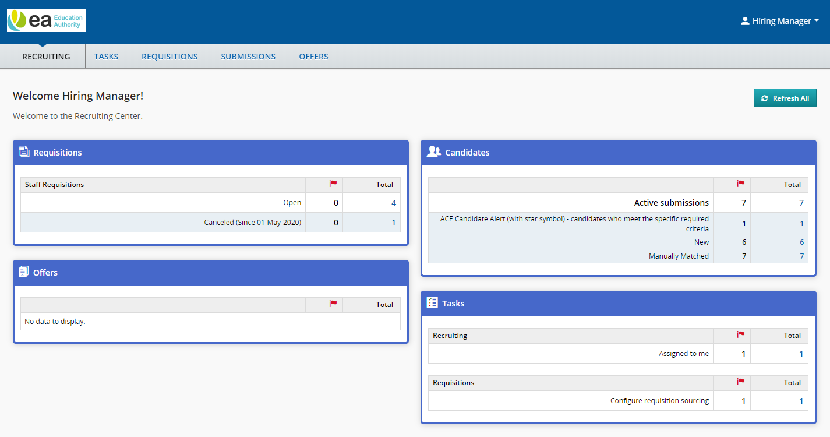

This is a **refresh** button. When pressed, the statistics in the Recruiting Centre will be the most up-to-date. Statistics are also updated immediately after login.

Items listed under the flag column are specific to each user. They represent the items that are new or that have been updated by another user since you last viewed them.

Managing your Account Setup

To edit your account setup, from the recruiting centre, click on your name on the top right hand corner of the screen and then select **Preferences**:

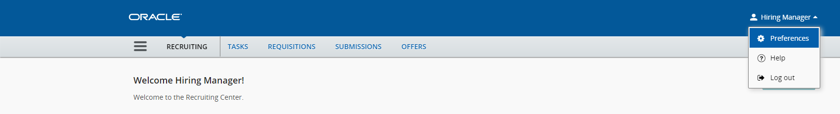

You can access the **My Setup** screen from the Welcome Centre however; you will be provided with a read only overview of your account and will be unable to edit the contents.

On the next screen you will be able to edit your preferences which are split into 4 sections:

1. Requisitions
2. Frequent Panel Members
3. Frequent Approvers
4. General Preferences

Preferences - Requisition

**Tip:** If you always send requisitions to the same Recruiter, add their name to the **Default Recruiter** field. It is also recommended that you add your name to the **Default Hiring Manager** field so that you do not have to manually select this each time you raise a requisition

To edit your requisition preferences, select the **Edit** button.

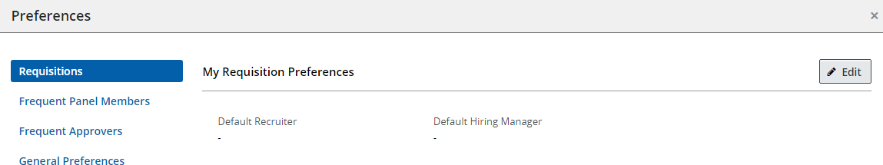

To select your **default recruiter**, you can either type the name of your recruiter in the **Default Recruiter** box and the name will display below the box. You can then hoover over the name and this will populate the recruiter name in the relevant box.

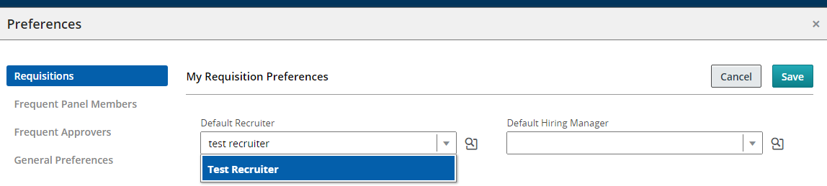

Alternatively, you can search for your recruiter using the

icon.

If you choose to use the search icon to find your recruiters name, clicking the search icon will display the following pop up.

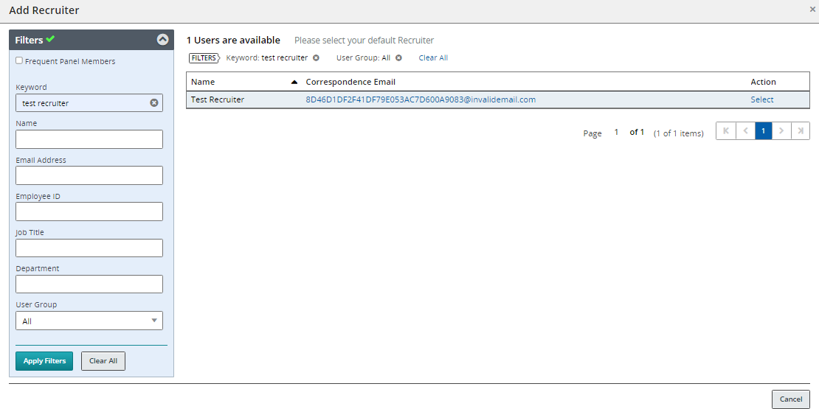

Using the Filters channel, type the recruiter name into the Keyword field and select **Apply Filters.** Your recruiter details will now be displayed in the list. To select your recruiter, use the **Select** button.

The Recruiter field will now be populated.

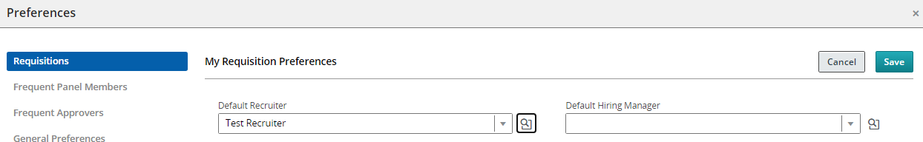

To select your name as the **Default Hiring Manager**, you can either type your name in the **Default Hiring Manager** box and your name will display below the box. You can then hoover over your name and this will prepopulate in the relevant box.

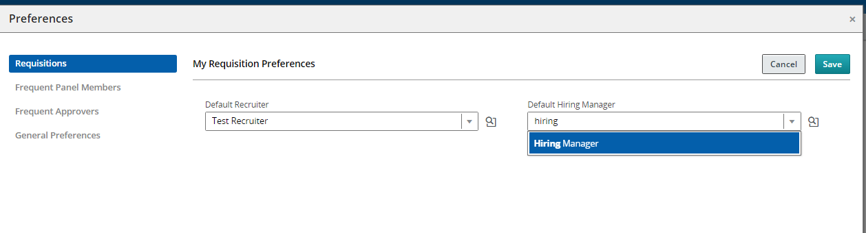

Alternatively, you can search for your name using the

icon.

The following page will be displayed. Using the Filters channel, type your name into the Keyword field and select **Apply Filters.** Your details will now be displayed in the list.

To add your name as the default Hiring manager, use the **select** button.

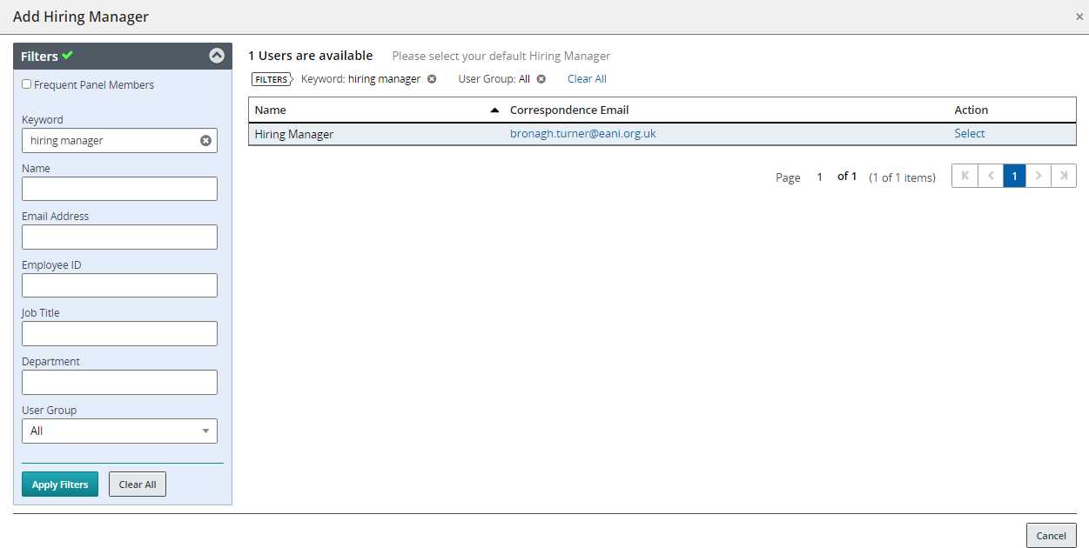

Your name will now be populated in the Hiring Manager field. When you have updated your requisition preferences, select **Save.**

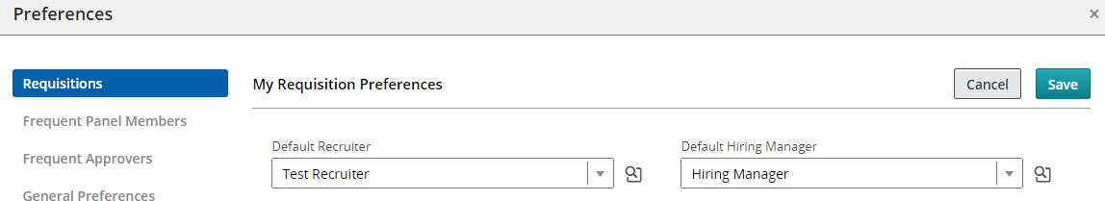

Preferences - Frequent Panel Members

If you are regularly using the same panel member(s) for your recruitment activity, you can add them as frequent panel members so that they can be quickly added to requisitions in the future. To do this, select the **Frequent Panel Members** tab and select the **Edit** button:

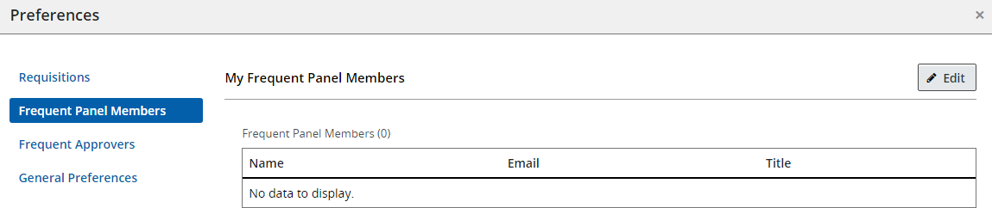

The ‘My Frequent Panel Members’ pop up will be displayed. Select the **Add Panel Members** button.

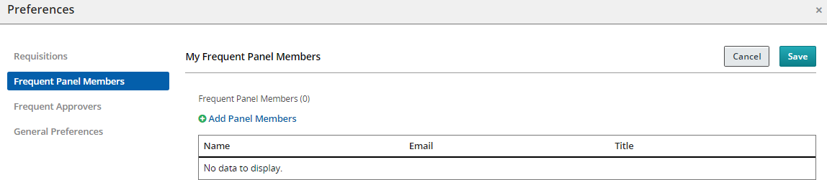

Using the Filters channel, type the name of the panel member you wish to add as your frequent panel member into the Keyword field and select **Apply Filters.**

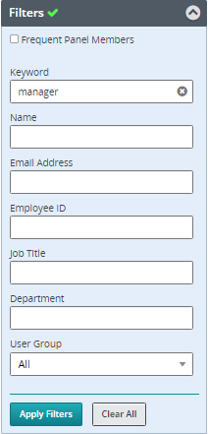

Details will now be displayed in the list.

To select frequent panel members from the list, select the checkbox beside the relevant panel member(s) name then select **Add Panel Members.**

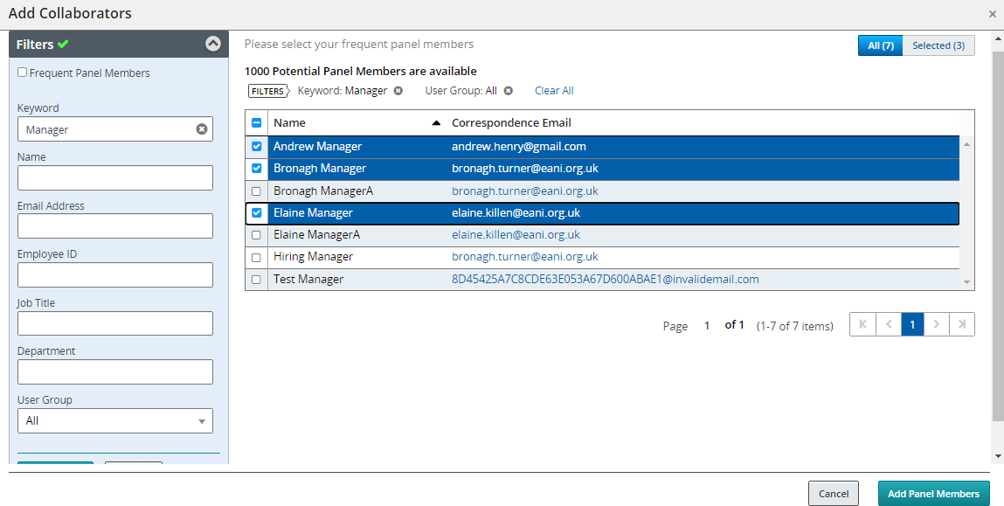

**Tip:** Use the Quick Filters to speed up your search.

The selected panel members will now be added to the list. Select **Save.**

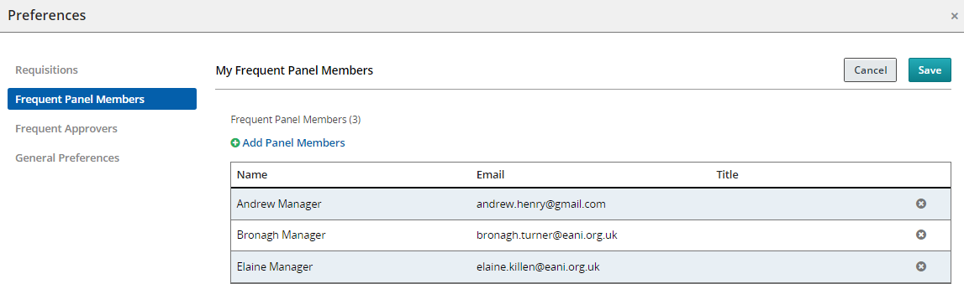

**Tip:** If you have selected a panel member name in error, hover beside their name and an **x** button will appear. Click this to remove the name from the top pane of the pop up.

You will return to the ‘Frequent Panel Members’ page where you will now find the selected names

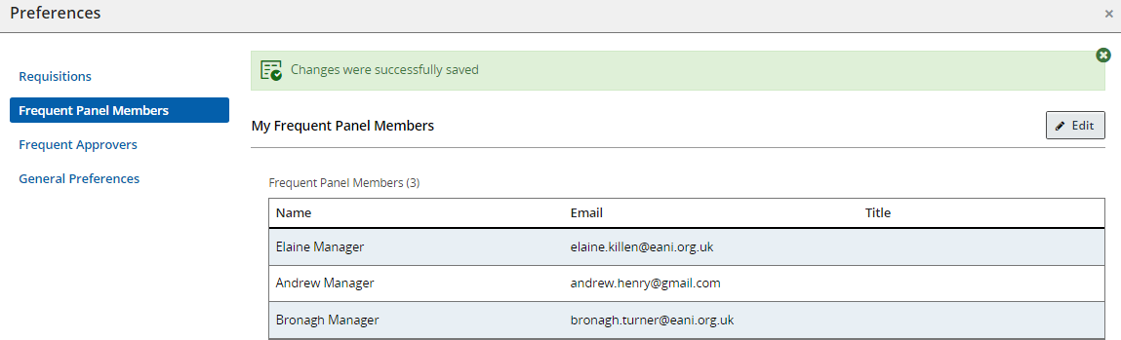

displayed:

To edit your frequent panel members, select the **Edit** button. The ‘Panel

Members’ pop up will be re- displayed and you can remove/edit your selection.

Preferences - Frequent Approvers

If you are regularly using the same approver(s) for your recruitment activity, you can add them as a frequent approver so that they can be quickly added to requisitions in the future. To do this, select the **Frequent Approvers** tab and then select the **Edit** button:

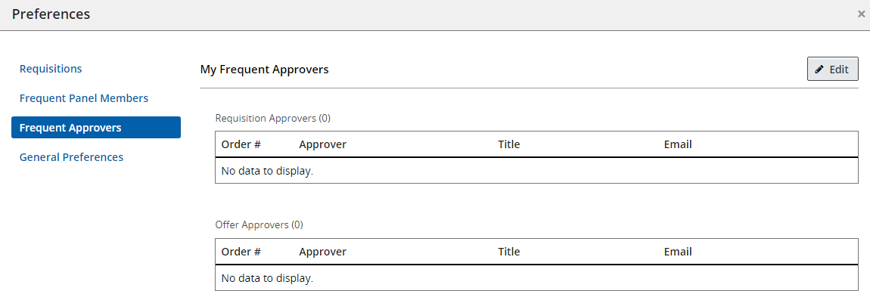

The ‘My Frequent Approvers’ pop up is displayed. Use the **‘Add Requisition Approvers’** button.

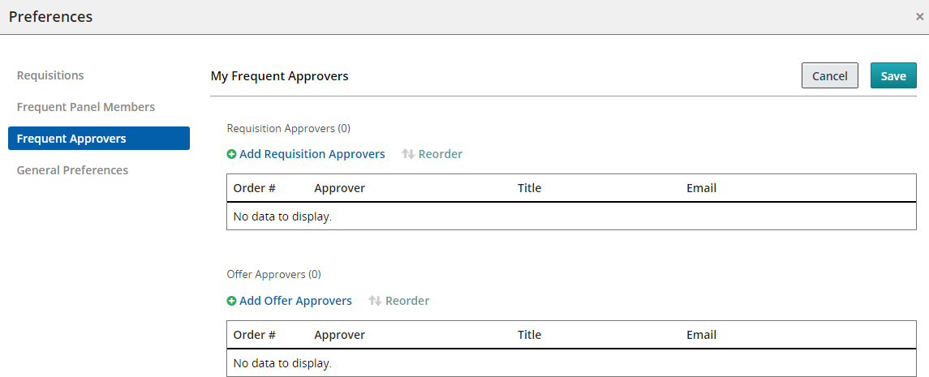

To select frequent approvers from the list, select the checkbox beside the relevant approvers name then select **Add/Update Approvers.**

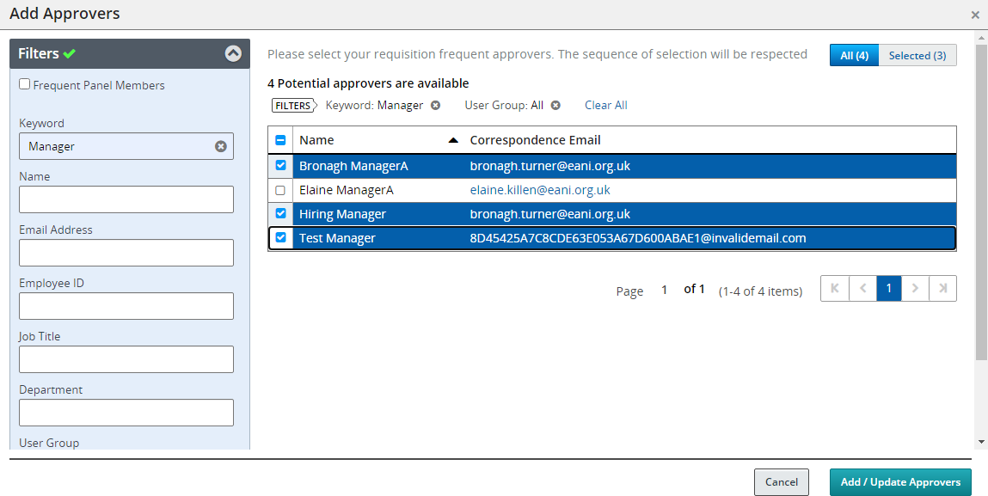

**Tip:** Use the Quick Filters to speed up your search.

The selected approver/s will now be added to the list. Select **Save.**

If you have more than one approver, you can reorder them in the top pane of the ‘Approver’ pop up by selecting the drop down and choosing your preferred order:

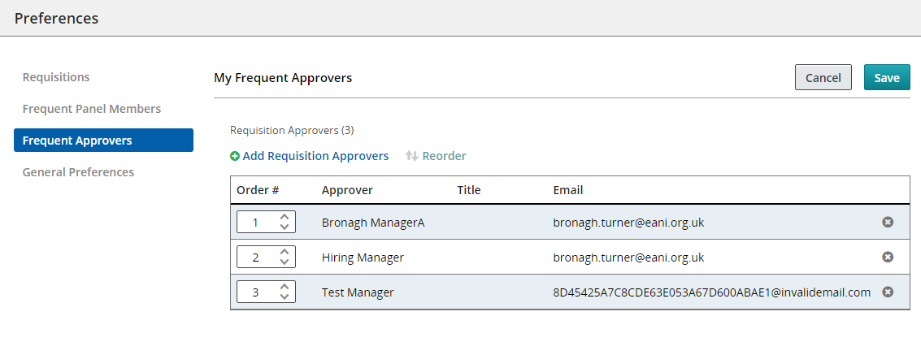

**Tip:** If you have selected an approvers name in error, hover beside their name and an **x** button will appear. Click this to remove the name from the top pane of the pop up.

You will return to the ‘Frequent Approvers’ page where you will now find the selected names displayed:

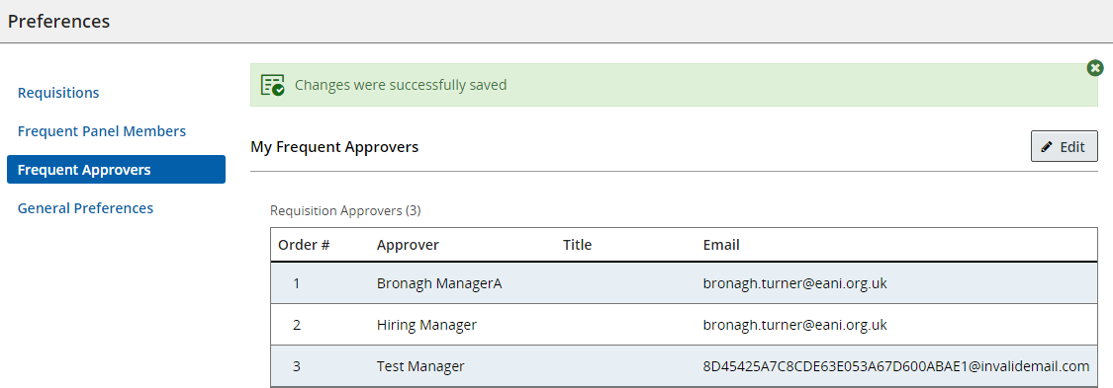

To edit your frequent approvers, select the **Edit** button. The ‘Approvers’ pop up will be re- displayed and you can remove/edit your selection.

Frequent Offers

Please note that the Education Authority do not send offers for approval. This functionality will not be used.

General Preferences

It is recommended that you select to receive the **Workflow Event Notification** and also **Enable eShare Email for Response Centre Access**. This means that you will automatically receive email notifications about approvals, job postings about to expire and notifications when a job posting has closed.

To edit your **General Preferences**, select the **Edit** button.

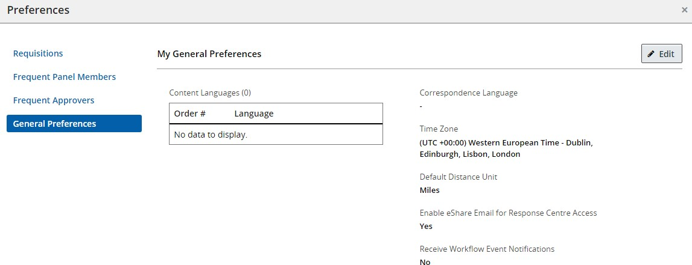

Select the tick boxes beside **Enable eShare Email for Response Centre Access** and **Receive Workflow Event Notifications.**

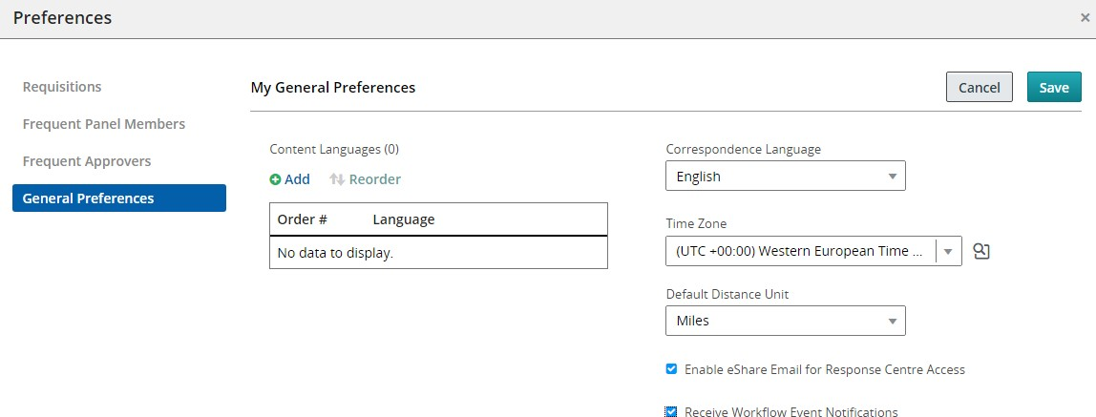

Select **Save.**

You will return to the ‘General Preferences’ page where you will now find your preferences have been updated:

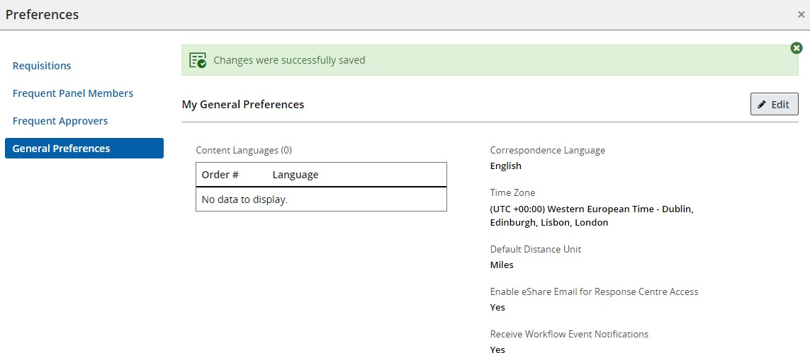

General Navigation Tips

|  |  |
| --- | --- |
| Back and Forward buttons | Do not use the Back and Forward buttons of your internet browser. For security reasons, you may find that the page you are looking for cannot be displayed. |
| Forward button. Display next item on list | A tooltip is a short explanatory text. Access tooltips by hovering over a button, icon, tab etc. More information relating to the area you are hovering over will be shown. |
| Log out icon | Always log out of the system using the **Log Out** button before closing the browser window. If you do not do this, you may find a delay in logging in the next time you launch the website. |
| back to requisition list button | Where displayed, use the **back to** button to take you back to the previous page. |
| back triangle button | Displays the previous page. |
| back to first button | Displays the first page. |
| next button | Displays the next page. |
| last page button | Displays the last page. |
| search button | This is a selector button. Use this to display selection lists throughout the system. |

Icon directory

The online recruitment system uses the following icons throughout the Recruiting Centre to help the user process information quicker and more efficiently:

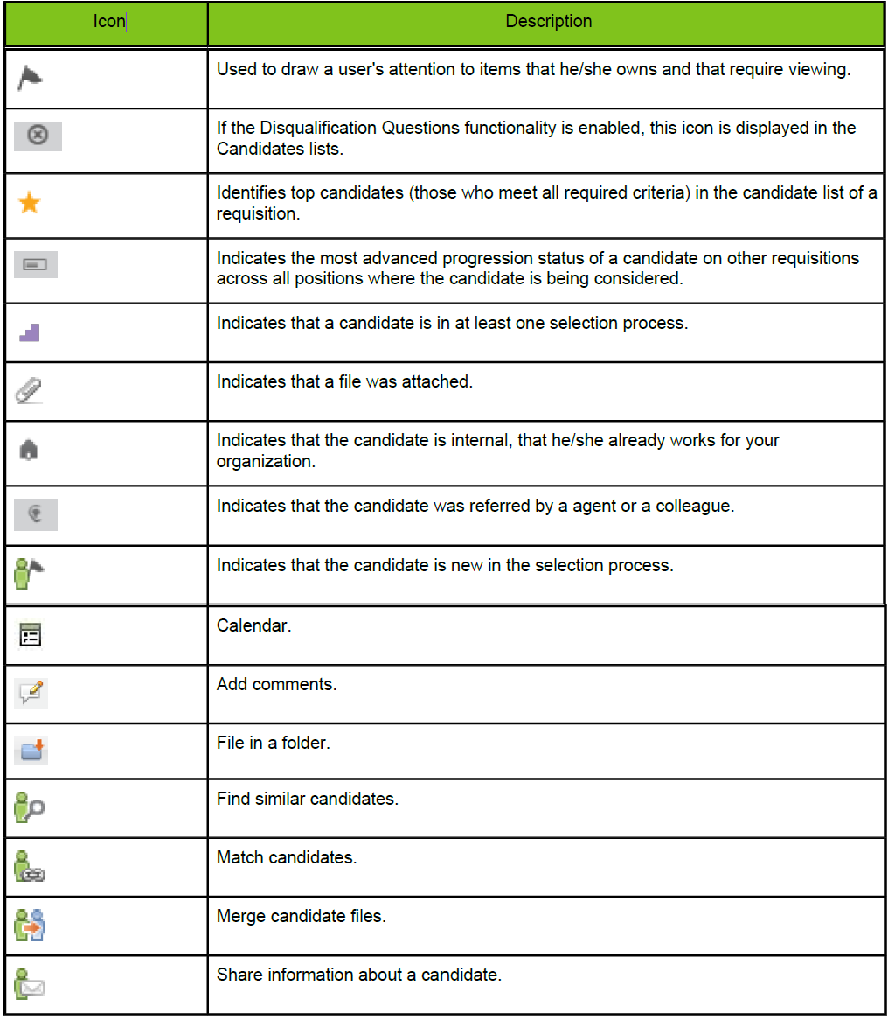

|  |  |
| --- | --- |
| This table shows the icons visible throughout the online recruitment systemexclamation mark in yellow triangle | Signals that a candidate has declared something that requires attention/verification. |
|  |  |

