For Teachers & Principals
Completing an Equal Opportunities Return
NOTE | Please read the below policy guidance carefully before completing your Equal Opportunities return on the system.  Employers of teachers in Northern Ireland are committed to promoting equality of opportunity to all persons regardless of their background. Further information can be found in the TNC 2023/1 Equal Opportunities Policy for Teachers in Schools and the TNC 2023/2 Joint Declaration of Protection.  In this form we ask you to provide some personal information about yourself. We do this for two reasons:  - To demonstrate our commitment to promoting equality of opportunity in employment.  - We monitor the community background and gender of our job applicants and employees in order to comply with the regulations associated with the Fair Employment and Treatment Order (NI) 1998 (as amended). If you answer the questions about community background and gender you are obliged to do so truthfully. If you do not answer the question on community background we are encouraged to use the residuary method of monitoring.  You aren’t obliged to answer any/all questions and you won’t suffer any penalty if you choose not to.  Access to this information is strictly controlled by the provisions of the Fair Employment and Treatment Order and the Data Protection Act. Monitored data does not disclose any individual identities. Information will only be used to monitor the effectiveness of Equal Opportunities Policies and comply with obligations relating to requirements of the Fair Employment and Treatment Order and other equality legislation applicable in Northern Ireland. Both EA and CCMS are obliged to comply with the UK General Data Protection Regulation when processing your personal information. Further information is detailed in the respective websites: https://www.eani.org.uk/about-us/privacy/ea-privacy-notices; https://www.ccmsschools.com/page/Data-Protection-Privacy-Notice/60350/Index.html
1 | If you have one of the below responsibilities you are now able to complete and update your Equal Opportunities return on Oracle:  - DE Permanent Teacher Self-Service  - DE Principal and Temporary Teachers Self-Service (for Principals and Temporary Teachers on the month-end payroll)  - DE Temporary Teachers Self-Service (for Temporary Teachers on the mid-month payroll)  If you have completed an Equal Opportunities return previously, this may already be on the system.  On the Oracle homepage, select the relevant responsibility on your account. Then click My Information and Equal Opportunity Monitoring Data.  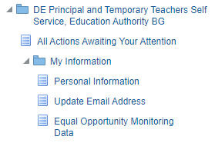
2 | This will open the Equal Opportunities Return menu. Depending on your circumstances, the form will be slightly different.  - The Section 75 Equal Opportunities return, used for DE-paid Teaching staff in EA and CCMS schools.  - Fair Employment return (asking for only gender and community background), used for DE-paid teaching staff in all other schools. If this applies to you, you are only asked to complete the questions on gender and community background.  - All fields are optional, and you are not obliged to answer questions you do not wish to, and will suffer no penalty for doing so  - If you have an existing Equal Opportunities return on the system, the details of this will appear here.  To complete your return, or update an existing return, click the Update button.  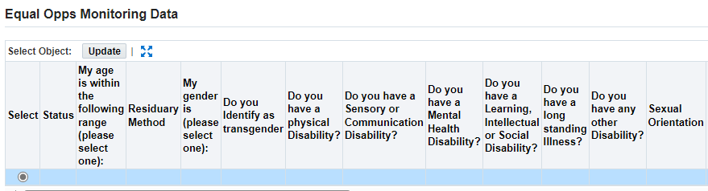
3 | This will open the form. Each question is a drop-down menu, and no question is mandatory.  Fill out the form as required:  Example Section 75 return  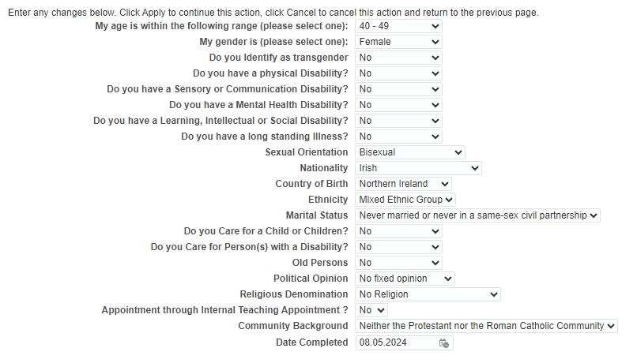  Example Fair Employment return:  Note – to get the Community Background dropdown to appear, you will need to set the Appointment through Internal Teaching Appointment field to No.  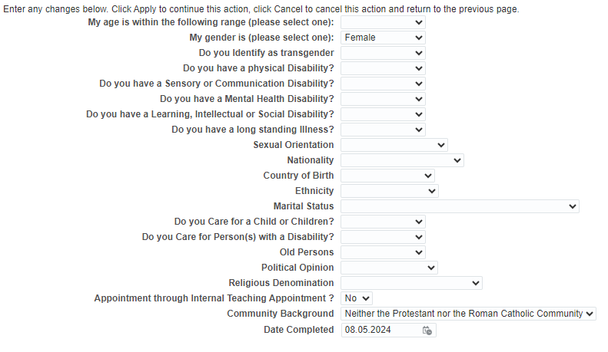
4 | Once you have completed or updated your form, click Apply in the top right of the screen.  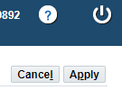  This will then add the draft return to your record. To submit this, click Next on the top right of the next screen.  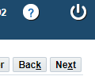
5 | You can review the information before you submit it.  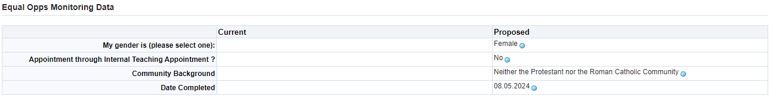  If you need to update any information after reviewing this, repeat the previous steps to amend the form.  Once you are content with the return, click the submit button in the top-right of the screen. This will complete your equal opportunities return.  