

Requesting Requisition Approval

To send a Requisition Form for approval you must have drafted and saved the requisition. There are 2 ways of doing this:

1. By clicking on this iconThe Send for Approval icon.along the top of the requisition or
2. From the drop down in the **More Actions** menu and then select **Submit for approval**

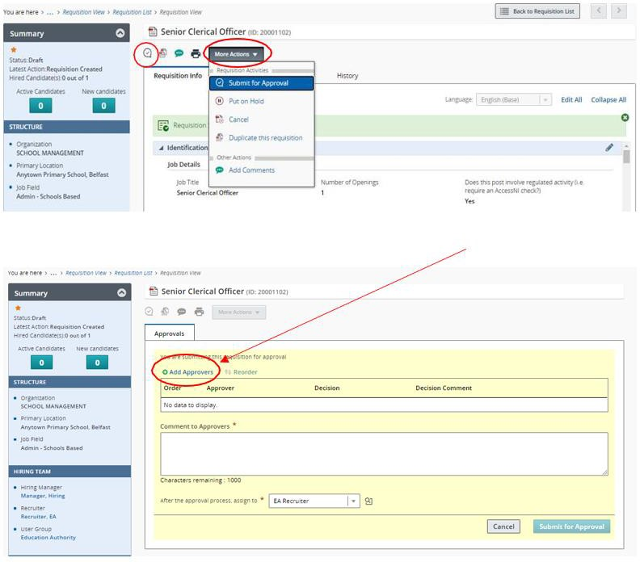

This approvals page is then displayed. To select your approver, click the **Add Approvers** link.

The user list is then displayed. You can use the filters to assist you with your search.

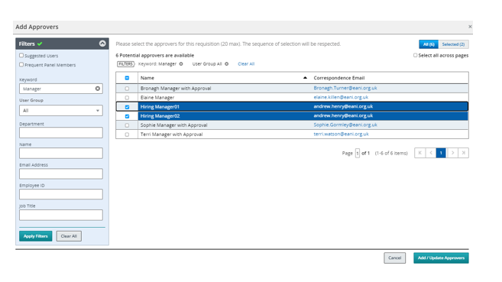

When you have identified the relevant approver(s) from the list, click the checkbox to the left of their name and then click **Add/Update Approvers.** NB. You can add up to 20 approvers to a requisition.

If you are unsure who your approver is, please refer to the relevant appendices.

Appendix 1 – Approval Routes School Based SEN positions as of 29.6.24

Appendix 2 – Approval Routes Corporate positions as of February 2024

When all relevant approvers have been added you can re-order the sequence to reflect the order that you require approval.

# Please ensure that you add your Resourcing Team as your approver or final approver. This will ensure that the Team Lead receives an approval notification and can pass your requisition on to your recruiter to begin working on your advert. If you do not do this, there may be a delay in your advert being processed.

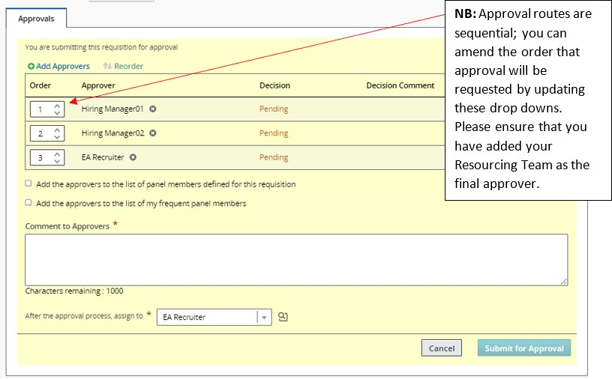

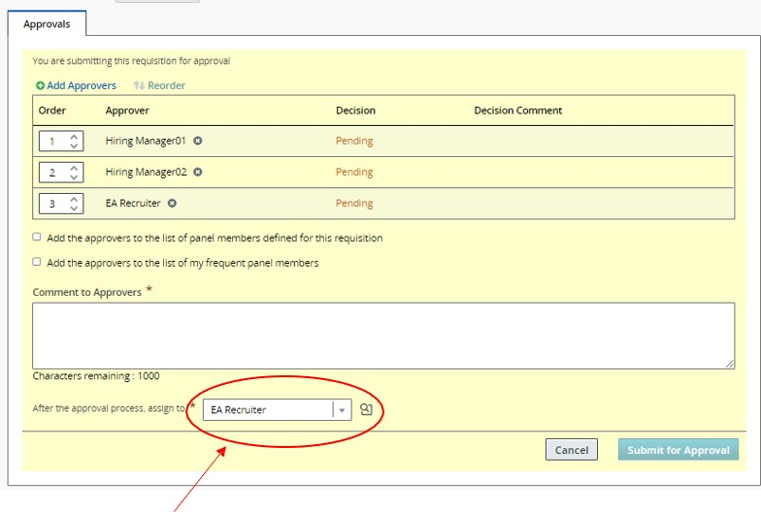

Verify that this field is also populated with the relevant Resourcing Team to whom the Requisition should be tasked to when approved (NB: Relevant Resourcing Teams are explained below):

|  |  |  |  |  |
| --- | --- | --- | --- | --- |
|  | **School Based Teams** | | **Corporate & EA Managed Roles** | |
| **Team** | **Teaching Team** | **Non-Teaching Team** | **EA Managed Frontline Team** | **Corporate Team** |
| **Roles** | * School Leadership roles * School-based teaching roles * EA Service teaching roles | * Classroom Assistant roles (including SEN) * Specialist Provision * All other school managed non-teaching roles | * Catering Services * Cleaning Services * Transport Services | * EA Corporate Professional/Admin Roles * Youth Services |

Add a comment to your approver and click **submit for approval.**

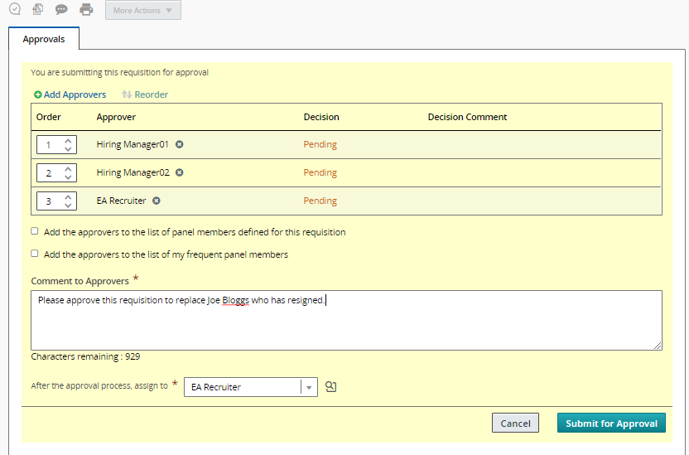

You will return to the requisition where the Status in the summary card will be updated to **Pending – To be approved.**

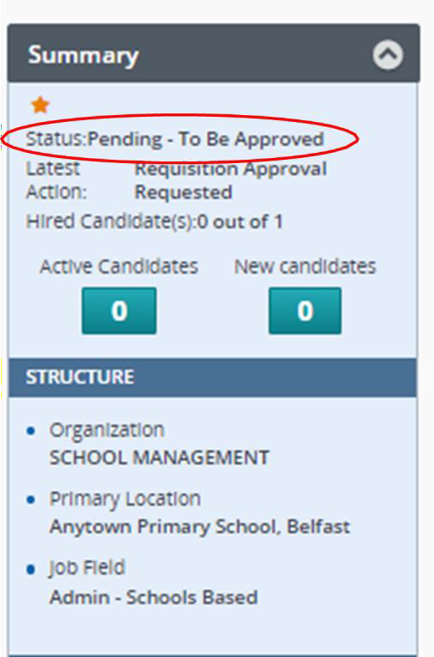

To return to your requisition list, press the **back to requisition list button.** Alternatively, use the arrows to view other requisitions you own or assist with.

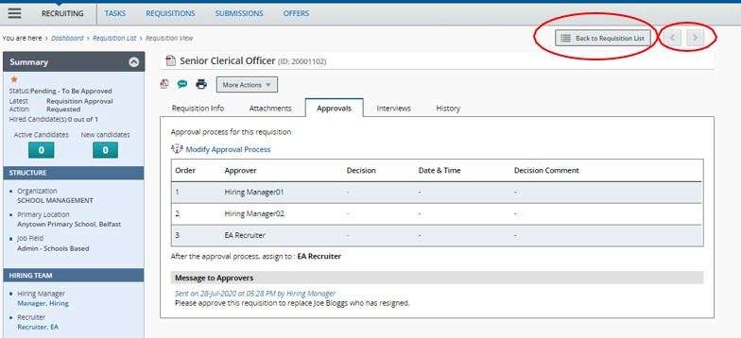

Appendix 1 - School Based Approval Routes – SEN Positions as of 3.4.24

All Teaching and Non Teaching posts in Special Schools/Specialist Provisions attached to a mainstream school **must** be approved by the relevant Budgetary Support Officer within CYPS before the Recruiter can progress your requisition.

# Special Schools

**Approval Route – Requisition raised by Hiring Manager (Principal)**

|  |  |
| --- | --- |
| 1st Approver | Budgetary Support Officer – Children and Young People Services (CYPS)* |
| 2nd Approver | Your Resourcing Team * |

**Approval Route – Requisition raised by Hiring Manager Assistant (Principal’s nominee)**

|  |  |
| --- | --- |
| 1st Approver | Principal |
| 2nd Approver | Budgetary Support Officer - Children and Young People Services (CYPS)* |
| 3rd Approver | Your Resourcing Team * |

**\*Budgetary Support Officer**

|  |  |  |
| --- | --- | --- |
| **Schools** | | **Named Officer** |
| Cedar Lodge | Killard | **Catherine Hull** |
| Clarawood | Longstone |
| Clifton | Mitchell House |
| Fleming Fulton | Oakwood |
| Glenveagh | Park |
| Greenwood House | St Gerard’s |
| Harberton | Tor Bank |
| Ardnashee | Lisanally | **Bernie Donnelly** |
| Arvalee | Parkview |
| Brookfield | Rathore |
| Ceara | Rossmar |
| Donard | Sperrinview |
| Kilronan | Willowbridge |
| Knockavoe |  |
| Ardmore | Lakewood | **Jennifer McElroy** |
| Beechlawn | Riverside |  |
| Belfast Hospital | Roddensvale |  |
| Castle Tower | Rosstulla |  |
| Hillcroft | Sandelford |  |
| Jordanstown | Thornfield |  |
| Knockevin |  |  |

**Specialist Provisions attached to mainstream schools.**

**Approval Route – Requisition raised by Hiring Manager (Principal)**

|  |  |
| --- | --- |
| 1st Approver | Budgetary Support Officer (Children and Young People Services (CYPS) -  **Maria Feeney/Katherine Gibson** |
| 2nd Approver | Your Resourcing Team * |

**Approval Rout****e – Requisition raised by Hiring Manager Assistant (Principal’s nominee)**

|  |  |
| --- | --- |
| 1st Approver | Principal |
| 2nd Approver | Budgetary Support Officer Children and Young People Services (CYPS) -  **Maria Feeney/Katherine Gibson** |
| 3rd Approver | Your Resourcing Team * |

**Learning Support funded positions (SEN) in mainstream schools**

**The provision letter must be attached to the requisition.**

**Approval Route – Requisition raised by Hiring Manager (Principal)**

|  |  |
| --- | --- |
| 1st Approver | Your Resourcing Team * |

**Approval Route – Requisition raised by Hiring Manager Assistant (Principal’s nominee)**

|  |  |
| --- | --- |
| 1st Approver | Principal |
| 2nd Approver | Your Resourcing Team * |

**\* Resourcing Teams**

|  |  |  |
| --- | --- | --- |
| **Resourcing Teams** | **Recruiter Name** | **Coverage Areas:** |
| **Teaching Resourcing Team** | Teaching Resourcing Team | EA Wide |
|  | | |
| **Non Teaching Resourcing Team** | Non Teaching Resourcing Team | EA Wide |
|  | | |

Appendix 2 – Approval Routes Corporate positions as of February 2024

**The approval routes detailed below will apply to corporate positions and agency staff.**

**The approval route for all front-line service positions**

Front line services are defined as community-based services providing operational delivery. If you are uncertain whether the post you are seeking to fill is core or front line, please contact your Business Support Manager.

|  |  |
| --- | --- |
| 1st /2nd Approver | Head of Service (Where nominated) * |
| Director (New Post) or Assistant Director (Replacement Post) |
| 3rd approver | Front Line Resourcing Team |

# The approval route for non-front-line service (HQ positions) must comply with the EA Protocol as detailed below:

HQ services are defined as core services across all budget lines which support the delivery of front-line services.

|  |  |
| --- | --- |
| 1st /2nd Approver | Head of Service (Where nominated) * |
| Director (New Post) or Assistant Director (Replacement Post) |
| 3rd Approver | Corporate Resourcing Team |

* Heads of Service in the larger directorates/functional areas have been nominated and are required to be selected as the 1st approver.

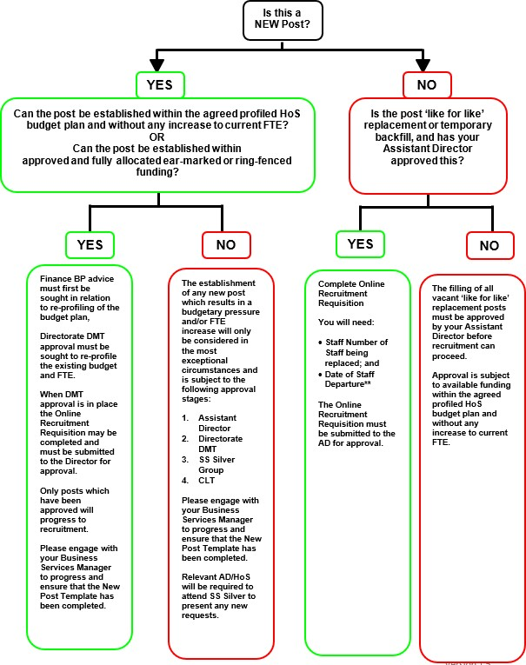

# GUIDANCE NOTES:

The EA Recruitment Protocol has been endorsed by the Savings and Sustainability Silver Group and EA Corporate Leadership Team and is a key component of financial grip and control within EA. The protocol recognises that increases in FTE are a key cost driver across all EA services and it is designed to ensure that there is financial control over movements in FTE.

Proposals for increases to FTE which create a funding pressure will not be approved unless business criticality or invest to save outcomes can be demonstrated.

In all circumstances where a new post is being established, either through re-profiling of the current budget plan, through ear-marked or ring-fenced funding or as an approved pressure, Finance Business Partner advice must be sought and fully documented in the New Post template.

# The protocol applies to:

* + **All headquarters budget holders** who wish to fill posts on a temporary, fixed term or permanent basis. *HQ services are defined as core services across all budget lines which support the delivery of front-line services.
  + **Irrespective of the method of filling the post** e.g. temporary engagement, internal trawl, acting- up, external recruitment or agency worker. Please note that temporary engagement forms are normally used as a mechanism to ensure timely payment of frontline staff. Where, in exceptional circumstances, a temporary engagement form is required to engage a member of Headquarters staff, this requires senior approval as set out on page 1 of this protocol.
  + **Posts funded by ring-fenced and ear-marked funding** streams where there is **approved and allocated full funding.** Posts should only be filled in line with the reason for/duration of the earmarked funding.
  + \*\***Replacement ‘like for like’ posts or temporary backfill** irrespective of date of staff departure.
  + **New Posts** proposed as part of an approved business case require Recruitment Protocol approval before recruitment can proceed.

# The protocol does not apply to:

* + **Frontline service posts**. Front line services are defined as community-based posts providing operational delivery for example Youth Workers, Catering, Cleaning, Transport, Pupil Support and EOTAS. If you are uncertain whether the post you are seeking to fill is core or front line, please contact your Business Services Manager.
  + **Temporary to Permanent requests relating to Headquarters staff** where HR/Legal advice has been sought and it has been confirmed that the staff member has a right to permanency under the Fixed Term Worker Regulations, **unless this requires the establishment of a new post and/or creates a new funding pressure**.

It is the personal responsibility of all budget holders to ensure that they comply with the spirit of the recruitment protocol in filling posts.

Recruitment activity will be reported through the Directorate Accountability Forum and compliance with the protocol will be reviewed at regular intervals throughout the year.

Any financial queries on the implementation of the protocol should be addressed to your directorate Finance Business Partner. Any specific HR queries should be addressed to the Relevant Resourcing Team.