

**Teachers Self-Service Handbook**



|  |
| --- |
| **Introduction**  This Handbook covers key areas of Teachers’ Self-Service, available to Teachers and Principals. It provides step-by-step guides to completing core processes along with best practice advice and a series of frequently asked questions.  If you cannot find the answer you are looking for in this handbook, contact the EA One helpdesk. Your query will be forwarded to a member of the team who will be happy to assist you. Contact details are:   * **Email:** [EAOneHelpdesk@eani.org.uk](mailto:EAOneHelpdesk@eani.org.uk) * **Phone:** 02890 418 060   For policy queries, please contact the DE Teachers’ Pay Team on the appropriate email for your region:  General payroll related queries - [teachers.pay@education-ni.gov.uk](mailto:teachers.pay@education-ni.gov.uk) Western Section - [westernsection@education-ni.gov.uk](mailto:westernsection@education-ni.gov.uk) Southern Section - [southernsection@education-ni.gov.uk](mailto:southernsection@education-ni.gov.uk) South Eastern - [southeasternsection@education-ni.gov.uk](mailto:southeasternsection@education-ni.gov.uk) North Eastern - [northeasternsection@education-ni.gov.uk](mailto:northeasternsection@education-ni.gov.uk) Belfast - [belfastsection@education-ni.gov.uk](mailto:belfastsection@education-ni.gov.uk) Temporary - [temporarysection@education-ni.gov.uk](mailto:temporarysection@education-ni.gov.uk) |

|  |
| --- |
| Contents  What is Teachers’ Self-Service? 3  DE Policies 3  Best practice 3  4  [Using Teachers Self-Service 4](https://elb-my.sharepoint.com/personal/mereditha_eani_org_uk/Documents/Teachers%20Self-Service%20Handbook%20v1.0.docx#_Toc151469021)  [How to access forms 4](https://elb-my.sharepoint.com/personal/mereditha_eani_org_uk/Documents/Teachers%20Self-Service%20Handbook%20v1.0.docx#_Toc151469022)  [Common Guidance 6](https://elb-my.sharepoint.com/personal/mereditha_eani_org_uk/Documents/Teachers%20Self-Service%20Handbook%20v1.0.docx#_Toc151469023)  [How to view Historical EA One Self-Service information 10](https://elb-my.sharepoint.com/personal/mereditha_eani_org_uk/Documents/Teachers%20Self-Service%20Handbook%20v1.0.docx#_Toc151469024)  [How to approve a self-certification 12](https://elb-my.sharepoint.com/personal/mereditha_eani_org_uk/Documents/Teachers%20Self-Service%20Handbook%20v1.0.docx#_Toc151469025)  [How to View P60 13](https://elb-my.sharepoint.com/personal/mereditha_eani_org_uk/Documents/Teachers%20Self-Service%20Handbook%20v1.0.docx#_Toc151469026)  [How to Update Bank Details 14](https://elb-my.sharepoint.com/personal/mereditha_eani_org_uk/Documents/Teachers%20Self-Service%20Handbook%20v1.0.docx#_Toc151469027)  [How to View an Employee Payslip 15](https://elb-my.sharepoint.com/personal/mereditha_eani_org_uk/Documents/Teachers%20Self-Service%20Handbook%20v1.0.docx#_Toc151469028)  Frequently Asked Questions 16  Glossary – Teachers Self-Service Definition List 17  Teachers Self-Service Elements 17 |

|  |  |
| --- | --- |
| What is Teachers’ Self-Service? Teachers’ Self-Service is a key component of EA One, with the purpose of:   * Enabling you to make updates to your personal, contact and bank details easily * Providing digital payslips * Enabling you to self-certify short absences digitally   The **Teachers’ Self-Service** functionality includes:   * Updating ‘My Information’ which will include information such as; * Personal Information * Job Details * Updating ‘Payroll Information’ which will include information such as; * Online Payslips * Bank Details * P60 * Mileage Claims * Updating ‘Absence Information’ which will include information such as; * Self-Certification * Viewing Absence History  DE Policies This form of Self-Service is well established in other parts of public sector in Northern Ireland including Health and Central Government. When using the new Teachers’ Self-Service facilities within Oracle, you will need **adhere to the various DE policies** that are currently in place.  When submitting **Self-Certifications** on the system, please ensure that you review the **TNC 2008 Teacher Attendance Procedure – Section 3.7** which can be found [here](https://www.education-ni.gov.uk/sites/default/files/publications/de/tnc-2008-2-teacher-attendance-procedure.pdf). Specifically, **online Self-Certificates can only be used for sickness absence for a maximum of seven calendar days.** Anything longer requires a doctor’s note. Best practice We have compiled some top tips for using Teachers’ Self-Service that you should be aware of. By following these tips, it will help ensure that you are using the system correctly and efficiently.  **Input information on time**  It is important to fill out Self-Service forms on time to ensure information is accurate. For example, where possible you should submit a self-certification the day you return work.  **Keep personal information up to date every six months**  To keep information accurate, it is recommended you review personal data every six months. For example, changing your address if you have moved house recently.  **Review and approve requests as they appear in your worklist**  For managers, to support your staff you should review and approve requests as they appear in your worklist. You will receive email notifications when a request needs approved.  **Read the common guidance for Teachers’ Self-Service forms**  All Self-Service forms follow a similar design and user path. To ensure that you have the confidence to complete forms with ease, please read the ‘Common Guidance’ section in this handbook. |  |

# 

# Using Teachers Self-Service

## How to access forms

|  |  |
| --- | --- |
| **1** | On the Oracle homepage, select the **Teachers Self-Service, Education Authority BG** responsibility.  Example of the Oracle Homepage, featuring Teachers Self-Service on the bottom-left of the screen. |
| **2** | After selecting the responsibility you can now view the drop-down menu from which you will access EA One Self-Service forms. The screenshot below shows the **My Information** tab**,** from this tab you can access the following forms:   * Personal Information * Assignment Details and Assignmen History   Overview of the My Information section of Teachers Self Service, covering the Personal Information and Assignment Details & Assignment History options. |
| **4** | The screenshot below shows the **Payroll Information** tab**,** from this tab you can access the following forms:   * DE Online Payslip * DE Online P60 * Assignment Level Payslip * Bank Details * P60 * Mileage Claims   Overview of the Payroll Information option, including DE Online Payslip, DE Online P60, Assignment Level Payslip, Bank Details, P60 and Mileage Claims. |
| **5** | The screenshot below shows the **Absence Information** tab**,** from this tab you can access the following forms:   * Self-Certification * Absence History   Overview of the Absence Information option, including Self Certification and Absence History. |

Using Teachers Self-Service

## Common Guidance

|  |  |
| --- | --- |
| **1** | All Self-Service forms follow a similar design and user path. In this example, we are using the Self Certification form to demonstrate common guidance when accessing these forms.  When you click ‘Self-Certification’ from the Absence Information drop down, this screen will be displayed. Any previous Self-Certification submissions you have on record will be listed here. To submit a new Self-Certification, click **Add**.  Overview of the Self-Certification homepage, detailing out an example of the user interface to a common Self-Service process. A short-term absence note is the feature of this example. |
| **2** | Begin to fill out the form. Fields marked with an **asterisk (*)** are **mandatory** and must be entered when completing any Teachers Self-Service form. When you get to the **Absence Reason** field, click the **search icon** (indicated below).  Example of the self-certification form, where the dates of absence are filled out. A magnifying glass in the Absence Reason field is highlighted. |
| **3** | Upon clicking the search icon in any Self-Service form, the search window will open. Click **Go.**  Example of Search and Select screen, featuring the Go button to look up Absence Reasons. |
| **4** | Upon clicking Go, a list of options will appear. In this case, a range of absence reasons will be displayed for the self-certification form. Select the most appropriate one for your circumstances and click **Select**.  Example of the selection of an Absence Reason. In this example, Cold, Cough, Flu, Influenza is selected. The Select button is also highlighted in the top-right of the screen. |
| **5** | Complete the rest of the dropdown fields as required. Once everything is complete on the form, click **Apply**.  The fully completed self-certification form. The Apply button is also highlighted in the top-right of the screen. |
| **6** | Once Apply is clicked, the information from the form will be recorded on the system. For Self-Certification the absence will be recorded. To confirm it, click **Next**.  An example of the draft form being summarised in the Self-Certification homepage. The Next button is also highlighted in the top-right of the screen. |
| **7** | A review page will be displayed. Check the information entered so far and upload any supportive evidence such as a doctor’s certificate. To upload documents, click the **“+”** button(inidicated below).  Once you are content to submit, click the **Submit** button.  An example of the review page where users can submit their self-certification note. The Submit button is highlighted in the top-right of the screen, and the green plus/attach button is highlighted in the bottom-left of the screen. |
| **8** | A confirmation message will be displayed informing you that your EA One Self-Service form has been sent to your line manager for approval. You can now exit the system.  An example of the confirmation message the user receives when they submit the note. |

Using Teachers Self-Service

## How to view Historical EA One Self-Service information

|  |  |
| --- | --- |
| **1** | In this example we are using self-certification and how to view your absence history.  On the Oracle homepage, select the **Teachers Self-Service, Education Authority BG** responsibility.  Example of the Oracle Homepage, featuring Teachers Self-Service on the bottom-left of the screen. |
| **2** | After selecting the responsibility you can now view the drop-down menus available. For Self-Certification select **Absence Information** and then **Self-Certification**.  Overview of the Absence Information option, including Self Certification and Absence History. In this example, the former two are highlighted. |
| **3** | The Self-Certification screen will then be displayed, showing a history of all your absences logged in the system. **Repeat this process for other Teachers Self-Service forms within both ‘My Information’ and ‘Payroll Information’.**  Overview of the Self-Certification homepage, detailing out an example of the user interface to a common Self-Service process. A short-term absence note is the feature of this example. |

Using Teachers Self-Service

## How to approve a self-certification

|  |  |
| --- | --- |
| **1** | Any self-certification requests will appear in your worklist in the centre of your screen. To view one of these, click on it.  An example of a received request from a Teacher, in this case for a Self-Certification. This is highlighted at the bottom of the screen. |
| **2** | Review the details of the request, and **Approve** if everything is correct.  If any details are missing/incorrect, **Reject** the claim and advise the employee to submit it again.  An example of the Review page of the request, detailing out the absence details in this example form. The Approve and Reject buttons are highlighted in the bottom-right of the screen. |

A quick reference overview of how to view P60s. This is a 3-step process:
1. Select Teacher Self Service on the Oracle homepage
2. Select Payroll Information, then P60
3. This will open the P60 screen; select the appropriate tax year for the P60 and then click View Report.

Using Teachers Self-Service

## How to View P60

A quick reference overview of how to update bank details. This is a 5-step process:
1. Select Teacher Self Service on the Oracle homepage
2. Select Payroll Information, then Bank Details
3. This will open the Define Payments screen; select the Pencil logo to update bank details
4. Update the bank details accordingly on the page that opens and then click Apply.
5. Review the details to double check they are correct, then click Submit.

Using Teachers Self-Service

## How to Update Bank Details

## How to View an Employee Payslip

Using Teachers Self-Service

A quick reference overview of how to view a payslip. This is a 5-step process:
1. Select Teacher Self Service on the Oracle homepage
2. Select Payroll Information, then DE Online Payslip
3. This will open the most recent payslip. To view a different month, use the Choose a Payslip dropdown menu and then click Go.
4. To print a payslip, use the Settings and More icon on your web browser, then click Print.
5. You can either print or convert to PDF. Select the appropriate open, then click Print or Save accordingly.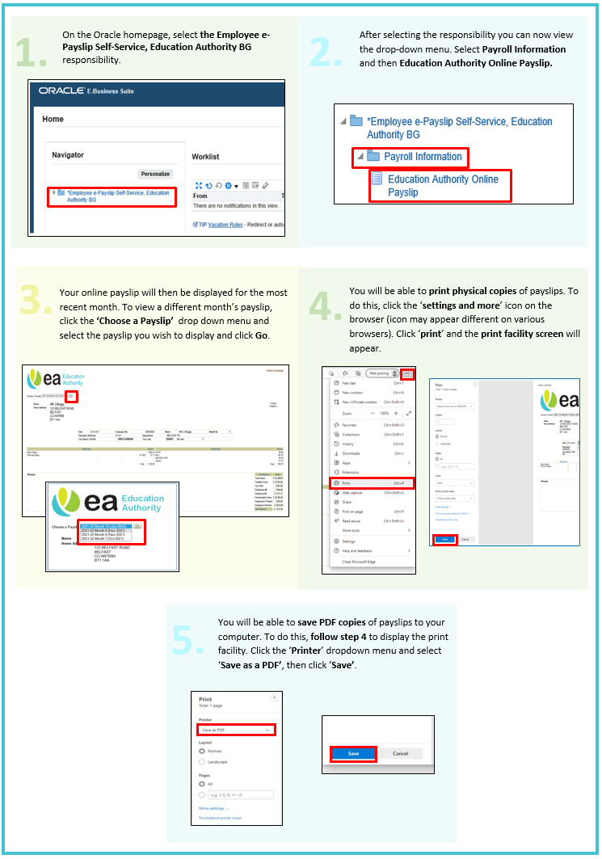

|  |
| --- |
| Frequently Asked Questions ***Why do I have both EA Employee Self Service and Teachers Self Service on my account?***  If you are a teacher, but also work in an additional EA-paid post for your school such as Extended Schools, you will have both options. This is because you are technically employed by two different authorities. Your payslip for your teaching post will be through Teachers Self Service, and the payslip for your additional post(s) at the school will be through EA Employee Self Service.  ***I need to view historic payslips from the previous system. How do I do this?***  All payslips from November 2023 onwards will be available from the new Oracle system. For any payslips before this, contact the DE Teachers Pay Team for support. Their details are on the title page for this handbook.  ***Will the Line Manager receive an email notification to approve a medical Self-Certification form when it is submitted on Self-Service? Can the approval be done via email?***  Yes, once the medical Self-Certification is submitted for a position, the Line Manager for that position will receive an email and can approve via that email. They will receive options to Accept, Reject and Request More Information that can be selected within the body of the email. The Line Manager can also access it via the “bell notification” icon in Oracle.  ***Will staff be expected to manage their own Self-Service requests?***  Self-Service makes it easier for Teaching staff to update their personal and bank details instantly and easily without having to send forms in to DE. Staff will be expected to update their personal details accordingly on Self-Service, such as when they move house or take a new bank account.  ***When do I need to update my address/bank details for these to be updated for the next pay run?***  This needs to be done before the payroll cut off date for that month, typically in the fourth week of the month. On Oracle, you will be notified of this when you go to change bank details.  ***What types of sickness can I use Self-Service for to self-certify?***  All sickness up to and including seven calendar days is to be recorded on Self-Service. Any sickness longer than this follows the same process as before, where a doctor’s note is required. Longer-term sickness does not need to be recorded on Oracle.  ***Will sickness still need to be recorded on the Timecard?***  Yes, continue to do this.  ***I’m a Principal – who do my self-certification claims go to?***  Self-certification claims from Principals go directly to your school’s DE Teachers’ Pay Team contact, who can approve these for you. |

|  |
| --- |
| Glossary – Teachers Self-Service Definition ListTeachers Self-Service Elements There are many different types of forms within Teachers Self Service. The table below explains which responsibilities and categories these forms apply to, as well as providing a definition for each form.  **Input Details**  **Personal Information**: Employees keep personal information up to date via Self-Service and should be refreshed every 6 months if necessary. Details such as; Basic Details, Phone Numbers, Main/Other Addresses and Emergency Contacts are maintained.  **DE Online Payslip**: DE Online Payslips & P60s simply refers to an electronic Payslip and P60. DE staff will be able to access their Payslips and P60s securely, as opposed to receiving paper copies (however these can be printed should you need a hard copy).  **Bank Details**: Bank details for employees are kept up to date via Self-Service, employees will be able to update bank payment details and main address.  **P60**: Employees will be able to view their P60 using Self-Service and choose the relevant tax year they wish to view.  **Self-Certification**: Employees can submit self-certification forms via Self-Service to prove they were absent from work due to illness for up to seven calendar days.  **Absence History**: Employees can view their entire absence history via Self-Service by viewing all their previous self-certification submissions in one place. |