For Principals

Approve a Teacher’s Mileage or Expenses Claim
1 | If a Teacher has made a mileage or expenses claim claim, this will appear in your Worklist on the Oracle homepage. Click on the entry.  Mileage claims will look like this:  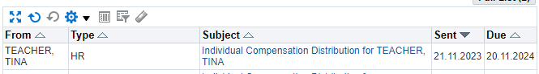  Expenses claims will look like this:  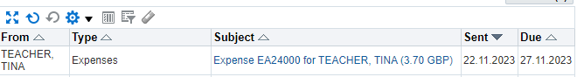
2 | Review the claim, and any attachments with it. Attachments can be viewed at the top of the page for mileage, and the right hand of the page for expenses – clicking on them will open the attached document.  IMPORTANT  - If the claim is for an individual journey, an attachment is not required. You can approve the claim without this.  - If the claim is for a series of journeys (e.g. all journeys in a month), the TSE form attachment is required. If this is missing do not approve the claim – instead reject this and get the employee to put through a new claim with the attachment.  - For expense claims, please ensure all required receipts are attached to the claim before approval. Any VATable claims must include a receipt with a VAT number – credit card receipts are not acceptable.  Example Mileage Claim  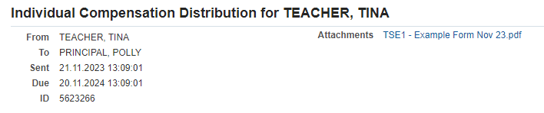  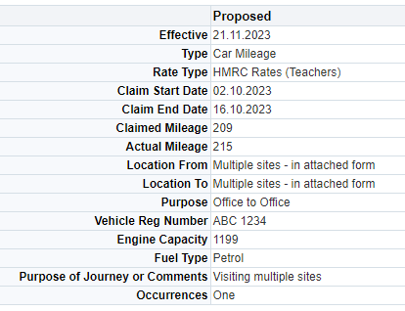  Example Expenses Claim  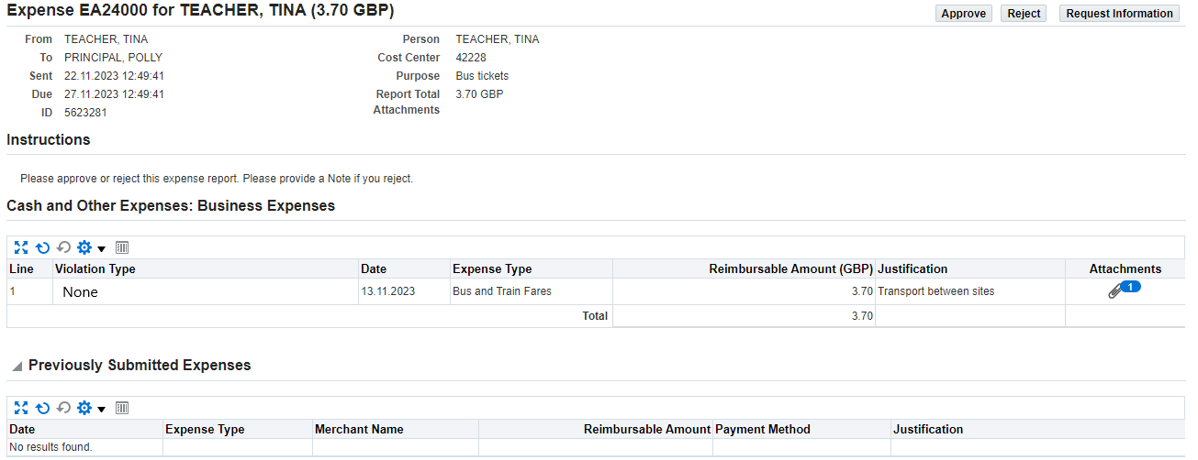
3 | To approve the claim, click Approve in the top-right or bottom-right corner of the screen. You can also Reject or Request Information as required. The employee will get a notification informing them of the outcome once you’ve made a decision.  

