# EA Logo **Caching issues in OAS OBIEE**

We are currently experiencing an increased amount of caching issues in OBIEE/OAS.  This results in the data being returned not being the most recent information.  Until we resolve this issue with Fujitsu we advise that you refresh your reports daily by the following method.

In the top right-hand corner of your OBIEE/OAS report select the cog wheel and select refresh and this will then ensure that your report is up to date with the most recent transactions.

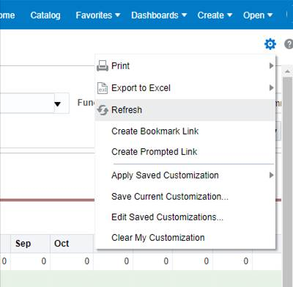

If you have any queries regarding this matter, please do not hesitate to contact:

Sarah Dawson **|** SAO Module Leader   
GL & Reporting - iFS  
Education Authority  
Grahamsbridge Road, Dundonald, BT16 2HS  
Telephone: 028 9056 6350 | Mobile: 07786 337160  
[Education Authority website](https://www.eani.org.uk)