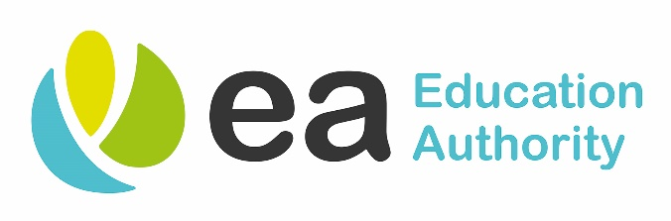

EDUCATION AUTHORITY

EQUALITY SCREENING OUTCOME REPORT
1 January 2021 – 31 March 2021

This document can also be made available, on request, in alternative formats including in large print, in Braille, by email, on computer disc, on audio-cassette and in minority languages to meet the needs of those people who are not fluent in English.

November 2020

Introduction
Section 75 of the Northern Ireland Act 1998 requires Public Authorities when carrying out their functions in relation to Northern Ireland, to have due regard to the need to promote equality of opportunity between nine categories of persons, namely:-

- Between persons of different religious belief, political opinion, racial group, age, marital status or sexual orientation;
- Between men and women generally;
- Between persons with a disability and persons without; and
- Between persons with dependants and persons without.

Public Authorities must also have regard to the desirability of promoting good relations between persons of different religious belief, political opinion or racial group.

Context
As policies are screened on an on-going basis, the completed screening templates will be available on the Education Authority’s website, direct link: http://www.eani.org.uk/about-us/equality/regional-equality-unit/regional-equality-unit-documents/.

Contacts
If you have any queries about this Screening Outcome Report, and its availability in alternative formats (including large print, in Braille, by email, on computer disk, on audio cassette, and in minority languages to meet the needs of those who are not fluent in English) then please contact:-

Mr Matthew McDermott
Head of Equality - Education Authority
41 Academy Street
BT1 2NQ
Ext: 304192 DDI: 02890564192
Email: matthew.mcdermott@eani.org.uk

Where to find Equality Information on the Education Authority Website
You can visit the Authority’s website at www.eani.org.uk to access equality information and review current and previous Section 75 reports/policy screening forms. Equality information including Screening reports are posted on the website within the ‘About Us’ tab and select ‘Equality’ to access further information.

Outcome of Screening Decisions 1 January 2021 – 31 March 2021

Screening Result | Screening Result Description
1 | 'screened in' for equality impact assessment- including date of (EQIA)
2 | 'screened out' with mitigation
3 | 'screened out' without mitigation

Description of Policy | Screening Outcome
Initial Equality Screening - St Brecans Youth Centre Closure | 3

