**FIRST LOGON CHANGE NOTIFICATION METHOD**

After logging in on your first initial logon you need to change the Notification within the Preferences.

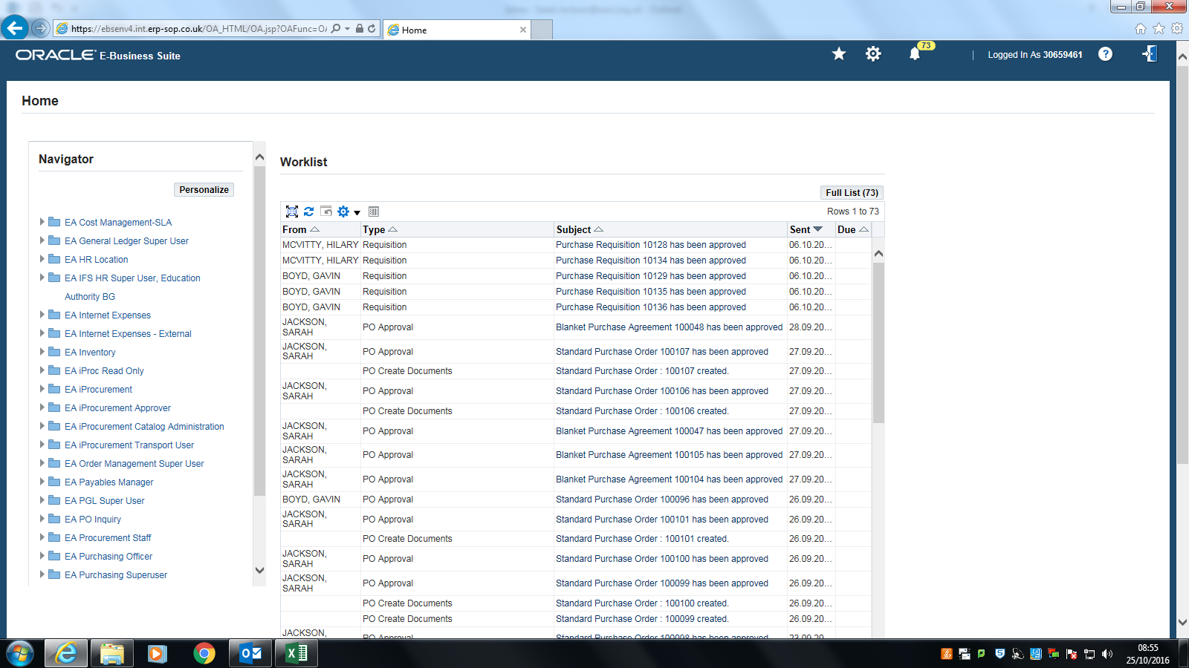

Click on the ‘Settings’ Gear symbol, click on ‘Preferences’.

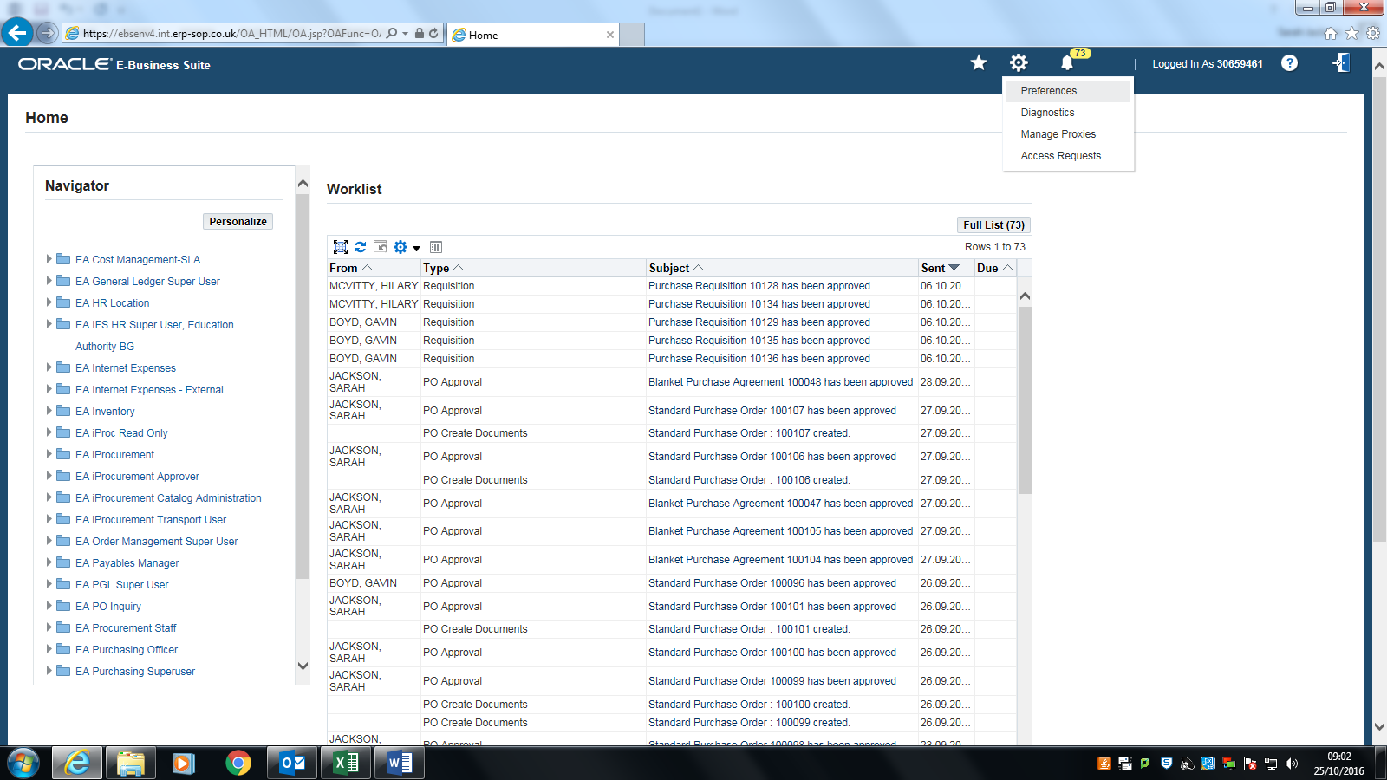

Scroll down to the bottom of the screen

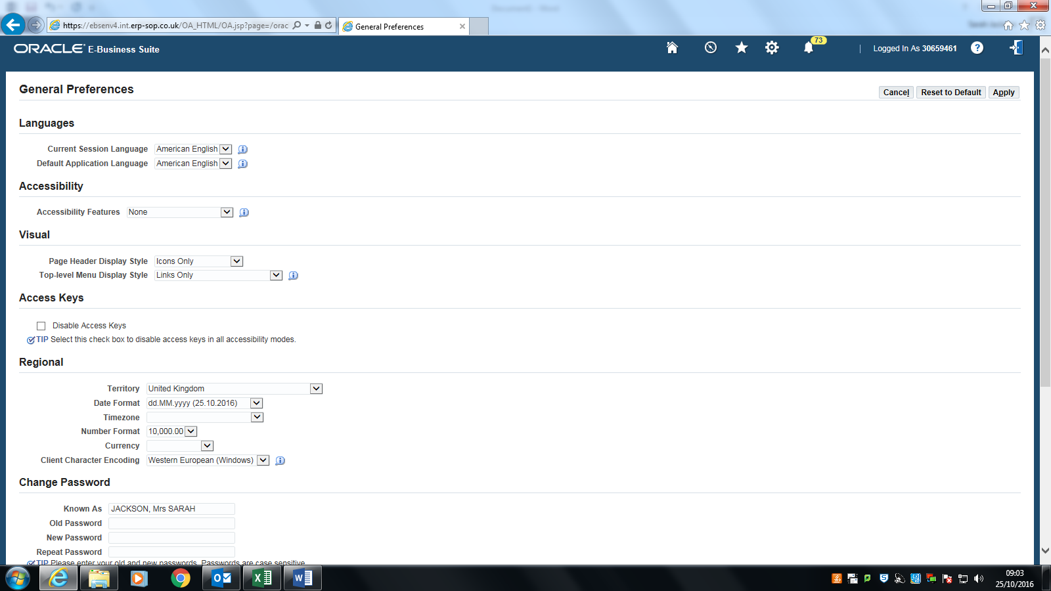

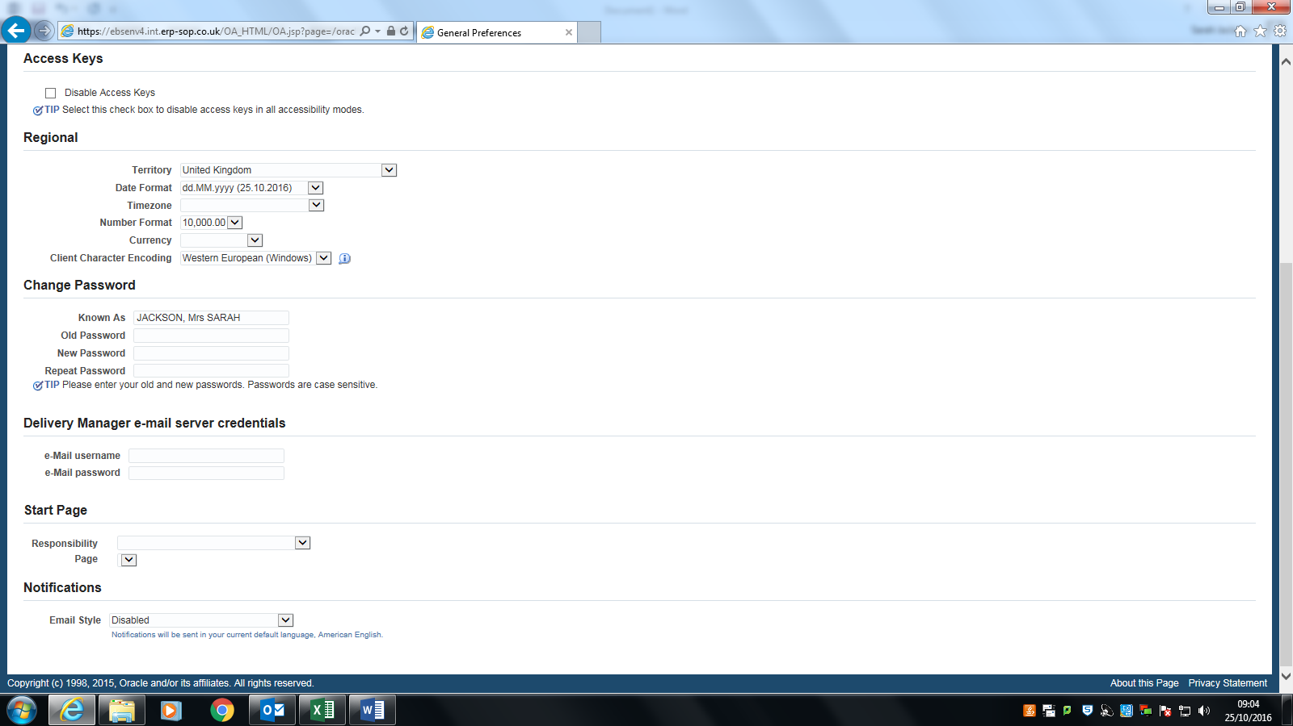

In the Notification section at the bottom of the page, click on the picklist and select HTML mail with attachments

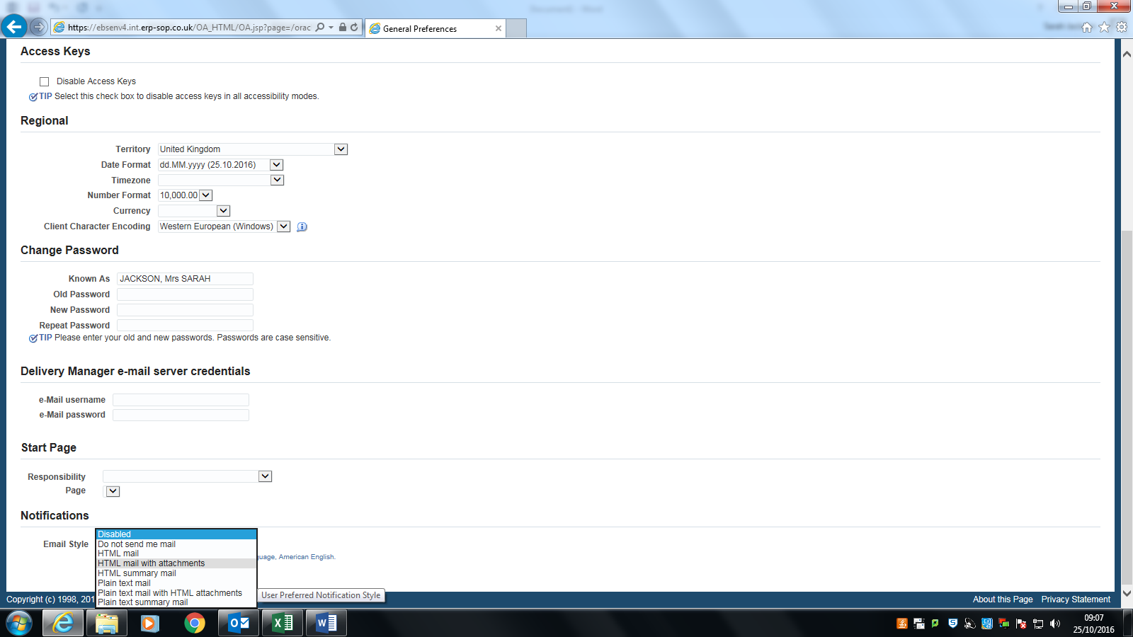

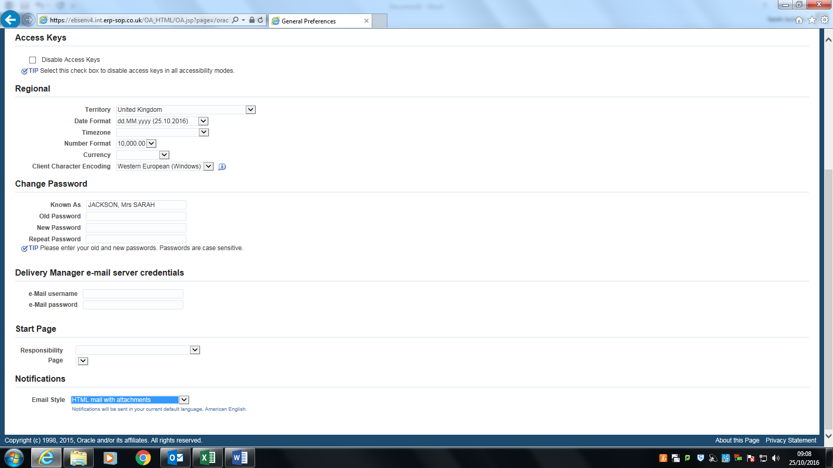

Scroll to the top and click ‘Apply’.

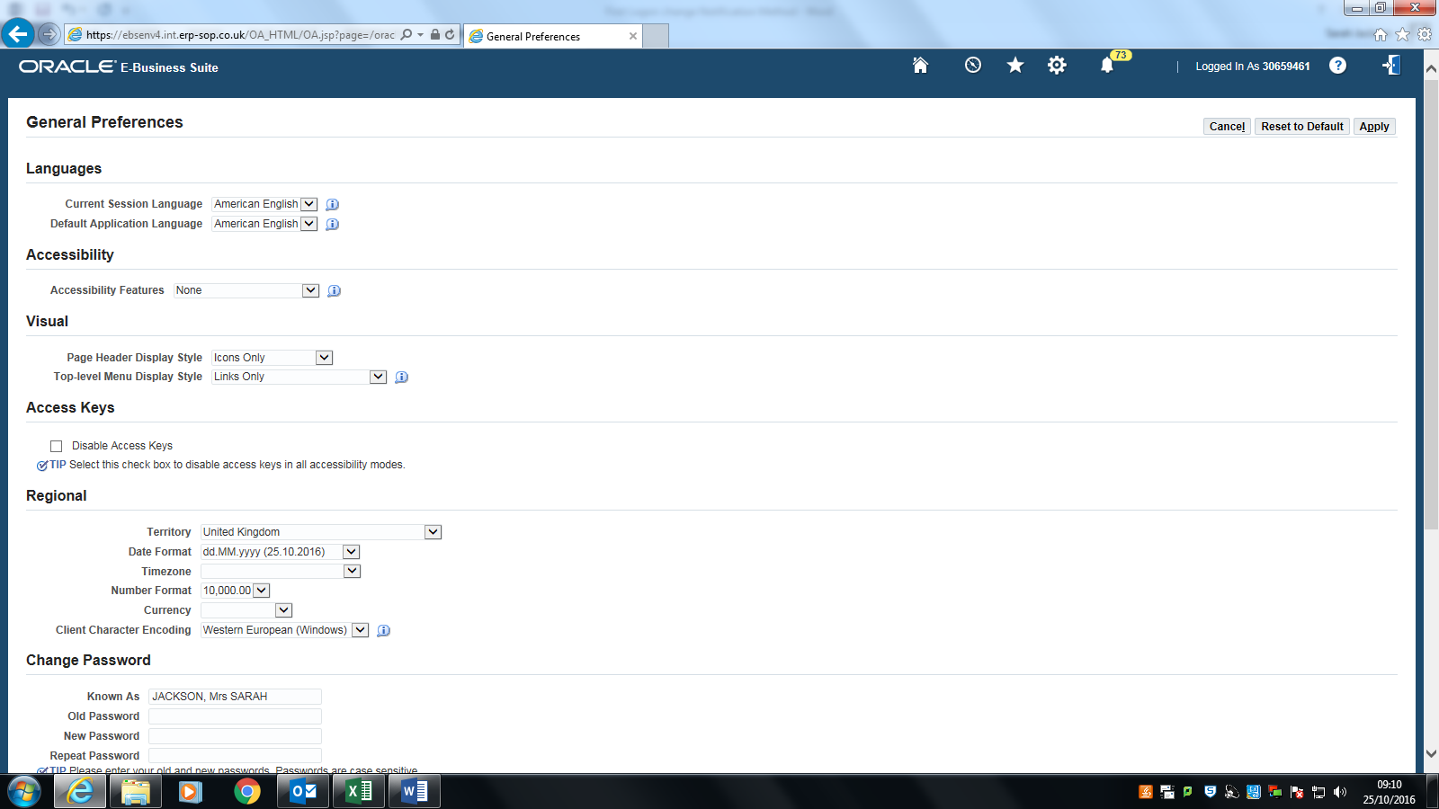

A confirmation will be displayed.

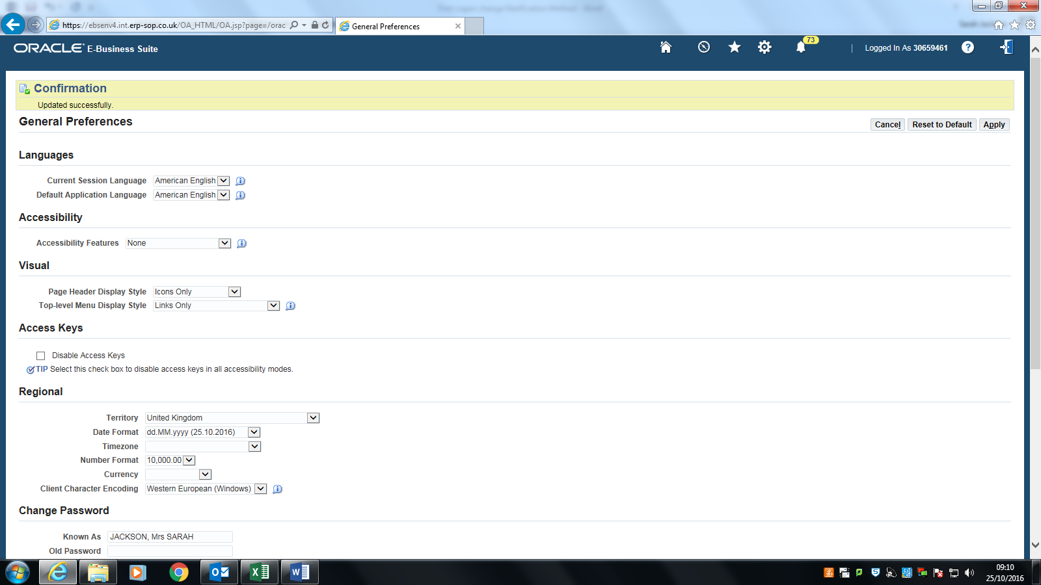

Click on the ‘Home’ icon to return to your Oracle homepage.