**Area Code (Oracle) = Department Code (School)**

*Please see notes at end (pages 4-7) re using the Area code in iProcurement*

The Area code has been set up in Oracle to facilitate raising requisitions and monitoring expenditure at department level within schools.

The Area (Department) code can be used to identify the school department you require a requisition to be coded to, such as the English department, Primary 1, Mrs Smith, etc.

If no department is required the default Area code 0000 will be used when raising a requisition. You cannot use area codes 9995 to 9999 for delegated requisitions.

There are currently 100 Area (department) codes setup within Oracle (contact [ifs.queries@eani.org.uk](mailto:ifs.queries@eani.org.uk) if more are required). These codes are generic, in that they have been set up as numbered departments, as schools do not have a common departmental structure. Schools can assign Area codes to departments at their discretion – see examples below. The department allocated to an Area code can be different in every school. Each school should maintain their own internal list of the departments assigned; this list will be known to the school only and will not be held at HQ.

The Area code is ready to use once you decide how many your school wishes to use and your internal descriptions; iFS do not need to be informed.

Example 1:

|  |  |  |
| --- | --- | --- |
| **Area Code** | **Area Code Description** | **School Internal Description** |
| 1001 | Department 1 | ENGLISH |
| 1002 | Department 2 | MATHS |
| 1003 | Department 3 | FRENCH |
|  | Etc |  |

Example 2:

|  |  |  |
| --- | --- | --- |
| **Area Code** | **Area Code Description** | **School Internal Description** |
| 1001 | Department 1 | PRIMARY 1 |
| 1002 | Department 2 | PRIMARY 2 |
| 1003 | Department 3 | PRIMARY 3 |
|  | Etc |  |

Example 3:

|  |  |  |
| --- | --- | --- |
| **Area Code** | **Area Code Description** | **School Internal Description** |
| 1001 | Department 1 | MRS SMITH |
| 1002 | Department 2 | MR JONES |
| 1003 | Department 3 | MISS WHITE |
|  | Etc |  |

School Reports

All spend against the Area codes will be detailed in the school reports. In relation to the **B&E** (both versions) and the **DTR** allow the reports to complete first with the default parameters, then select the relevant Area code from the available picklist and click on **Apply**.

The **Encumbrance** & the **Requisition** reports both provide Area detail as well.

Invoices

Invoices related to goods requisitioned on iProcurement should be sent directly to the Accounts department in Dundonald by the supplier. If the supplier sends such invoices to the school, you should forward to Accounts in Dundonald, highlighting the PO number and that it is an iProcurement order. *Do not attach an FMS coding slip*.

If you want an area (department) code included on any non iProcurement invoices, add the area code to the coding slip and it will be processed by your local Accounts.

Function Code

Please note, when raising a requisition the default function code 00000 should always be used unless it is for a special initiative. In such instances the function code required should be provided by the HQ section funding the initiative.

Please contact iFS [ifs.queries@eani.org.uk](mailto:ifs.queries@eani.org.uk) Tel: 028 9056 6478 if you require any further information.

|  |  |  |
| --- | --- | --- |
| **Area Code** | **EA Area Description** | **School Internal Description** |
| 1001 | Department 1 |  |
| 1002 | Department 2 |  |
| 1003 | Department 3 |  |
| 1004 | Department 4 |  |
| 1005 | Department 5 |  |
| 1006 | Department 6 |  |
| 1007 | Department 7 |  |
| 1008 | Department 8 |  |
| 1009 | Department 9 |  |
| 1010 | Department 10 |  |
| 1011 | Department 11 |  |
| 1012 | Department 12 |  |
| 1013 | Department 13 |  |
| 1014 | Department 14 |  |
| 1015 | Department 15 |  |
| 1016 | Department 16 |  |
| 1017 | Department 17 |  |
| 1018 | Department 18 |  |
| 1019 | Department 19 |  |
| 1020 | Department 20 |  |
| 1021 | Department 21 |  |
| 1022 | Department 22 |  |
| 1023 | Department 23 |  |
| 1024 | Department 24 |  |
| 1025 | Department 25 |  |
| 1026 | Department 26 |  |
| 1027 | Department 27 |  |
| 1028 | Department 28 |  |
| 1029 | Department 29 |  |
| 1030 | Department 30 |  |
| 1031 | Department 31 |  |
| 1032 | Department 32 |  |
| 1033 | Department 33 |  |
| 1034 | Department 34 |  |
| 1035 | Department 35 |  |
| 1036 | Department 36 |  |
| 1037 | Department 37 |  |
| 1038 | Department 38 |  |
| 1039 | Department 39 |  |
| 1040 | Department 40 |  |
| 1041 | Department 41 |  |
| 1042 | Department 42 |  |
| 1043 | Department 43 |  |
| 1044 | Department 44 |  |
| 1045 | Department 45 |  |
| 1046 | Department 46 |  |
| 1047 | Department 47 |  |
| 1048 | Department 48 |  |
| 1049 | Department 49 |  |
| 1050 | Department 50 |  |

**Using the Area Code in iProcurement**

*For full instructions on raising requisitions see* ***iProcurement Requisitioner School User Guide*** *on the EANI website*

**Entering the Department (Area) Code**

**Option 1: Recommended**

After selecting all the items required click on **View Cart and Checkout**. The **Shopping Cart** screen opens. Enter the Area Code required into this screen (i.e. overwrite the default)

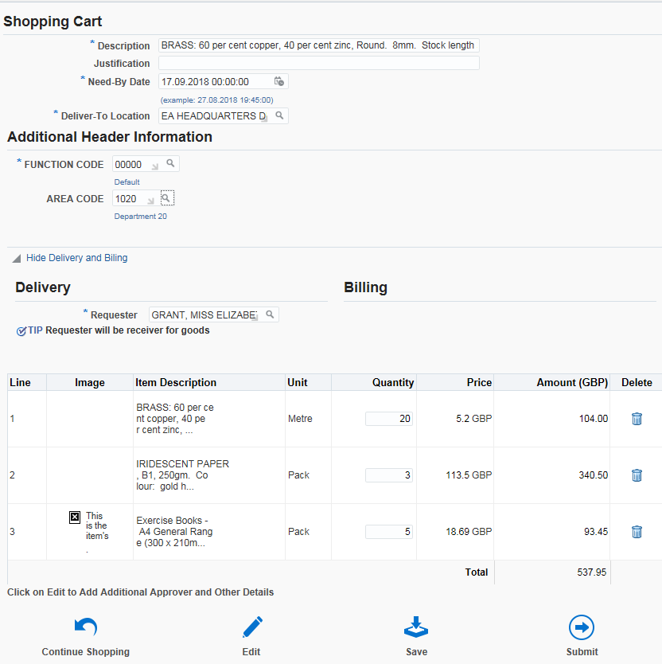

Area Code

Click on **Submit** (or **Edit** if you need to change something, e.g. Approver)

**Option 2:** **Use if you have forgotten to use Option 1**

If you have proceeded to the **Edit and Submit Requisition** screen or saved your requisition without entering the department code in the **Shopping Cart** screen you must enter the codes as follows:

Navigate to the **Edit and Submit Requisition** screen

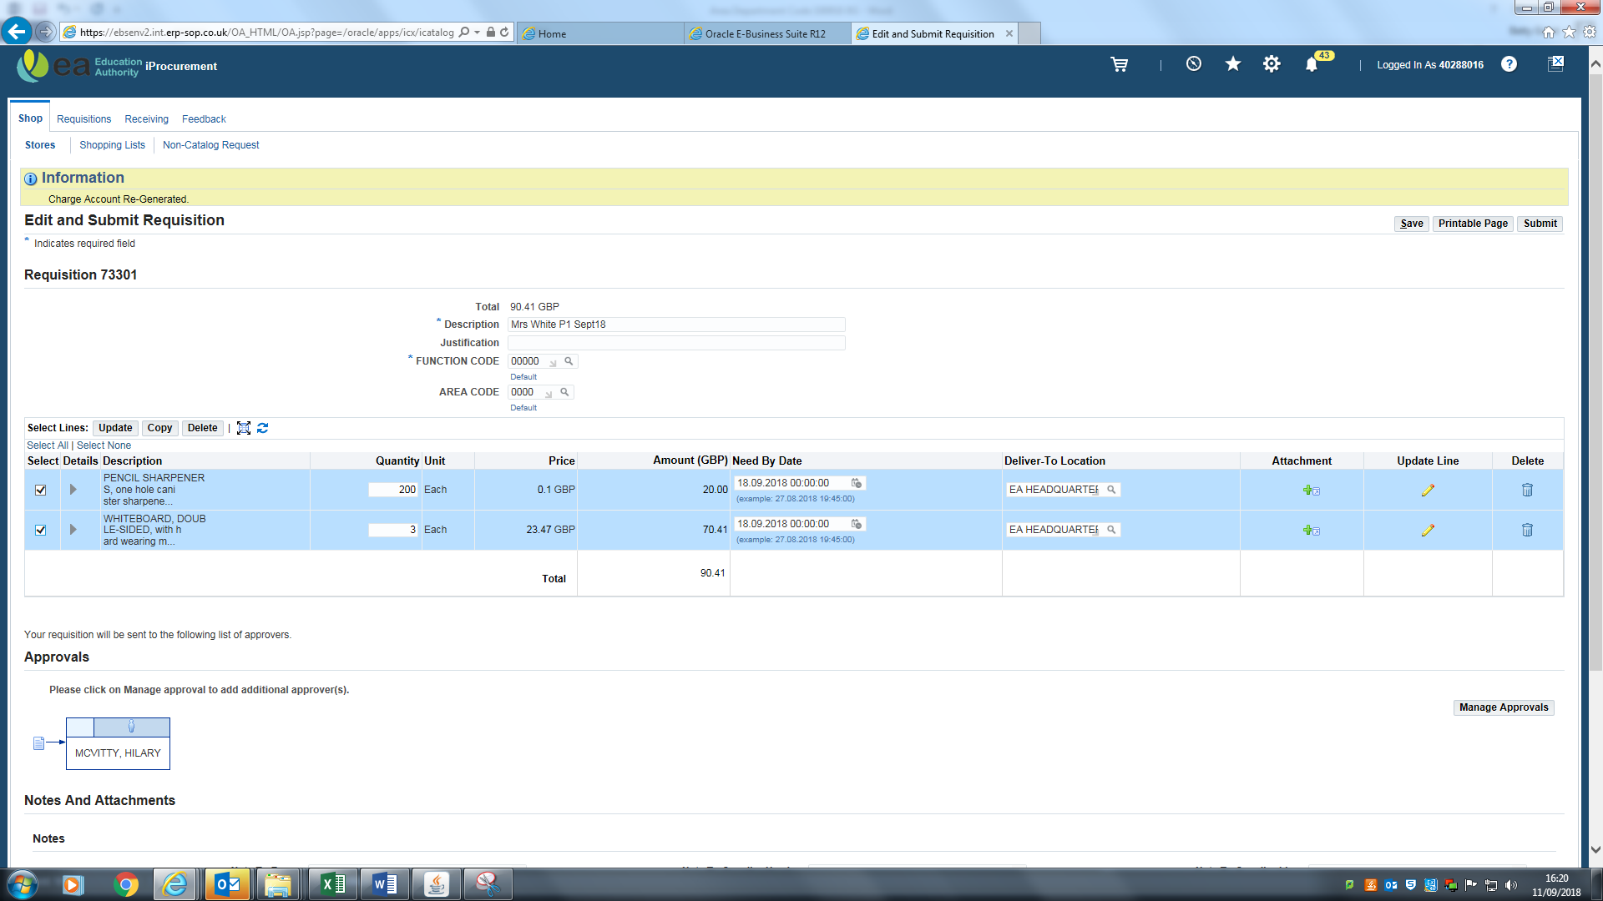

Codes entered here in this screen will NOT take effect

Click on the pencil symbol for the line required to be amended or changed.

If more than one line needs to be changed click on the tick box to the left of all the lines that need amended or changed. Click on the update line pencil on the first (top) line.

The **Update Line** screen opens. Scroll down to **Billing**. To enter the Area code click on the magnifying glass to the right of the code combination line to be amended.

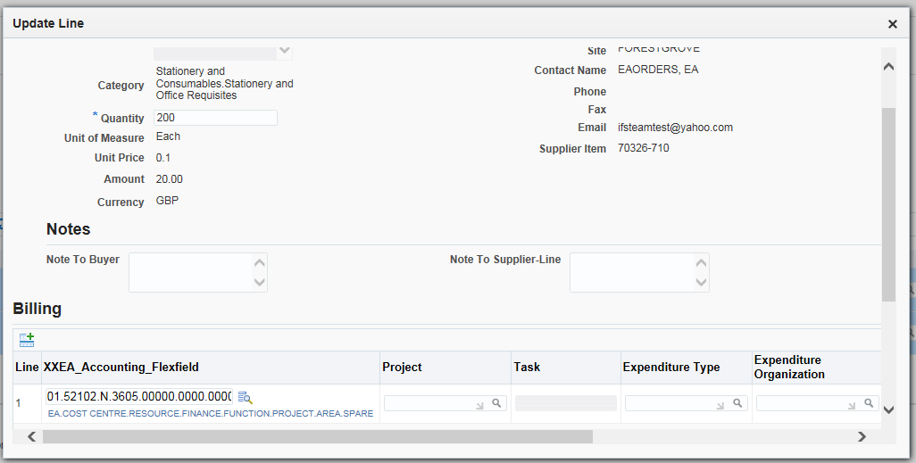

The **Search and Select: XXEA Accounting Flexfield** screen appears. Overwrite the default code in the **Area** field and click on **Create.** This will create a valid code combination. Click on **Select**

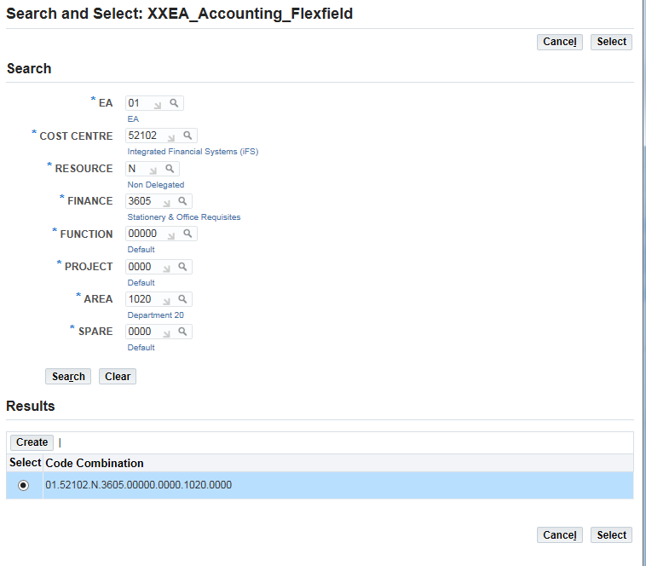

If correct codes are now in place, click on **Apply**

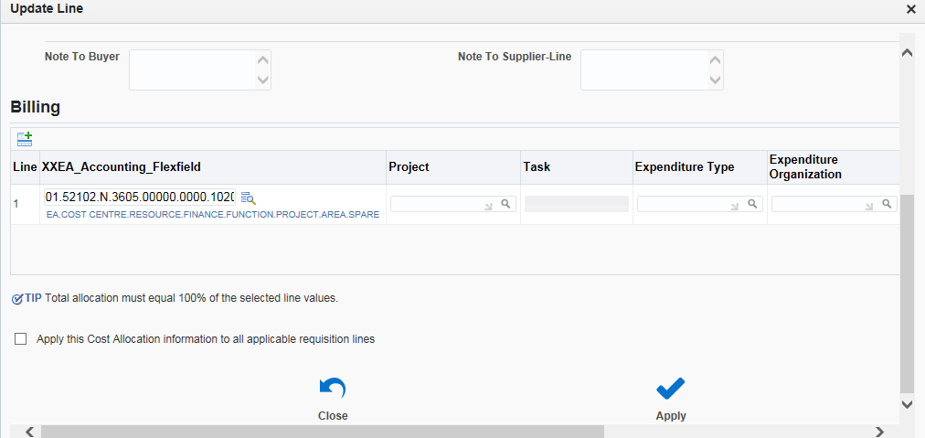

If you forgot to click all the lines earlier in the **Edit and Submit Requisition** screen & wish to apply the Area code to them all, tick the box beside **Apply this Cost Allocation to all applicable lines.** Click on **Apply**

This returns you to the **Edit and Submit Requisition** screen. Click on **Submit**

The requisition has now been submitted to the Approver for approval