**C:\Users\KangombeW\Desktop\EA Version 3 Logo for printing.tif**

**Processing Encumbrance and Requisition Reports – Special School Guide**

**Finance Module of the EA Integrated Finance, Payroll and HR system**

**This is a supplement to the ‘Accessing Article 60 Reports’ guide which provides full details on accessing and processing school reports.**

**Drafted: September 2018**

**ENCUMBRANCES**

An encumbrance is created when a purchase order has been approved (and sent to the supplier).

The rationale is that once the purchase order has been sent to the supplier, EA has an obligation to pay the supplier once the goods are delivered, so the budget is already committed.

When the goods are received and receipted on the system, the actual expenditure is recorded on reports and the encumbrance is reversed.

There is a second version of the budget and expenditure report called **Article 60 B&E with Encumbrances** which includes encumbrances.

This means that when you order goods to the value of £100, your reports will look like this:

|  |  |  |  |
| --- | --- | --- | --- |
| Budget | Expenditure | Encumbrance | Balance Available |
| 1000 | 0 | 100 | 900 |

When you receipt the goods, it will look like this:

|  |  |  |  |
| --- | --- | --- | --- |
| Budget | Expenditure | Encumbrance | Balance Available |
| 1000 | 100 | 0 | 900 |

An Encumbrance is created when a Purchase Order (PO) has been raised but the goods have not been receipted on the system. The **Encumbrance column** displays the total outstanding encumbrance for the school (i.e. from December 2016 to date). On receipt the encumbrance becomes an actual; the value in the encumbrance column is reduced and the value in the spend column (for that period) increases.

A PO will remain as an outstanding encumbrance if it is not receipted on the system. If for any reason all or part of the goods will not be received by the school, the school should contact the Procurement section and ask for the PO to be closed. This will clear the encumbrance value.

**Encumbrance reports**

Navigate > Oracle Financials > EA Article 60 Head Teacher – 45678 > OBIEE

> OBIEE Dashboard > Dashboards > EA Article 60 Head Teacher. The reports appear in tab form. The encumbrance & iProcurement reports have been added after the current reports.

1. **Article 60 B&E with Encumbrances Report**

1.1 Navigate to the **Article 60 B&E with Encumbrances** tab**.** Like the standard B&E report, this report is designed to be run for the full year and, on opening, automatically runs for the current year. If your school is using iProcurement this version of the B&E is recommended for use.

Please do not select a **Fiscal Period**. Selecting 1**+ Fiscal Period** returns misleading data for the **Annual Budget** and **Encumbrance** columns, i.e. data for the selected periods only, not to date.

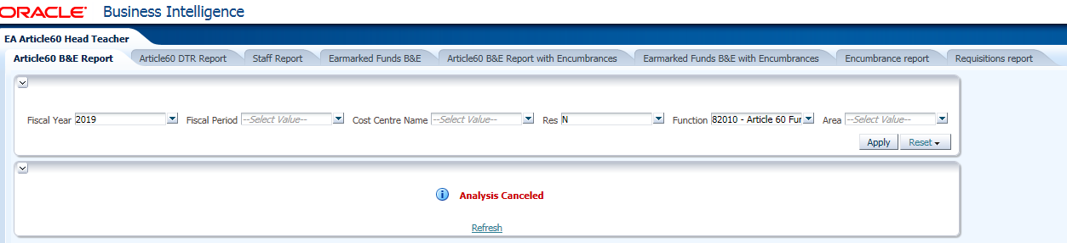

* 1. To process this (or any) report by **school department** (if required)**:**
* allow the report to complete for the year (this retrieves the data for all the school)
* click on ⇩ arrow beside the **Area** filter and the available departments will be displayed as shown below

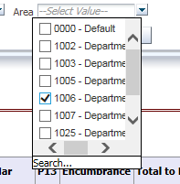

* tick ****the relevant department and click on **Apply**
* To view a sample report click below



1. **Earmarked Funds B&E with Encumbrances Report**

Process as **Article 60 B&E with Encumbrances** report above

1. **Encumbrances Report**

Navigate to the **Encumbrances** tab**.** This report automatically runs for all open encumbrances for the school, i.e. it displays all the items raised via iProcurement that have not yet been receipted on the Oracle system. The total **amount outstanding** should equal the **total encumbrance** on the B&E

* To view a sample report click below



If you wish, this report can be filtered by Finance, Resource, Function, Project or Area (department)

When you first run this report, it may show very old encumbrances. The most likely explanation for this is that a Purchase order was raised on the system, but the goods were not receipted and the invoice was paid without matching to the PO. We recommend that you review any old purchase orders on the report and, unless you know that you are still expecting to receive these goods, ask Procurement to cancel the old order. This will remove it from your encumbrances on both reports.

1. **Requisitions Report**

Navigate to the **Requisitions** tab**.** This report automatically runs for all **Requisitions** that have been raised on the system since the beginning of the current financial year. It is sorted by area (department).

* To view a sample report click below



This report is designed to let individual department heads monitor their in year expenditure in order to manage their budgets. Note that any requisition that has not yet been approved or has been returned by procurement will not appear on this report.

If the requisition has already been turned into a Purchase Order, the details of the purchase order will also be shown on the report.

You can choose to run the report for any period of time, by individual area (department) or for a number of different departments (selected individually from the picklist).

1. **Features of OBIEE Reports**

Note the following features on all the reports:

1. All reports can be exported to Excel and sorted to suit
2. All reports are **live** and include data up to 6pm on the previous day. Remember that you need to wait until the next day to see transactions that you have processed.
3. The report will automatically run each time you open it. Any changes you made in the past will not be retained.