Accessing the EA Finance System -
School Guide

Drafted: September 2018
Accessing the EA Finance System - School Guide

Finance Module of the EA Integrated Finance, Payroll and HR system
LMS School Monthly Financial Reports

1. Logon to Oracle Financials
An Oracle icon will be placed on your C2K FMS desktop. If this icon is not available, add the url https://ebs.int.erp-sop.co.uk/ into an internet explorer page.

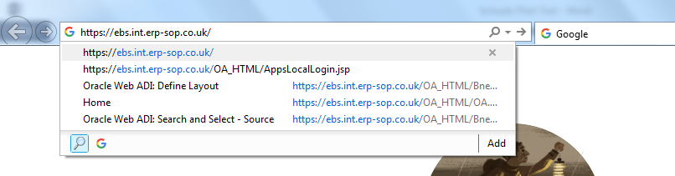

After a few seconds the following screen will open:

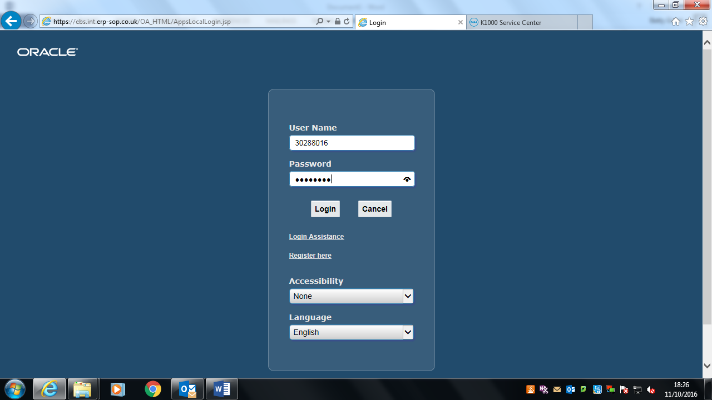

- Save this to your Favourites;
- Enter your User Name (employee number with prefix, e.g. 60 for teaching staff) and password as provided;
- Click on ‘Login’.

The following screen will appear:

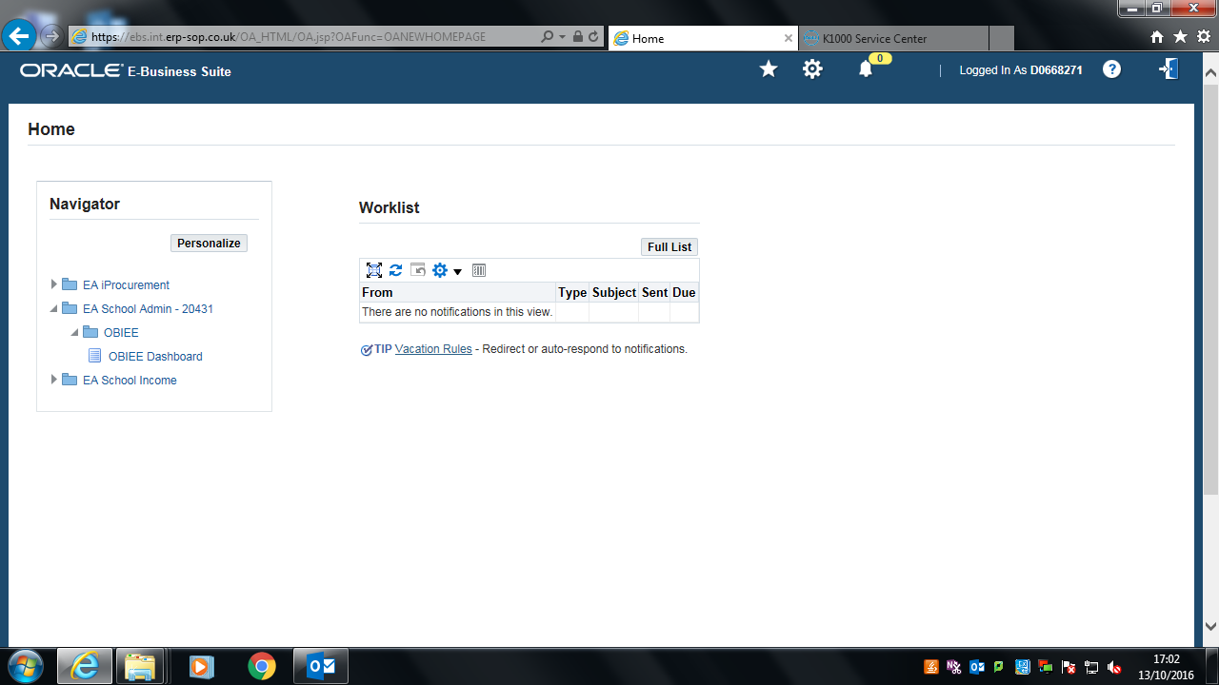

2. View your LMS Reports
Reports are available using OBIEE (Oracle Business Intelligence Enterprise Edition)
There are two main reporting responsibilities for schools:
- EA School Principal – 12345 (includes Staff reports)
- EA School Admin – 12345 (excludes Staff reports)

- Click on (example) ‘EA School Principal – 12345’
- Click on OBIEE
- Click on OBIEE Dashboard.

The following screen will appear:
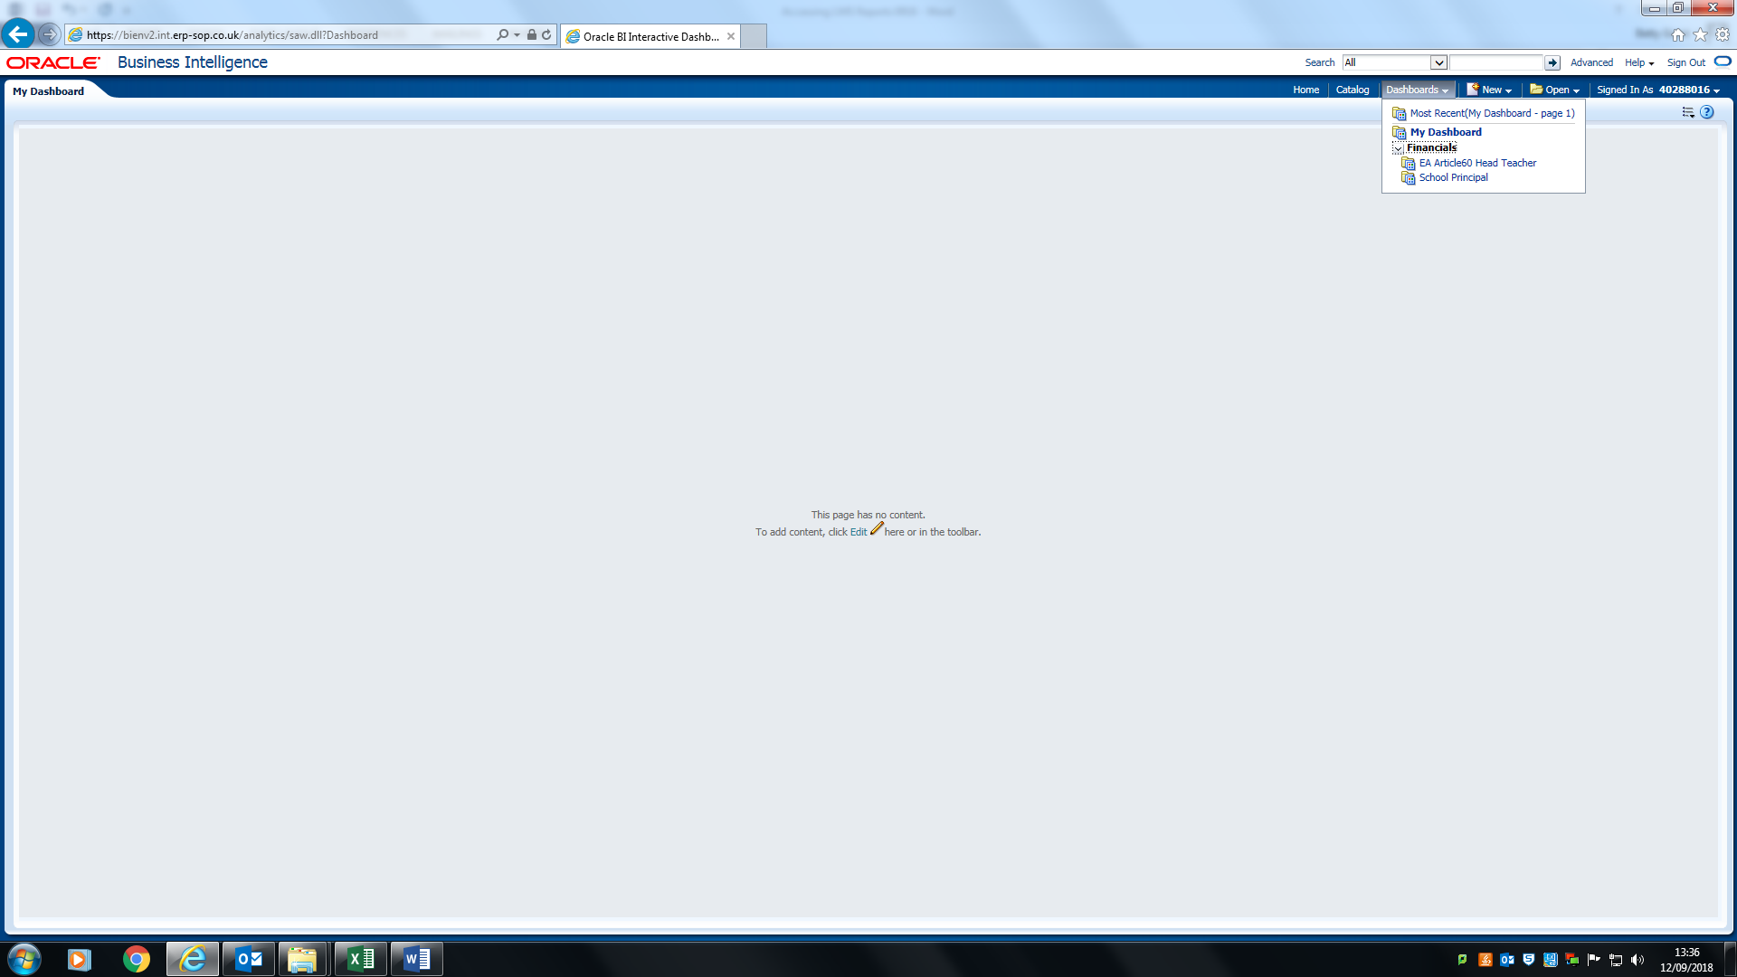
Navigate > Dashboards > Financials > School Principal (or School Admin) – see below:
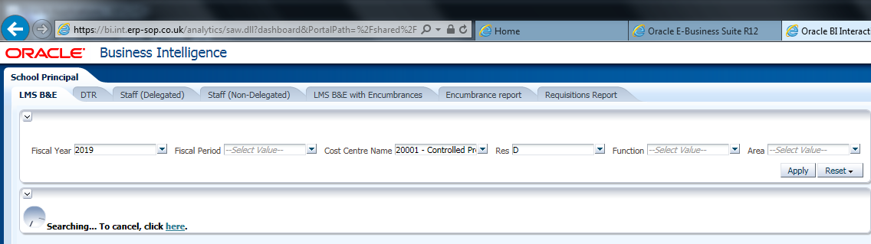
Reports appear within a tab (see above) and these 7 tabs can be moved between:
- LMS Budget & Expenditure Report;
- Detailed Transaction Report (DTR);
- Delegated Staff reports (monthly and cumulative);
- Non-Delegated Staff reports (monthly and cumulative);
- LMS Budget & Expenditure Report with Encumbrances;
- Encumbrance Report
- Requisition Report
The school reports are now live reports and include data up to 6pm of the previous day.
The DTR & Staff reports open at the latest period minus 1 (i.e. in September 2018 the report will open at the August 2018 period).
The reports will automatically run each time you open it. Any changes you made in the past will not be retained.
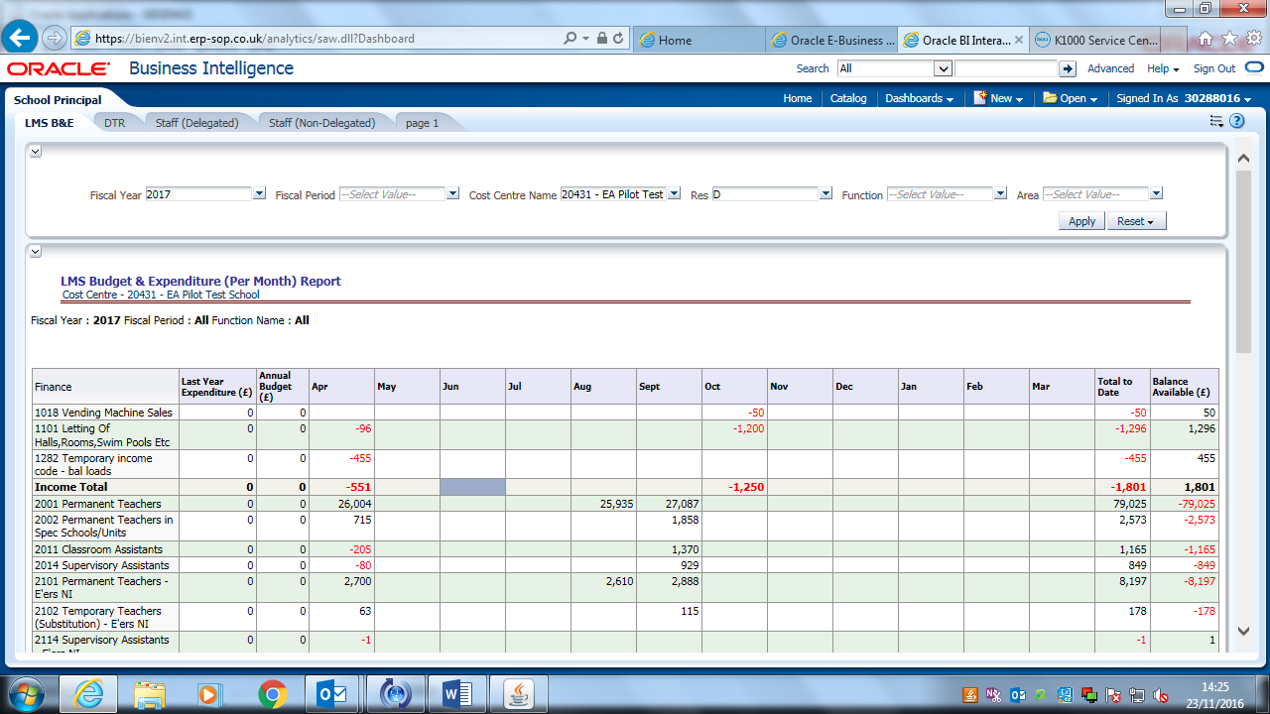

Across the top of each report are Prompts - see table below:

Prompt | Default | Sample | Note
Fiscal Year | Current Year | 2017 | Apr 2016 to Mar 2017
Fiscal Period | Current Period minus 1 (DTR & Staff) | Dec16/17 | Dec 2016 (default for Jan17)
Cost Centre Name | Your school code & name | 12345 Local | School Number & Name
Res | D | D | D = Delegated
Function | 00000 | 80076 | e.g. CYP - Extended Schools
Area | 0000 | 0000 | Initially EA former region. Can be used as school department
Spare | 0000 | 0000 | For possible future use by EA

3. View the latest available data
The reports contain live data, i.e. as at 6pm the previous day. The Budget & Expenditure LMS B&E report (with/without encumbrances) displays the spend for the financial year in a per month format, including the current period. As goods are receipted and payments are made; expenditure will appear in the current (latest) period on this report.
To view expenditure for the current period for the DTR & Staff Reports
- Change the ‘Fiscal Period’ prompt to the current period;
- Click on Apply (top right of screen – below ‘Signed In As…. & Spare);
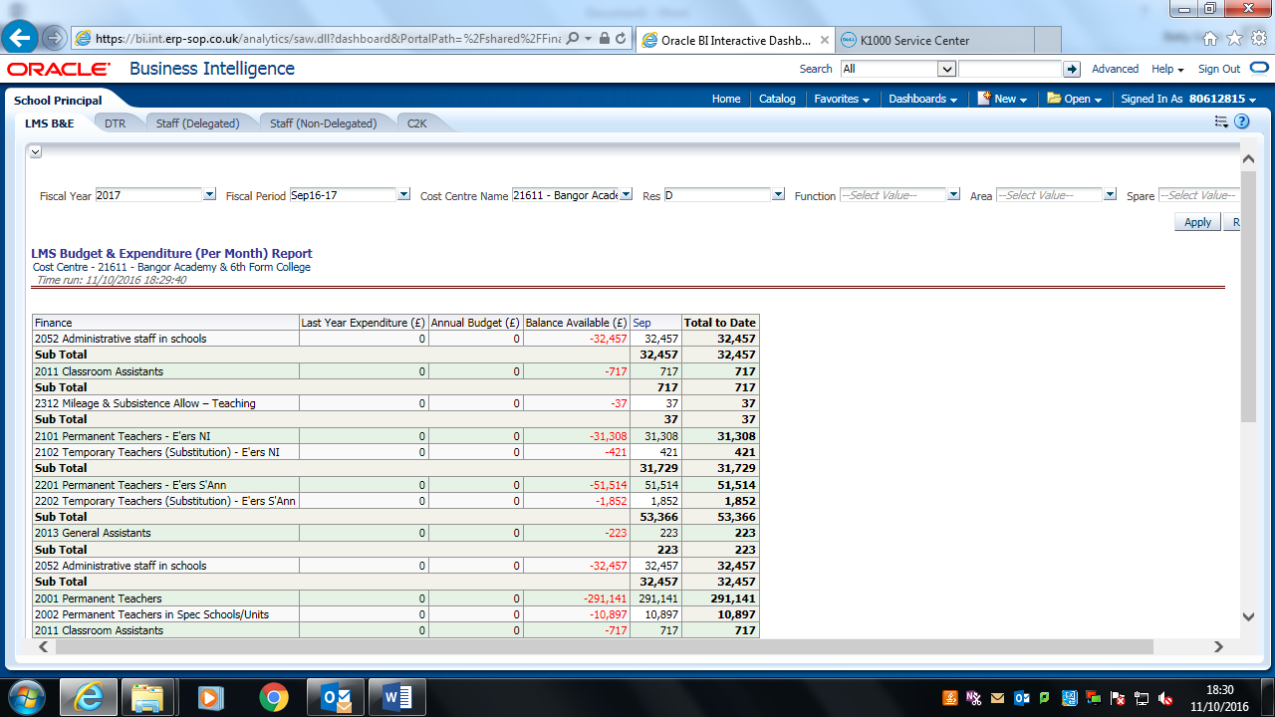

The report will update to the latest available data (data refreshed each evening at 6pm).

4. Print Reports
4.1 Print
To print these reports you must first export them.
Please note: a blue screen will appear if you do not export first.
- Scroll to the bottom of the report to ‘Export’
- Click on ‘Export’

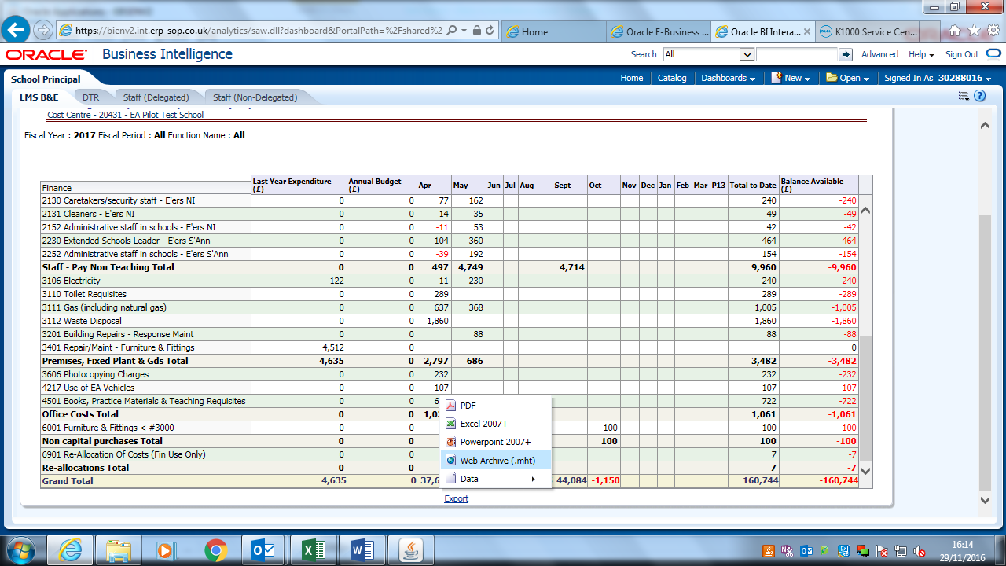
Export to (e.g.) WEB Archive (mht)
Use pdf for the DTR & Staff Reports and headings will appear on all pages

The screen below opens. Two messages appear in quick succession (see notes on messages below screenshot).

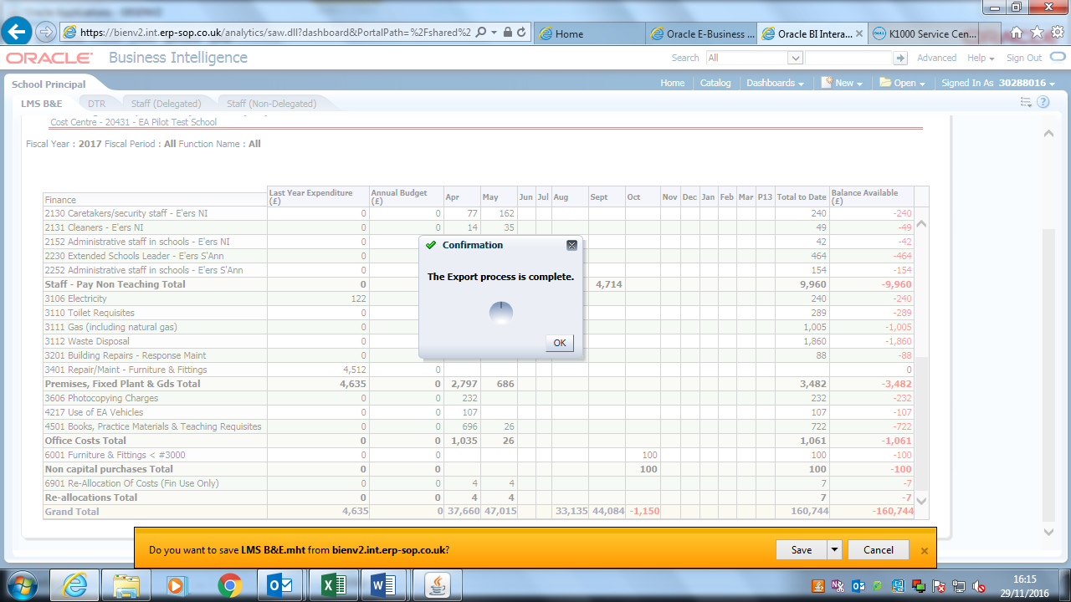

- First message – Confirmation: The Export process is complete.
- Click OK (you must respond to this message before the data will export).
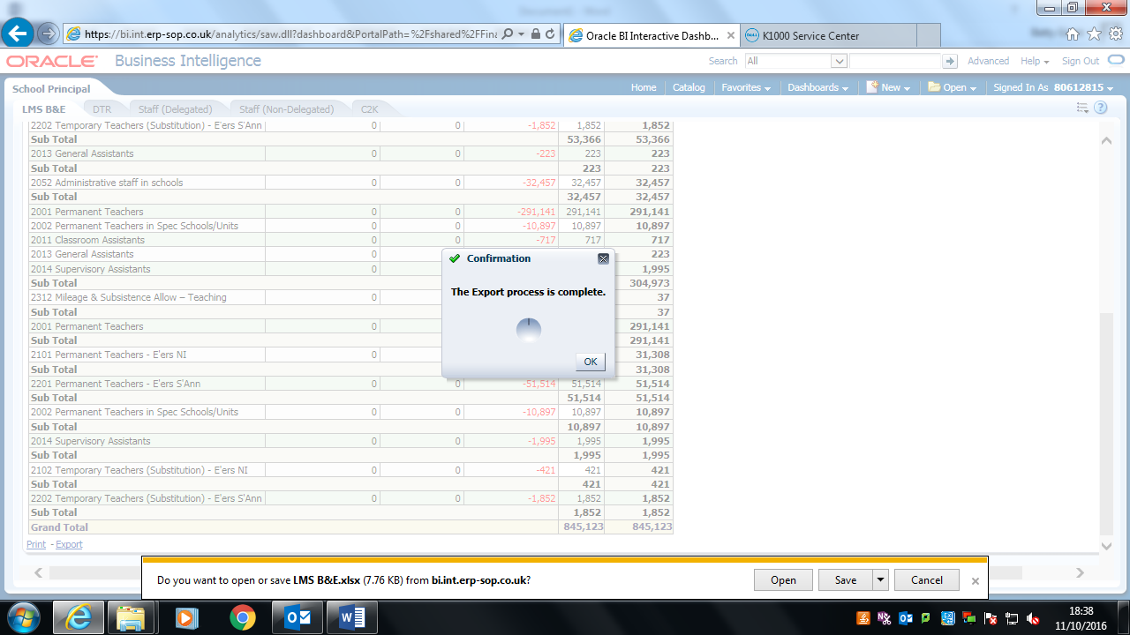
- A second message appears very soon after: Do you want to open or save….?
- Click Save and then Open. It is important to follow this order as it may not open otherwise.

The following screen appears. Navigate > Internet Tools icon 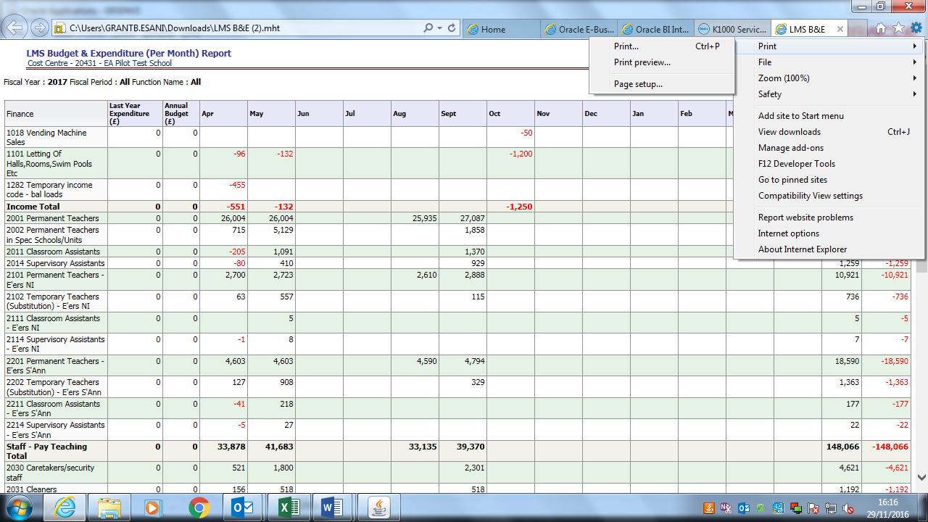 > Print > Print Preview
Ensure print orientation is Landscape then Close
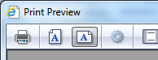
Navigate > Internet Tools icon > Print > Print and print your report.
4.2 Excel
Reports can also be exported to Excel. The worksheet can then be saved & manipulated as necessary
- Scroll to the bottom of the report to ‘Export’
- Click on ‘Export’
- Select option Excel 2007+ (compatable with this or later versions of excel).
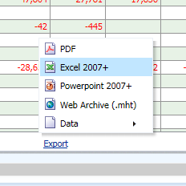

The following output will occur:

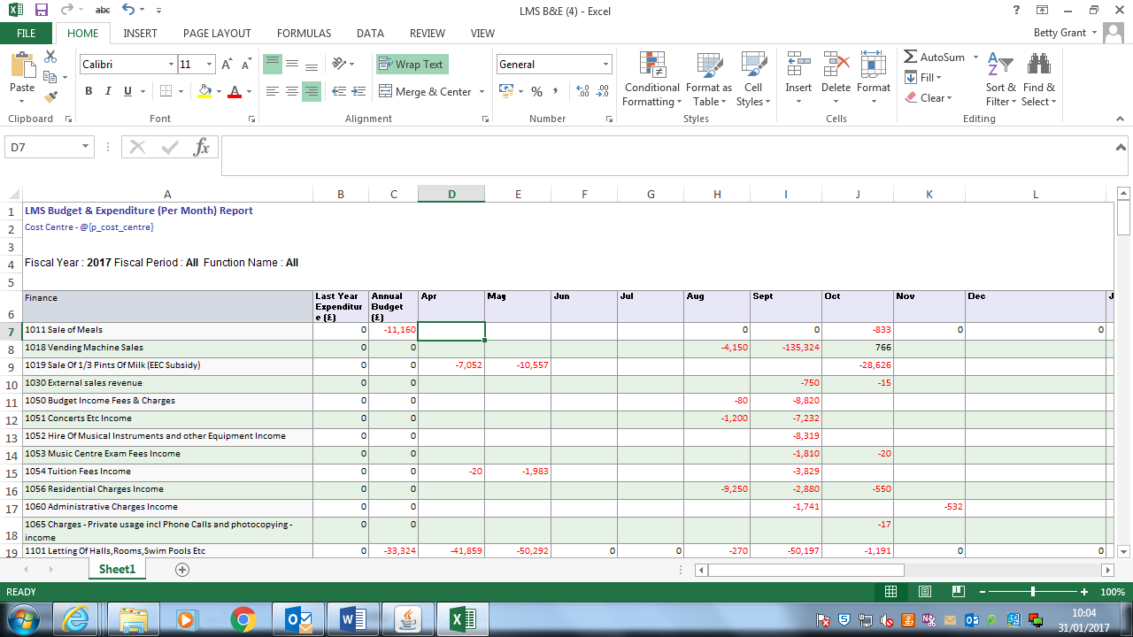
Note: each time you run this process a copy saves to your ‘Downloads’ folder on your PC. We recommend that you regularly clear this folder.
5. Tabs
There are various Tabs available on the dashboard representing the various reports that you receive.
The Principal responsibility will contain Staff (Delegated) & Staff (Non-Delegated) tabs displaying the staff reports; the Admin responsibility will not.
Move between tabs to view the different reports.
6. Sign Out or Close from Oracle
6.1 Exit from reports but still stay online (for example to raise an order or enter income)
Click on Sign Out (top right of screen)

This will take you back to the Home page:
Change responsibility or, if finished, log out.
6.2 Log Out from Oracle
Click on the open door symbol at top right of screen.
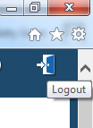
This returns the user to the login screen:
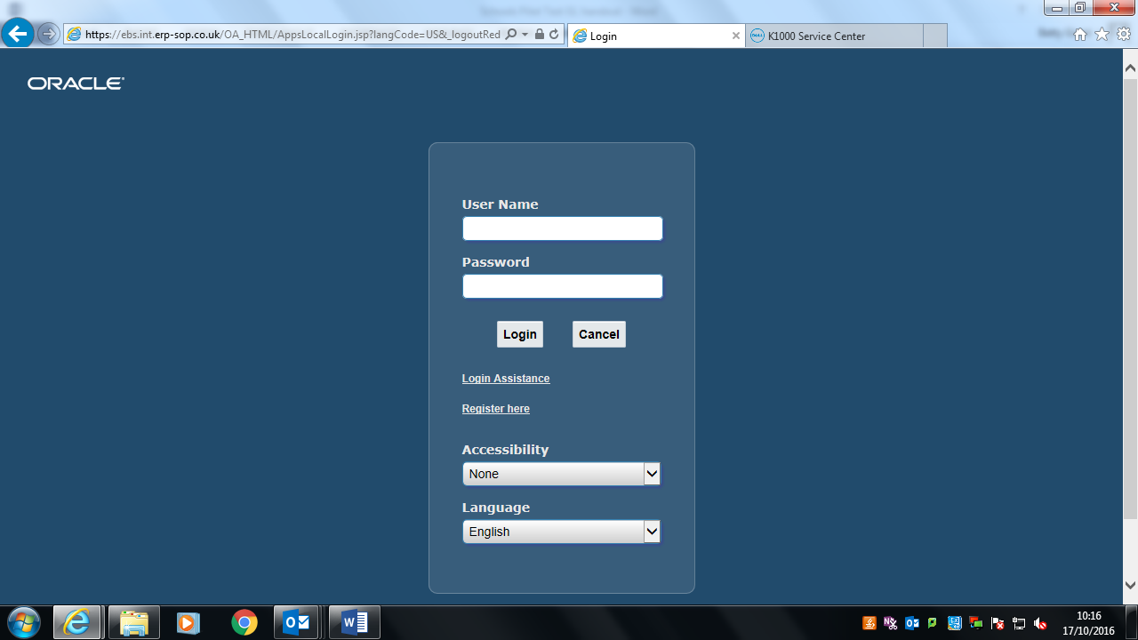
You can use the red X in the top right corner to close down completely.

Ensure you are closed down fully from Oracle – click on the ‘internet’ 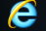 icon at the bottom of your screen to check if any windows are open.

Tip: you are not correctly logged out if, when you open Oracle, your User Name appears already keyed in.

