**C:\Users\KangombeW\Desktop\EA Version 3 Logo for printing.tif**

**Accessing the EA Finance System -**

**Special School Guide – Article 60**

**Drafted: September 2018**

**Accessing the EA Finance System – Special School Guide**

**Finance Module of the EA Integrated Finance, Payroll and HR system**

**Article 60 Special School Monthly Financial Reports**

**1. Logon to Oracle Financials**

AnOracle icon will be placed on your C2K FMS desktop. If this icon is not available, add the url <https://ebs.int.erp-sop.co.uk/> into an internet explorer page.

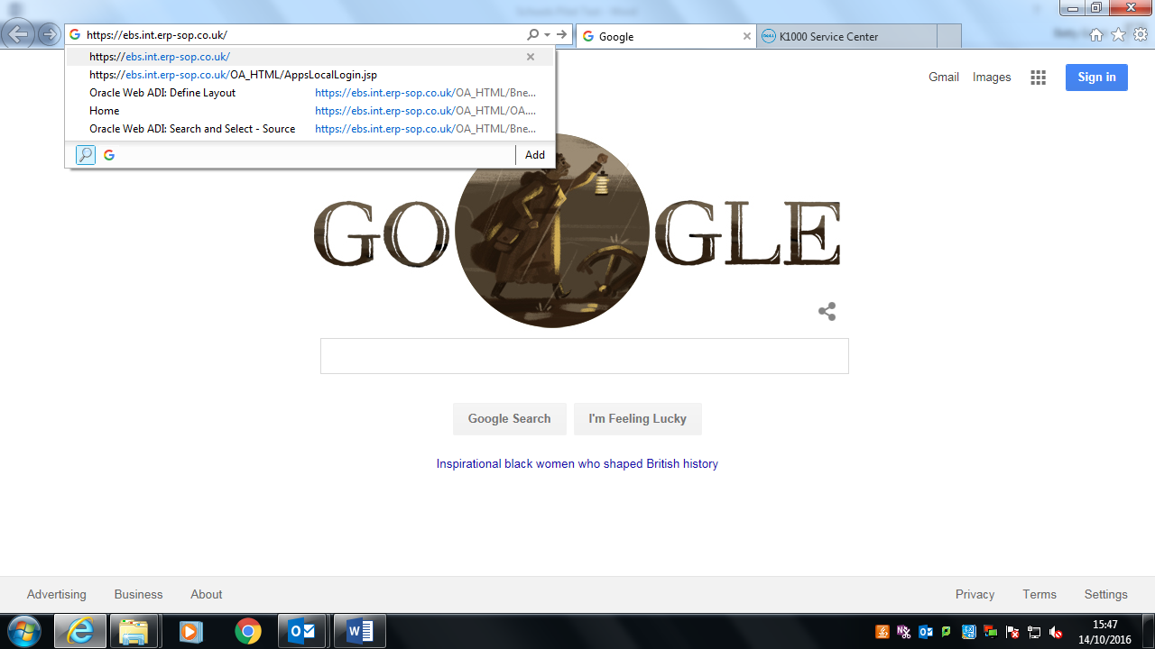

After a few seconds the following screen will open:

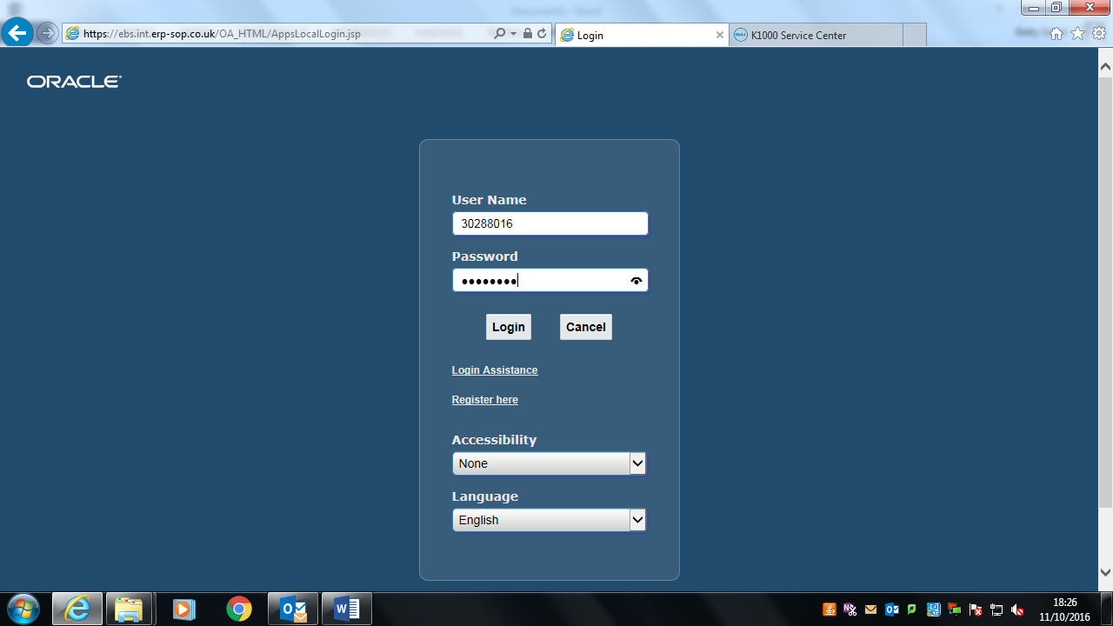

* Save this to your Favourites;
* Enter your User Name (employee number with prefix, e.g. 60 for teaching staff) and password as provided;
* Click on ‘Login’.

The following screen will appear for your school (displaying your responsibilities and access).

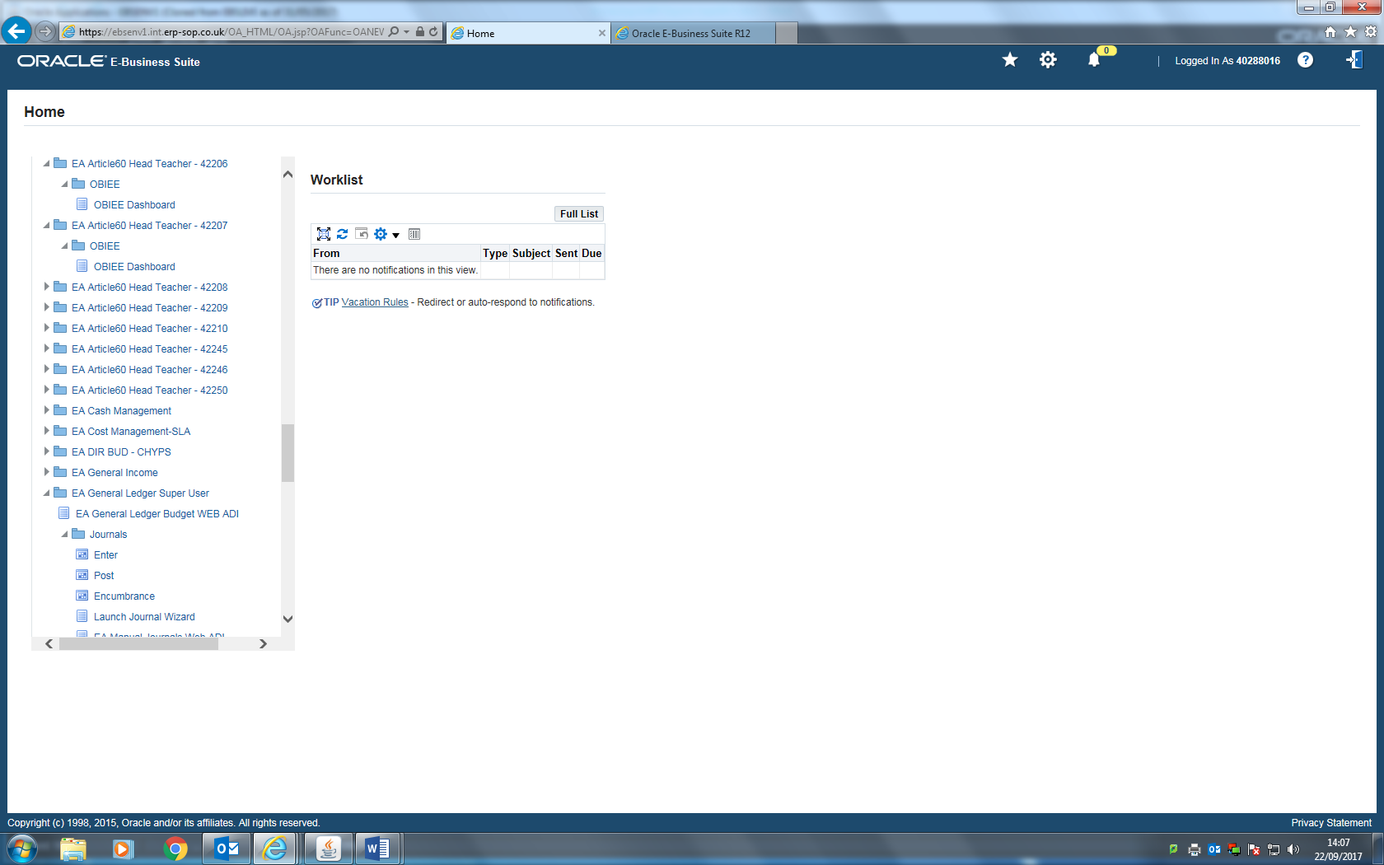

**2. View your Article60 Reports**

Reports are available using **Oracle Business Intelligence Enterprise Edition** (OBIEE)

There are two main reporting responsibilities for schools:

1. EA Article60 Head Teacher – 12345 (includes Staff reports)
2. EA Article60 Clerical – 12345 (excludes Staff reports)

* Click on **EA Article60 Head Teacher** – 12345
* Click on **OBIEE**
* Click on **OBIEE Dashboard**

The following screen will appear:

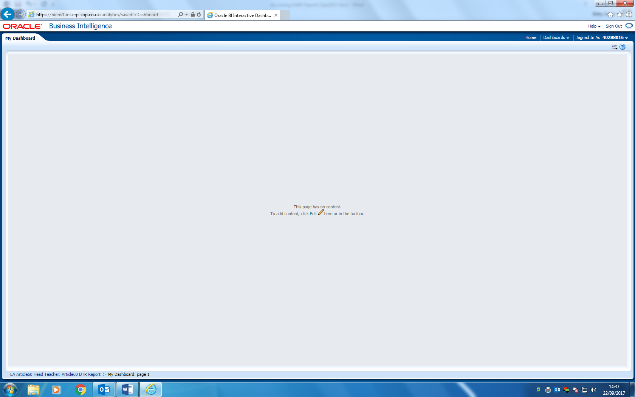

Navigate > Dashboards > Financials > **EA Article60 Head Teacher** or **EA Article60 Clerical** (Do not use School Principal or School Admin dashboard) – see below:

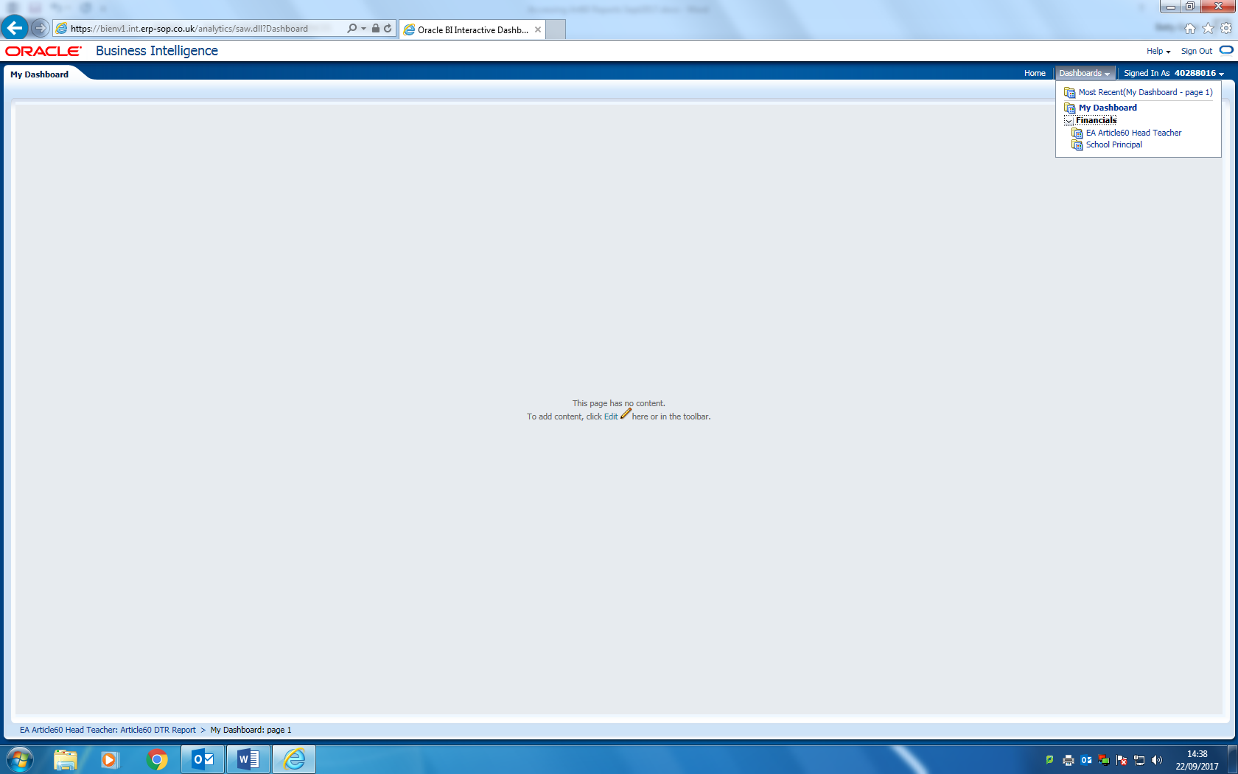

After a few seconds the report will have run and the screen below will appear. Reports appear within a tab and these tabs can be moved between.

Needs screenshot of tabs for special – check detail

Reports appear within a tab (see above) and these 8 tabs can be moved between:

1. **Budget & Expenditure Report** for Article 60 spend;
2. **Detailed Transaction Report** (DTR);
3. **Non-Delegated Staff reports** (monthly and cumulative);
4. **Earmarked Funds B&E** which contains details of the Earmarked Funds for your school;
5. **Budget & Expenditure Report with Encumbrances**;
6. **Earmarked Funds B&E with Encumbrances**
7. **Encumbrance Report**
8. **Requisition Report**

The school reports arenow **live** reports and include data up to 6pm of the previous day.

The DTR & Staff reports open at the latest period minus 1 (i.e. in September 2018 the report will open at the August 2018 period).

**The reports will automatically run each time you open it. Any changes you made in the past will not be retained.**

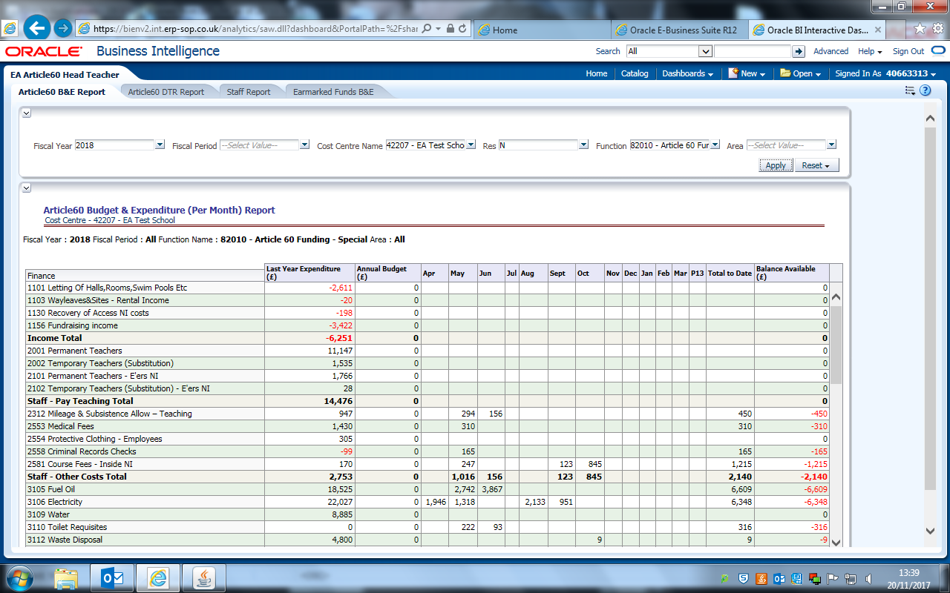

Across the top of each report are **Prompts** - see table below:

|  |  |  |  |
| --- | --- | --- | --- |
| **Prompt** | **Default** | **Sample** | **Note** |
| Fiscal Year | Current Year | 2018 | Apr 2017 to Mar 2018 |
| Fiscal Period | Current Period minus 1 **(DTR & Staff only)** | Aug17/18 | Aug 2017 (default for Sept 17) |
| Cost Centre Name | Your EA school code & name | 43210 EA Test | EA School Number & Name |
| Res | N | N | N = Non-Delegated |
| Function | 82010 | 82010 | e.g. Article60 |
| Area | 0000 | 0000 | Initially EA former region. To be used as school department for iProcurement |

**3. View the latest available data**

The reports contain **live** data, i.e. as at 6pm the previous day. The Budget & Expenditure **Article60 B&E** (with/without encumbrances) displays the spend for the financial year in a per month format, including the current period. As goods are receipted and payments are made, expenditure will appear in the current (latest) period on this report.

Do not select a Fiscal Period on the B&E.

To view expenditure for the current period for the DTR & Staff Reports

* Change the ‘**Fiscal Period’** prompt to the current period;
* Click on **Apply** (top right of screen – below ‘**Signed In As…**. & **Spare**);

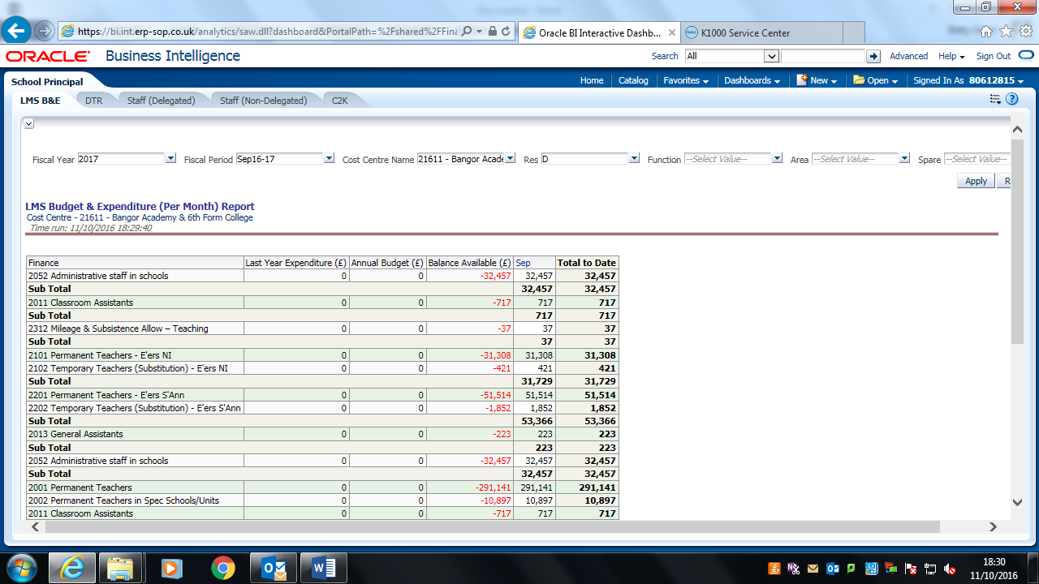

The report will update to the latest available data (data refreshed each evening at 6pm).



The report will update to the latest available data (data refreshed each evening at 6pm).

**4. Print Reports**

**4.1** **Print**

To print these reports you must first export them.

Please note: **a blue screen will appear if you do not export first**

* Scroll to the bottom of the report to ‘**Export’**
* Click on **‘Export’**

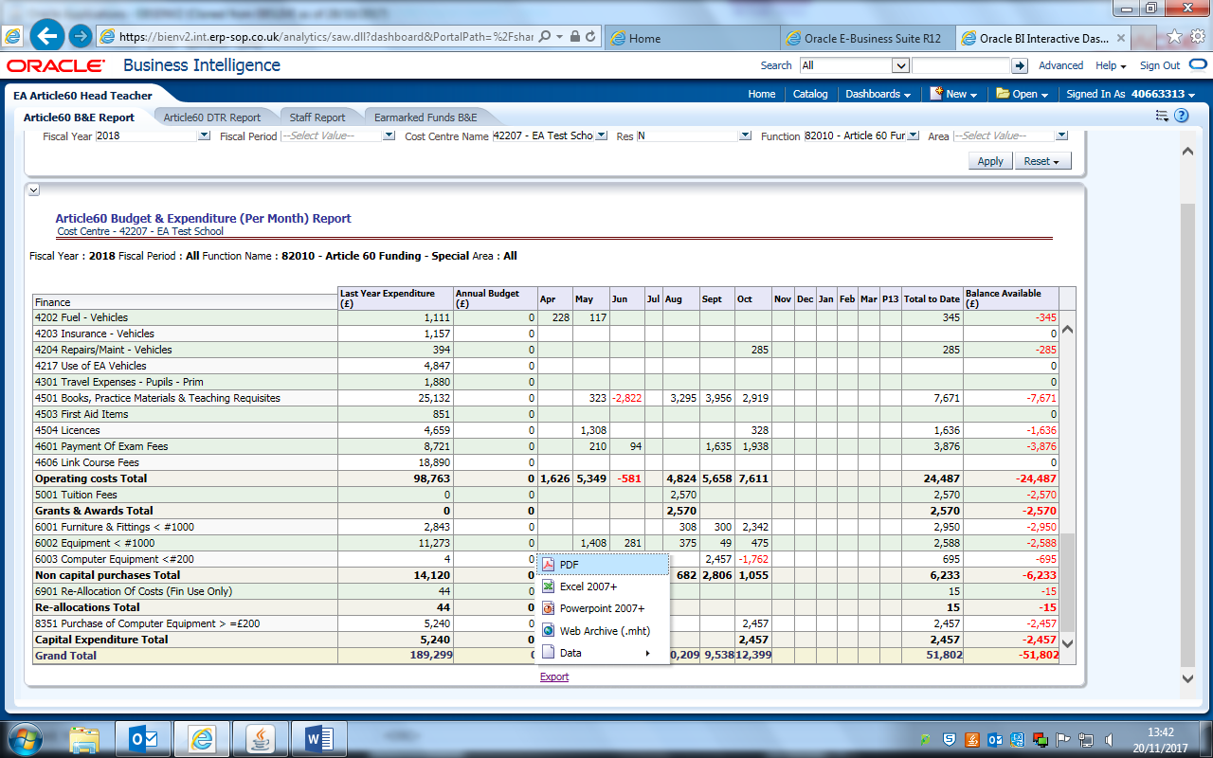

Export to (e.g.) WEB Archive (mht) for **B&E**

**Use pdf for the DTR & Staff Reports and headings will appear on all pages**

The screen below opens. Two messages appear in quick succession (see notes on messages below screenshot).

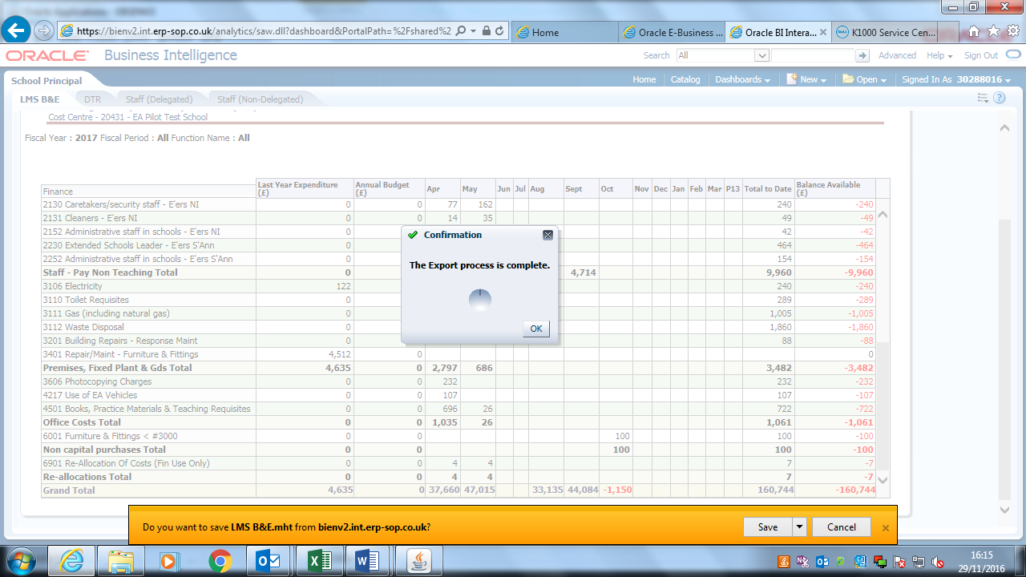

* First message – **Confirmation: The Export process is complete**.
* Click **OK** (you must respond to this message before the data will export).

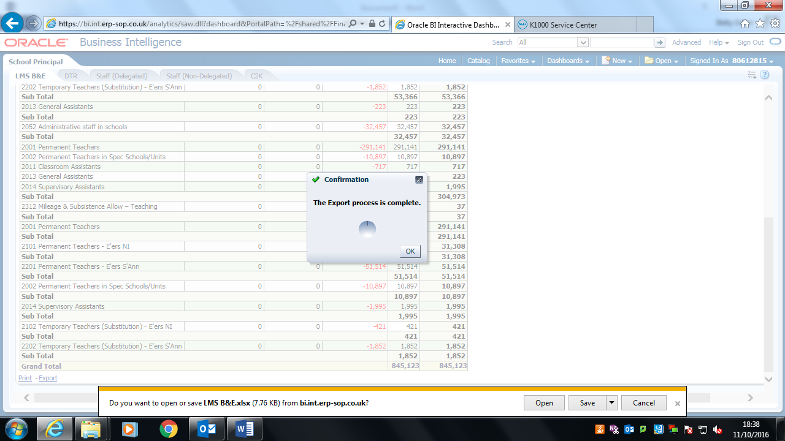

* A second message appears very soon after: **Do you want to open or save….?**
* Click **Save** and then **Open.** It is important to follow this order as it may not open otherwise.



The following screen appears. Navigate > **Internet Tools** > icon 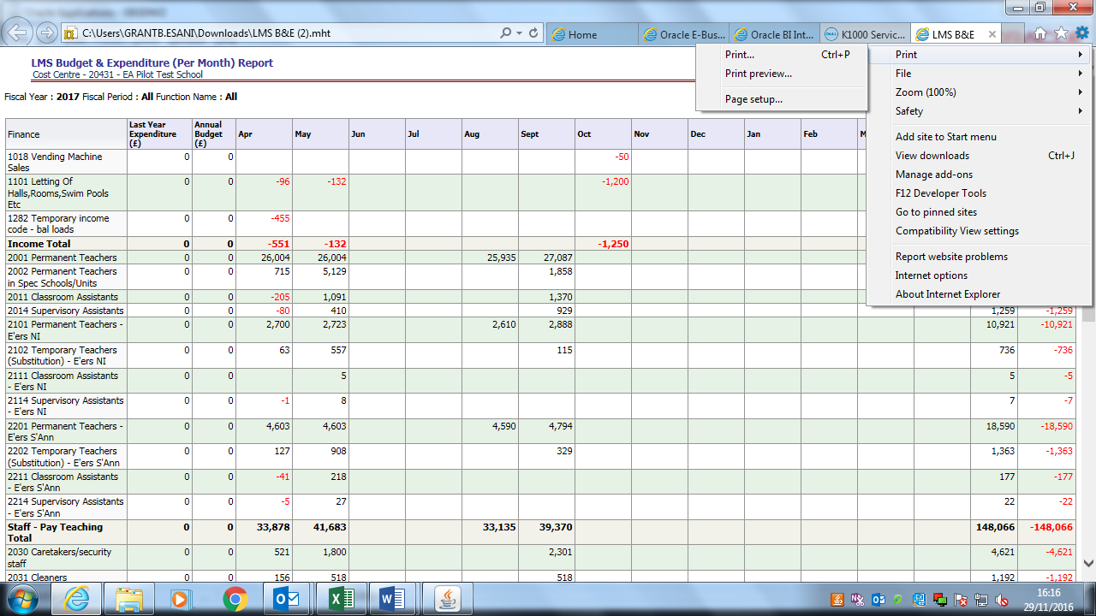 > **Print** > **Print Preview**

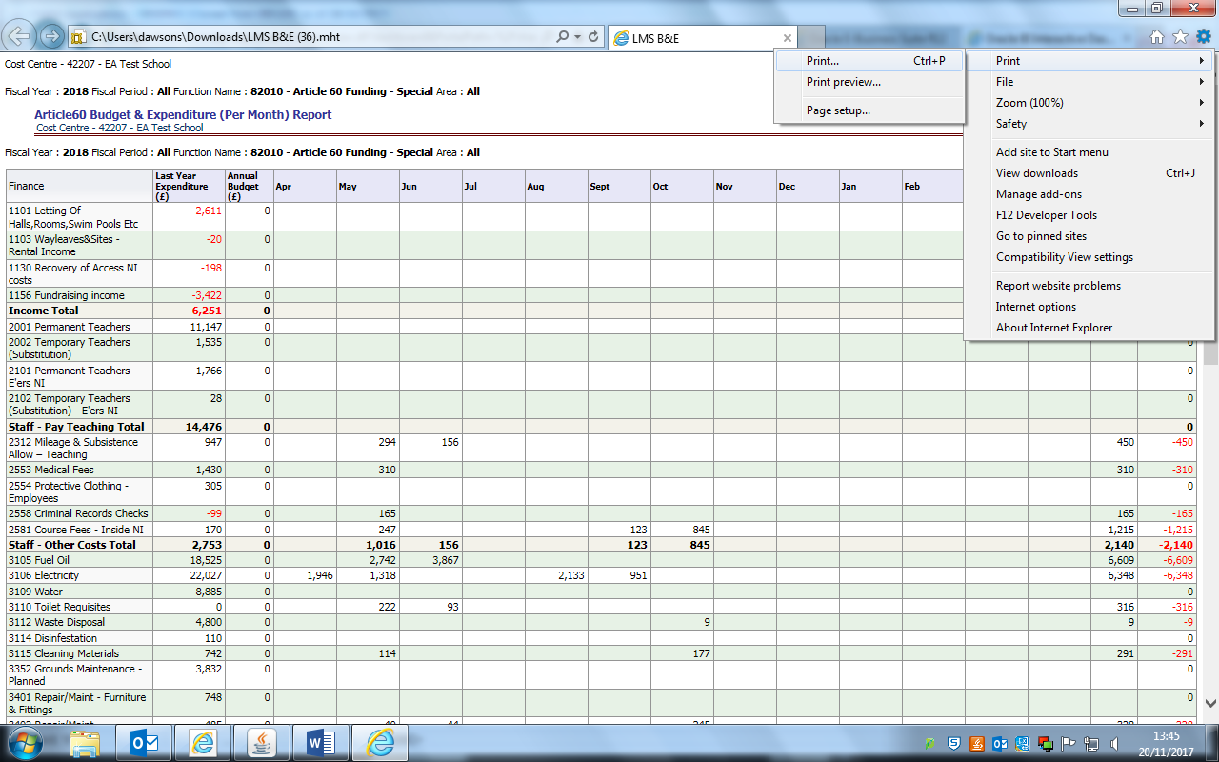

Ensure **print orientation** is **Landscape**.

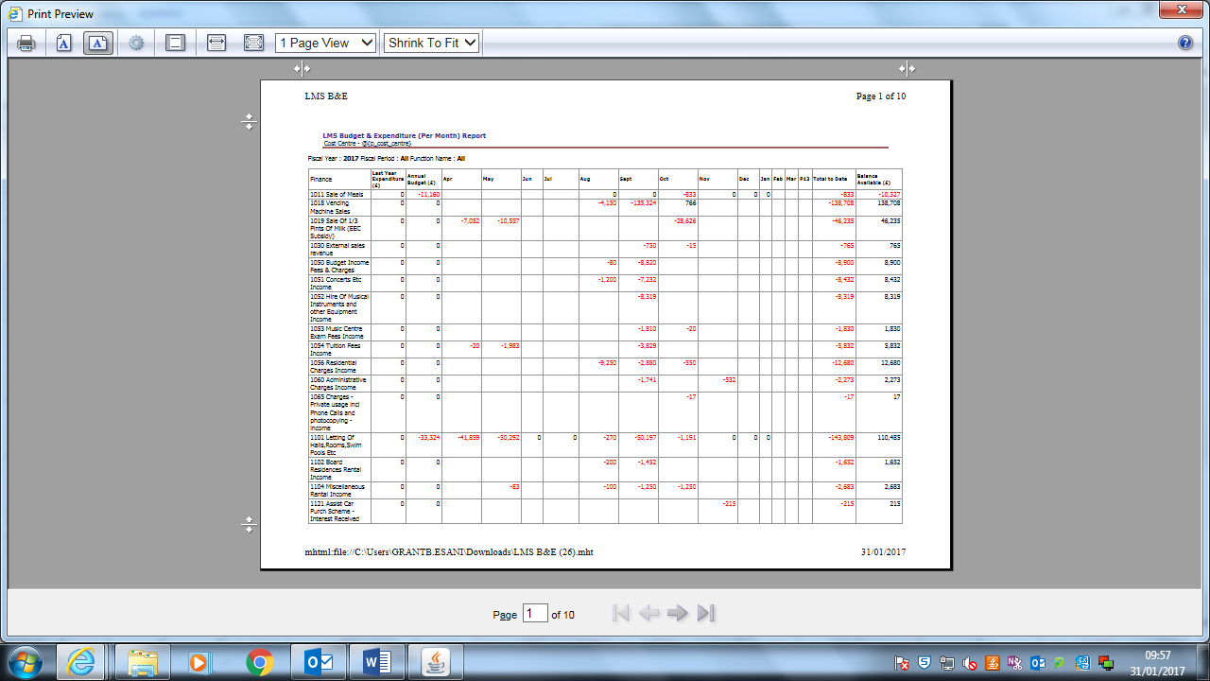

Then click on the printer icon.

Alternatively, navigate > **Internet Tools** icon  > **Print** > **Print** and print your report.

**4.2 Excel**

Reports can also be exported to Excel. The worksheet can then be saved & manipulated as necessary

* Scroll to the bottom of the report to ‘**Export’**
* Click on **‘Export’**
* Select option **Excel 2007+** (compatable with this or later versions of excel).

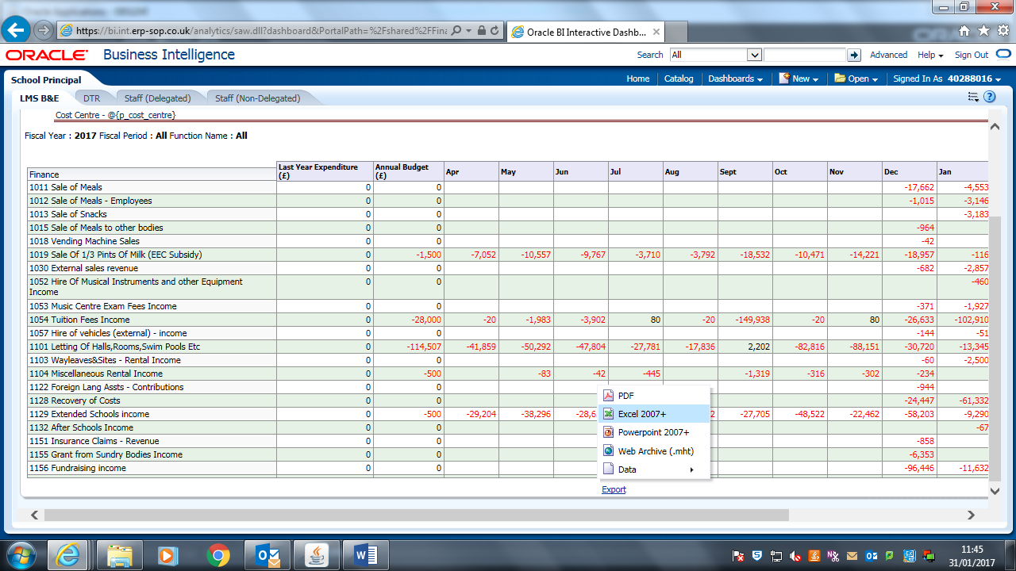

* Click **Save** and then **Open.** It is important to follow this order as it may not open otherwise.



The following output will occur:

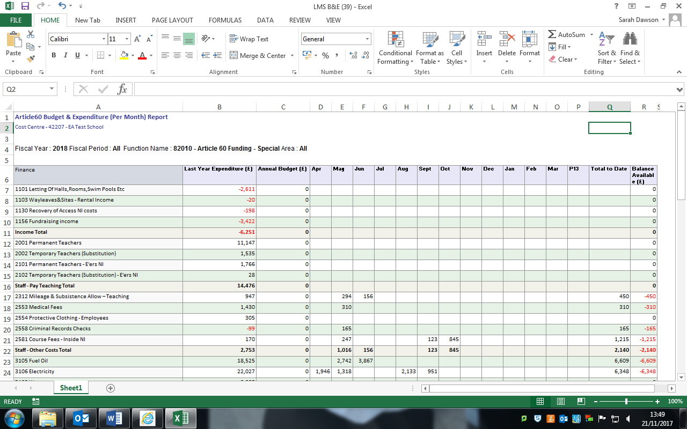

Note: each time you run this process a copy saves to your ‘Downloads’ folder on your PC. We recommend that you regularly clear this folder.

**5. Tabs**

There are various Tabs available on the dashboard representing the various reports that you receive.

The **Head Teacher** responsibility will contain a Staff (Non-Delegated) tab displaying the staff reports; the **Clerical** responsibility will not.

Move between tabs to view the different reports.

**6. Sign Out or Close from Oracle**

**6.1 Exit from reports but still stay online** (for example to raise an order or enter income)

Click on **Sign Out** (top right of screen)



This will take you back to the **Home** page:

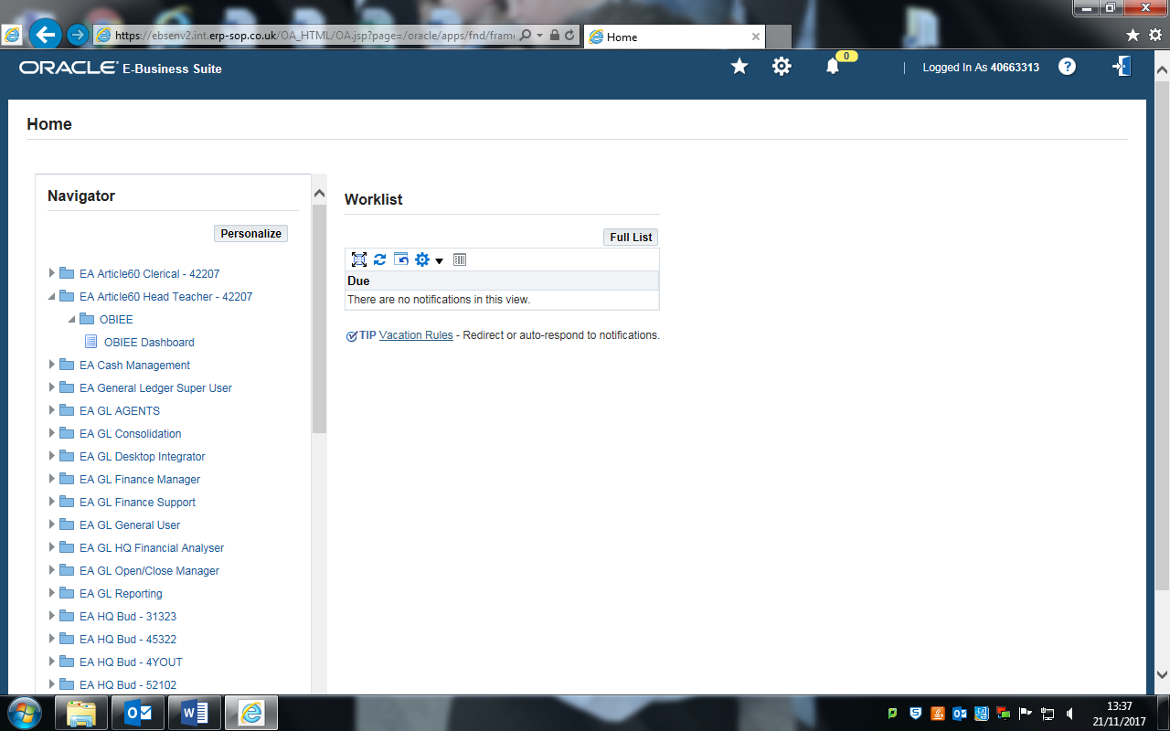

Change responsibility or, if finished, log off.

**6.2 Log Out from Oracle**

Click on the open door symbol 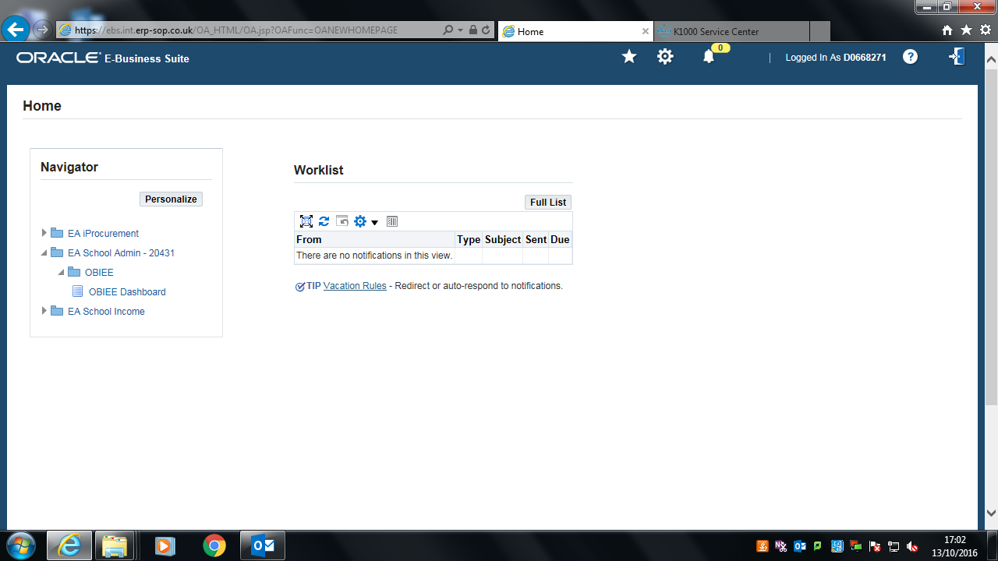 at top right of screen.

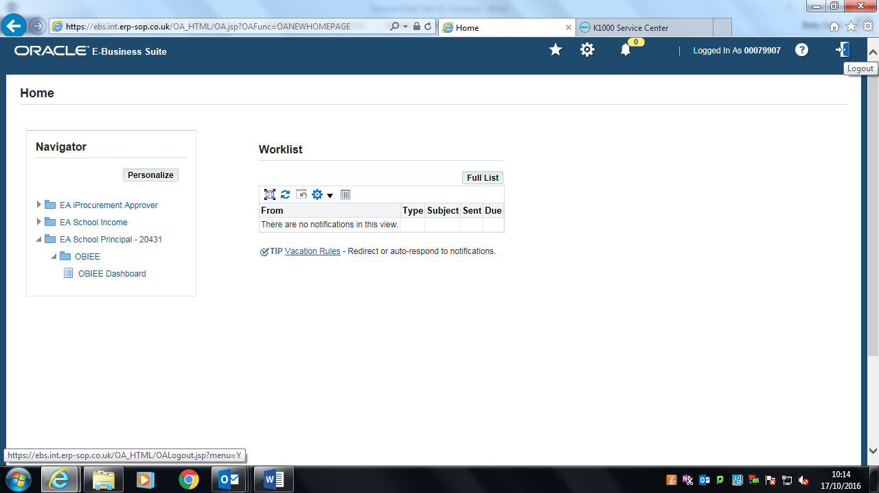

This returns the user to the login screen:

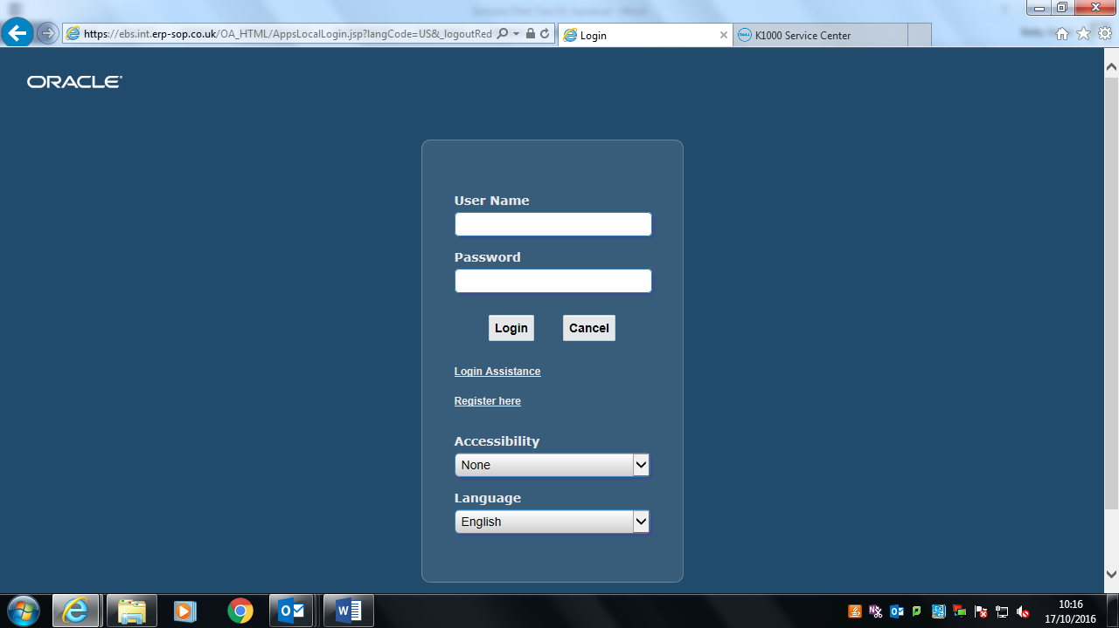

You can use the red X in the top right corner to close down completely.

**Ensure you are closed down fully from Oracle** – click on the ‘internet’ 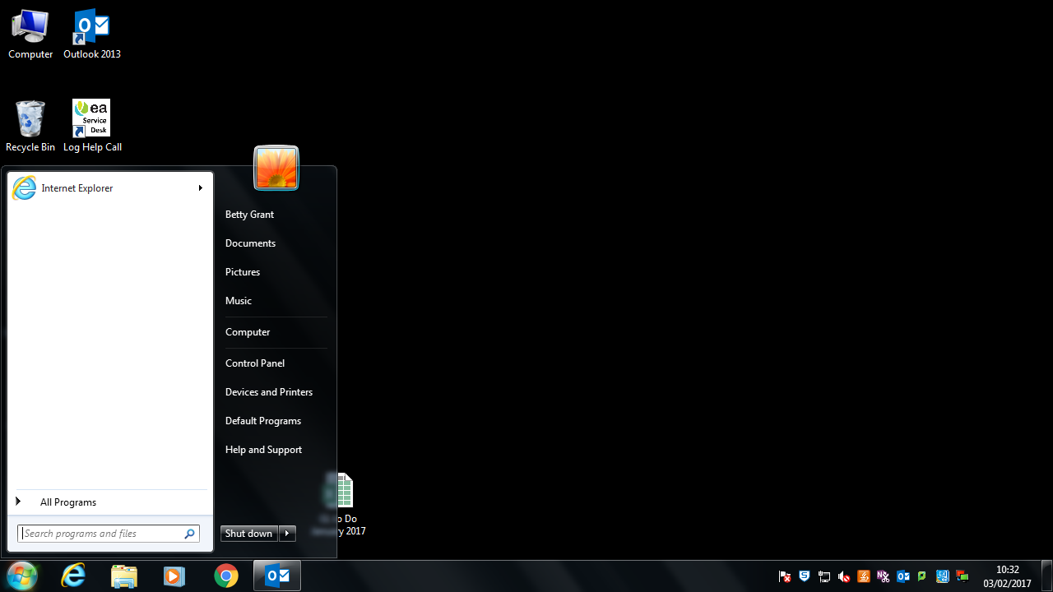 icon at the bottom of your screen to check if any windows are open.

**Tip:** you are not correctly logged out if, when you open Oracle, your User Name appears already keyed in. If this happens, we commend you log off fully.

